Horizon
Features Guide

Version | Date | Description
1.0 | 23/08/2016 | Gamma Academy Launch
1.1 | 04/01/2017 | Call Barge added
1.2 | 15/02/2017 | Included one digit dialling ranges  Improved scheduling guide for Call Groups
1.3 | 06/03/2017 | Call Recording Retention Period for existing companies added  Removed known behaviour of call recordings being deleted if a telephone number is removed from a user/company.
1.4 | 17/03/2017 | Updated with call recording search limitations when a user's or group DDI number is deleted or removed
1.5 | 05/06/2017 | Updated the Call Barring details.
1.6 | 07/07/2017 | Updated User settings text
1.7 | 11/07/2017 | NCM settings added
1.8 | 20/07/2017 | Reformatted document
1.9 | 01/08/2017 | Updated version control and added version history to document title
1.10 | 01/08/2017 | Horizon shortcodes section added
2.0 | 08/08/2017 | Portal release feature updated Call recoding bulk download with delete.
2.1 | 02/10/2017 | Revised "The leading zero Missing from the “Destination” Number” need not be there" from the "Set up 1or 2 digit dialling" sections as the Leading Zero needs to be there for the speed dials to work correctly.
2.2 | 07/11/2017 | Added in known issue of missing file during bulk call recording.  Wording amendments to Auto Attendant section to enable search on Academy for "Convert Audio File".
2.3 | 13/11/2017 | Added in new section re admin control over call recording functionality
2.4 | 15/12/2017 | Amended " Nuisance Call Management" section as "Virtual Power Pack" is now "Group Advanced Settings"
2.5 | 08/01/2018 | Added BLF and bulk speed dial information to coincide with portal release
2.6 | 13/02/2018 | Bulk speed dial add all users details added.  Changes to call recording storage rates added.  Site to site presentation policy details added.
2.7 | 16/03/2018 | Amended "Call Transfer" section.  Added "Send All Calls to Voicemail" and "Transfer on 0 for Voicemail" guides.
2.8 | 05/04/2018 | Amended "Schedules" section with further information about the Forward To: box.
3.0 | 30/07/2018 | Updated document format and reviewed content
3.1 | 07/09/2018 | Updated Hot Desk guide
3.2 | 18/12/2018 | Amended "Hunt Groups" and "Call Forwarding" with further information in what scenario a user / call group is "Unreachable".
3.3 | 09/01/2019 | Updated Busy Lamp Field, Device Customisation & Test Results section to include information on VVX150, Trio 8500 & 8800.
3.4 | 11/01/2019 | Added Call Forwarding Selective step (5) to Call Forwarding section.  Updated list of shortcodes.
4.0 | 04/02/2019 | Updated in line with new Horizon Portal rebrand images
4.1 | 26/06/2019 | NSF Updates – removed term “Subscription” and replaced with “Bolt Ons” throughout document.
4.2 | 15/07/2019 | Updated Busy Lamp Field, Device Customisation & Test Results section to include information on VVX250 & VVX450. Also updated “Configure my Polycom VVX Device” section to reflect the new DC pages on the Horizon GUI.
4.3 | 12/09/2019 | Updated Busy Lamp Field, Device Customisation & Test Results section to include information on Cisco MPP 8841, 8851, 8861 devices. Also updated “Configure my Cisco Device” section to reflect the new DC pages on the Horizon GUI.

Contents
Contents 3
1 or 2 Digit Dialling (Speed Dials) 10
Set up 1 or 2 Digit Dialling as a Company Admin 10
Set up 1 or 2 Digit Dialling as a User 13
Set up 1 or 2 Digit Dialling from a Handset 16
Account and Authorisation Codes 17
Switch Account Codes On/Off 17
Manage Account Code Users 20
Switch Authorisation Codes On/Off 22
Manage Authorisation Code Users 23
Horizon Shortcodes 26
Anonymous Call Rejection 28
Shortcodes 28
Activating / Deactivating Anonymous Call Rejection for a User 28
Auto Attendant 30
Setup Auto Attendant 30
The Dialling Scope is: 33
Recording an Auto Attendant message with my Horizon Phone 36
Automatic Call Back 37
Shortcodes 37
Setup Automatic Call Back for a User 37
Busy Lamp Field (BLF) 42
Setup and Edit Busy Lamp Fields (BLFs) 42
Busy Lamp Field (BLF) Name Searching 44
Call Barge 46
Setup & Edit Call Barge 46
Barging into a call 47
Call Barring 48
Setup and Manage Site Call Barring 48
Override Site Call Barring for a User 49
Call Forwarding 51
Shortcodes 51
Turn Call Forwarding On/Off as a Company Administrator 52
Turn Call Forwarding On/Off as a User using the Horizon Portal 54
Turn Call Forwarding On/Off as a User using a Soft Client 54
Call Notify by Email 55
Turn Call Notify by Email On/Off 55
Call Paging 57
Setup Call Page Group 57
Edit a Call Page Group (including Add/Removing Users) 60
Call Park 64
Shortcodes 64
Setup Call Park Group 64
Delete Call Park Group 67
Call Pickup 68
Setup Call Pickup Group 68
Add/Remove users from an existing Call Pickup Group 69
Delete Call Pickup Group 71
Call Queue Groups 72
Setup a Call Queue Group 72
Add/Remove Users to/from a Call Queue Group 77
Edit a Call Queue Group Settings 79
Delete a Call Queue Group 81
User logging in and out of a Call Queue Group 82
Call Recording 83
Call Recording Retention Period 84
Call Recording Options 86
Shortcodes 86
Call Recording for a User 86
Call Recording for a Hunt Group 87
Call Recording for a Call Queue Group 88
Bulk Call Recording with delete. 89
Searching for a Call Recording 92
Searching for a Call Recording using Advanced Call Recording 93
Access and notification control to call recordings 95
Call Transfer 98
Activate/Deactivate Call Transfer as a Company Administrator 98
Privacy on Transfer and/or Forwarding 99
Privacy on Transfer Service Interaction Impacts 100
Examples / Findings 100
Call Groups – Auto Attendants, Hunt Group, Call Centre & Call Queue Groups findings 104
Call Transfer – Attended findings 104
Service Combinations 110
Attended Call Transfer to User with Call Forward 110
Attended call transfer to call group 111
Redirection service display of call received via a call group 111
Test Results for Hardware and Clients 113
Receptionist, Call Centre and Integrator Clients 113
Akixi and Horizon GUI CDR’s 113
Known Behaviours 114
Cisco devices and Soft Clients fail to update display attended transfers before answer and transfer of call on hold scenarios 114
Mobile clients do not see a display update in attended transfer before answer scenarios 114
Attended transfer before answer to call group does not update display 114
Integrator does not update display when updated display information is anonymous 114
Integrator doesn’t update display correctly on attended transfers when remote party is set to originator 114
No alpha tagging / loss of alpha tagging in some scenarios 115
Cisco devices do not remove names on display if no name is provided in updated PAID 115
Cisco devices show different name and number in call logs 115
Call Forwarding Selective and Connect App 115
Device Call Log Impacts 117
Call Barge 117
Call Park / Group Call Park 117
Call Pickup 118
Call Transfer Attended 118
Blind Transfers 119
Call Forwarding – No Answer / Busy / Unreachable / Always 119
Sequential Ring 120
Call Waiting 121
Shortcodes 121
Enable / Disable Call Waiting for a User 121
Enable / Disable Call Waiting for a Hunt Group 122
Enable / Disable Call Waiting for a Call Queue Group 124
Click to Dial 126
Site to site presentation policy 127
CLI Presentation 130
Override Site Call Policy 130
Comfort Messages 132
Departments 133
Setup Departments 133
Delete Departments 133
Add/Remove users from Departments 134
Device Customisation 136
Give a user access to set up Device Customisation 137
Device Customisation as a Company Admin 138
Configure my Cisco Device 139
Assigning Soft Keys 139
Assigning Line Keys 141
Configure my Polycom VVX Device 143
Assigning Soft Keys 143
Assigning Line Keys 143
Configure my Polycom SoundPoint Device 145
Assigning Soft Keys 145
Assigning Line Keys 147
Directory 150
Add New User to Company Directory 150
Add/Remove External Contact(s) to the Company Directory 150
Add Multiple External Contacts to the Company Directory 152
Add Single Contact to User Directory 155
Add Multiple Contacts to User Directory 156
Delete Contact(s) from User Directory 158
Distinctive Ringing for External Calls 160
Setup Distinctive Ringing as a Company Administrator 160
Do Not Disturb 161
Shortcodes 162
Enabling Do Not Disturb (DND) from a Handset or soft Client 162
Enabling/Disabling Do Not Disturb (DND) from Administrator Portal 162
Health Check 164
Access Tab 164
SIP ALG 165
Handset Registration 165
Hot Desking 167
Switch Hot Desking On/Off 167
Login to a Hot Desk as Administrator 168
End Hot Desk Association as Administrator 169
Login to a Hot Desk as a User 170
Login to a Hot Desk using a Polycom Handset 171
Login to a Hot Desk using a Cisco Handset and the Voice Portal 172
Hunt Groups 173
Hunt Group Types 173
Setup a Hunt Group 173
Add/Remove Users to/from a Hunt Group 177
Edit a Hunt Group Settings 179
Delete a Hunt Group 181
Apply a Schedule to a Hunt Group 181
Listening to your Hunt Group Voicemail 183
Resetting a Hunt Groups Voicemail Passcode 183
Instant Conference Group 186
Setup an Instant Conference Group 186
Edit an Instant Conference Group 189
Delete an Instant Conference Group 190
Music on Hold 191
Shortcodes 191
Setup Music on Hold 191
Nuisance Call Management for Horizon Call Groups 193
Availability Profiles 197
Give permission to a user to use Availability Profiles 197
Setup and Edit Availability Profiles as a User 198
Activate Availability Profiles as a User 199
Remote Office 200
Give permission to a user to use Remote Office 200
Activate / Deactivate Remote Office as a User 201
How to make outgoing calls using Remote Office 202
How to receive calls using Remote Office 202
Sequential Ringing 203
Enable/Disable Sequential Ringing 203
Schedules 206
Setup Schedules 206
Example out of hours schedules (Company open hours 09:00 - 17:00 Monday to Friday) 208
Edit Schedules 210
Twinning 214
Enable/Disable Twinning as an Administrator 214
Enable/Disable Twinning as a User 215
Enable / Disable Twinning using the Horizon Portal 215
Enable / Disable Twinning using the PC Soft Client and Collaborate 216
Voice Portal 217
Setup a Company Voice Portal 217
Managing a Company via the Voice Portal 218
Option 1 - Voicemail 218
Option 2 - Voicemail Express 219
Option 3 - Recording your name greeting 219
Option 4 - Call Forwarding 219
Option 8 - Call Forwarding 219
Voicemail 220
Voicemail Map 220
Setup Voicemail for a user 220
Setup Voicemail from a handset 223
Change a user's passcode for Voicemail 223
Change a user's passcode for Voicemail 225
Send All Calls To Voicemail 227
Transfer on 0 for Voicemail 228
Feedback 229

1 or 2 Digit Dialling (Speed Dials)
One Digit Dialling enables users to dial single digit codes to call up to eight different numbers, such as frequently dialled numbers or long strings of digits that are hard to remember. You should press
# AFTER the number for one digit dialling (i.e. 0#). The One Digit Dialling range is 2 through to 9.
Two Digital Dialling enables users to dial two-digit codes to call up to 73 frequently called numbers. You can use the speed dial codes from 00 - 78, with the exception of 21, 31, 40, 41, 43 and 58 which are dedicated Short codes. Such as frequently dialled numbers or long strings of digits that are hard to remember. You should press # BEFORE the number for two digit dialling (i.e. #00)
 If your user is using the Receptionist Console, Speed Dials set up by the user here will appear in the Receptionist Console.

Set up 1 or 2 Digit Dialling as a Company Admin
Step 1
Log into the Gamma Portal and go to Provisioning and Service Management, Hosted, Horizon and Horizon Manage Company.
Step 2
Select your account and locate the company that you want to update the speed dials for. Using the "Actions" button select "Login to Horizon".

Step 3
Hover over "Users" and then click "List Users".
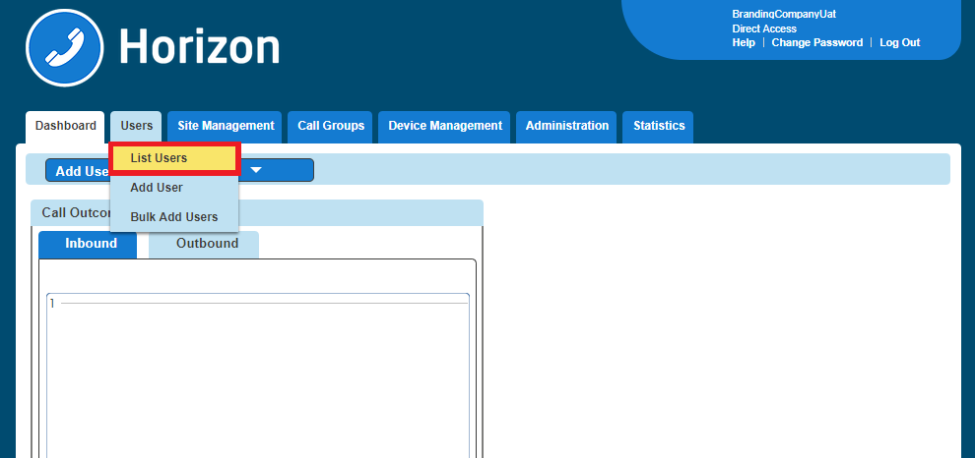
Step 4
Locate the User you are wanting to set up 1 or 2 Digit Dialling for. You can do this by scrolling through the User list, or you can use the search facility presented on the page.
Click the "Edit" button next to the User.
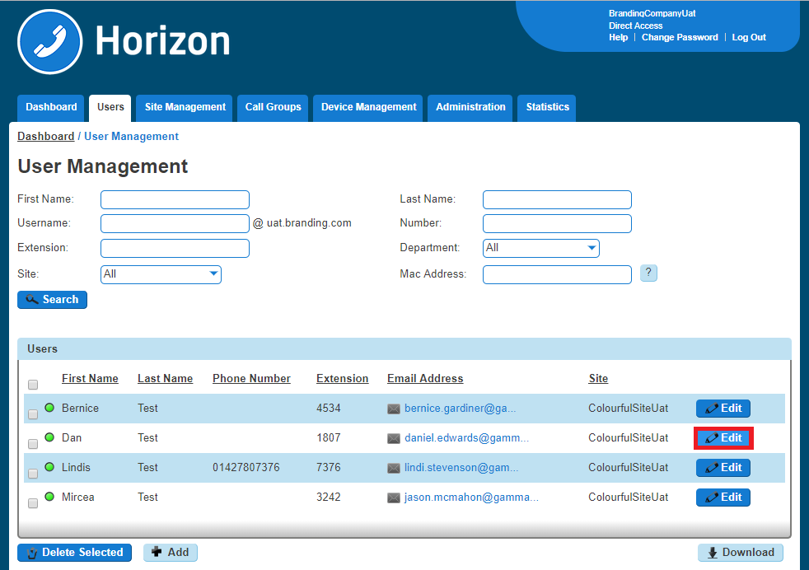

Step 5
Click Call Setup and then under the "Outgoing Calls" tab select "Speed Dial"

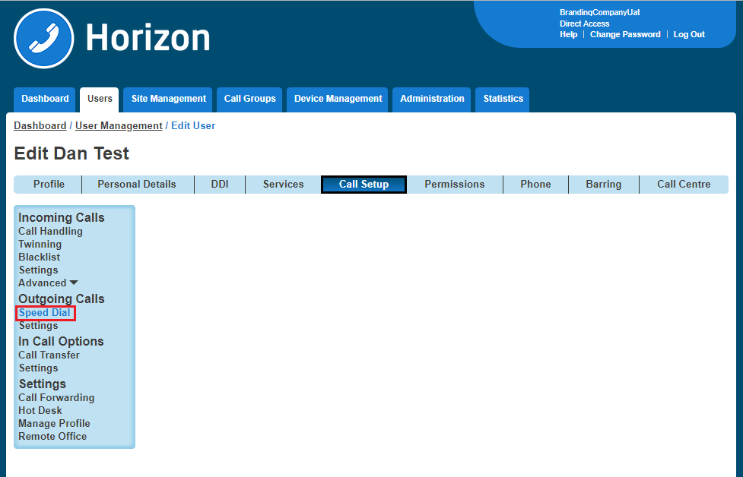
Step 6
1 Digit Dialling is selected by default. If it is 1 Digit Dialling you want to set up then you should click "Add New". If it is 2 Digit Dialling then select the "2 Digit Dialling" tab and then click "Add New"

You can also do this in bulk by clicking the "Download Template" button and downloading a CSV file. Remember when you're uploading the file to do the following:
The "Destination" column needs to be formatted as "text". To do this right click on column C > Format Cells > Text and click OK.
The leading zero from the from the “Destination” Number”needs to be there for speed dials to work correctly
There is a blank row. There must be no blank rows when uploading your bulk spreadsheet.
If you do not wish to use a particular number a speed dial then you will need to remove it. The numbers do not need to be in numerical order.
Speed dials can be 1-79 excluding 21, 31, 40, 41, 43 and 58 which are hashtag Shortcodes for Horizon.
The file needs to be saved as a CSV file before uploading. Any other file format will cause the upload to fail.
If no speed dials are setup then the speed dial will start from 2. This is because most carriers configure 1 as Voicemail).
Step 7
Click the "Search Directory" icon to assign a number from the company. Use the Search Directory fields (minimum of one field must be completed) and click "Search" to find the users you want to have a speed dial for.
Use the button next to the name of the user to select them.
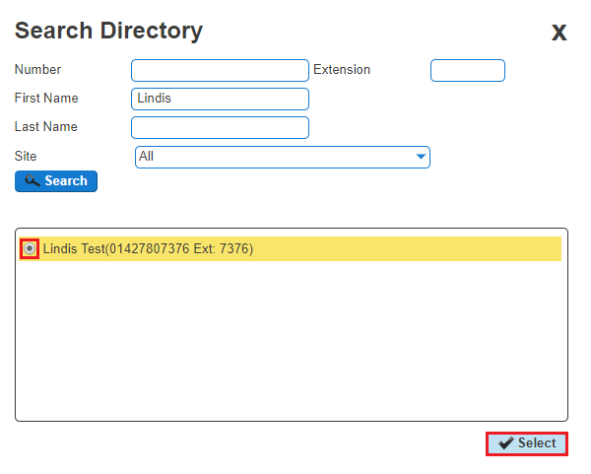

Step 8
Once you've got the Name and Destination field completed click Save.
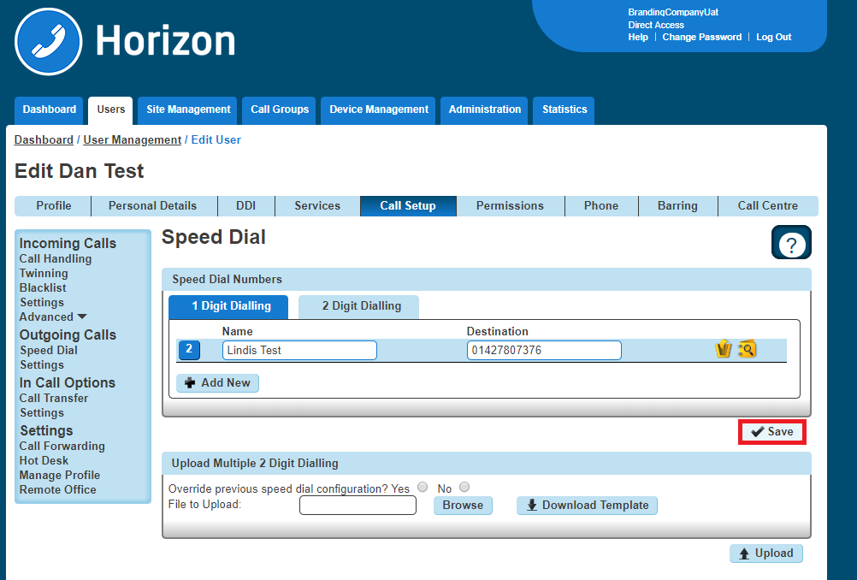

Set up 1 or 2 Digit Dialling as a User
Step 1
Log into the Horizon Portal as a Horizon User and click on "Call Setup"

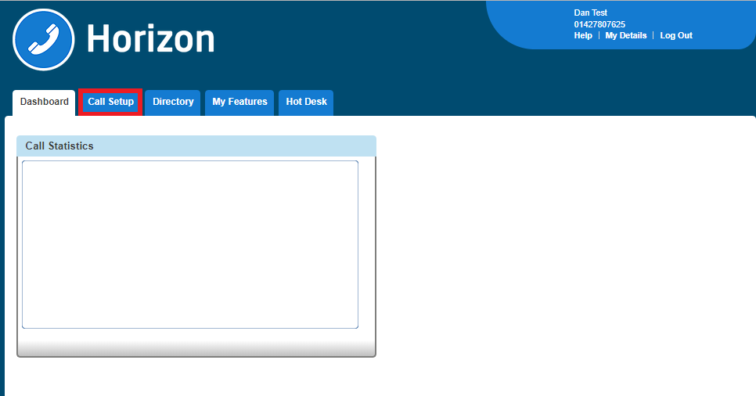

Step 2
Click on Speed Dial. 1 Digit Dialling is selected by default. If it is 1 Digit Dialling you want to set up then you should click "Add New". If it is 2 Digit Dialling then select the "2 Digit Dialling" tab and then click "Add New"
You can also do this in bulk by clicking the "Download Template" button and downloading a CSV file. Remember when you're uploading the file to do the following:

The "Destination" column needs to be formatted as "text". To do this right click on column C > Format Cells > Text and click OK.
The leading zero from the from the “Destination” Number” needs to be there for speed dials to work correctly
There is a blank row. There must be no blank rows when uploading your bulk spreadsheet.
If you do not wish to use a particular number a speed dial then you will need to remove it. The numbers do not need to be in numerical order.
Speed dials can be 1-79 excluding 21, 31, 40, 41, 43 and 58 which are hashtag Shortcodes for Horizon.
The file needs to be saved as a CSV file before uploading. Any other file format will cause the upload to fail.

If no speed dials are setup then the speed dial will start from 2. This is because most carriers configure 1 as Voicemail).
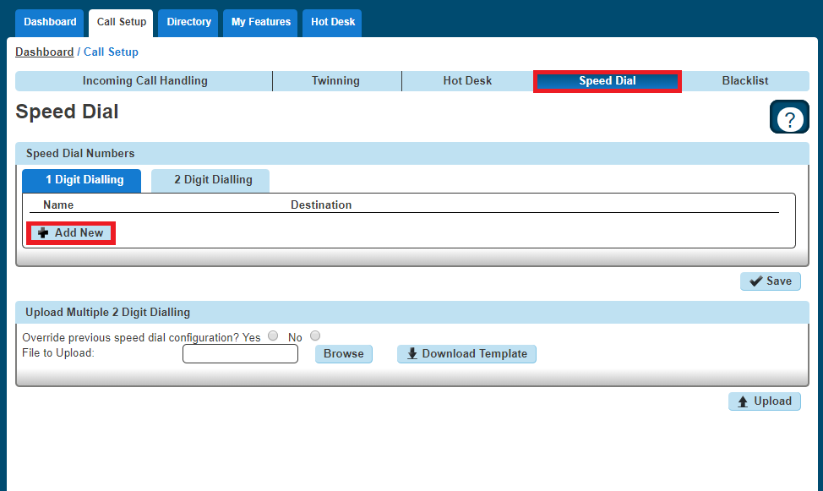

Set up 1 or 2 Digit Dialling from a Handset
To set up One Digit dialling from your Horizon Handset dial *74, the number you want to assign a speed dial to, and then the telephone number you want to dial.
For example *74208081788000 will assign 08081788000 to speed dial digit 2.

Account and Authorisation Codes
Account codes are enabled to track calls made by defined users outside the Horizon Company by prompting the users for an account code. You have the option of setting up a list of optional and mandatory groups. In order to enter a code in either group then you will need to dial *71, then the account code, and then the number to be dialled.
Authorisation codes are used to perform authorisation of calls made outside of a calling group by prompting the user for an authorisation code. This could be for example where a phone is located in a public area and calls are to be restricted.
You can only use an Account Code if you have Authorisation Codes disabled. You cannot have both running concurrently.

Account and Authorisation Codes can only be set up by a Company Administrator.

Switch Account Codes On/Off
Step 1
Log into the Gamma Portal and go to Provisioning and Service Management, Hosted, Horizon and Horizon Manage Company.

Step 2
Select your account and locate the company that you want to update the Account Codes for. Using the "Actions" button select "Login to Horizon".

Step 3
Select "Site Management" and then click the "Manage" button of the site that you wish to switch Account Codes on or off for.

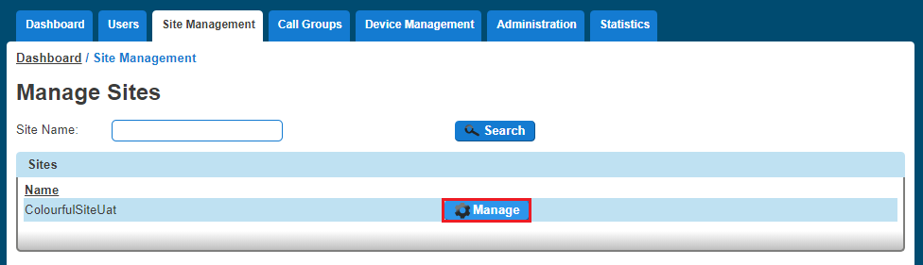

Step 4
Select "Authorisation Codes"
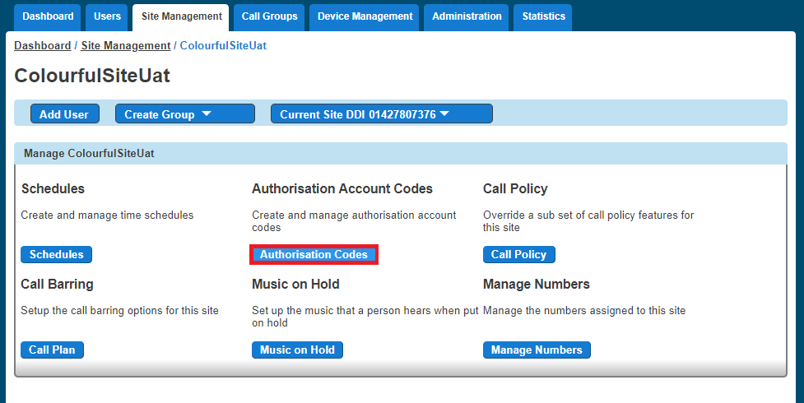
Step 5
To switch off the account codes then you should make sure that the "Enabled Codes" button is set to "Off".
To switch on account codes then you should set "Enable Codes" to "On", and select how many digits you want before clicking "Save." The code length can be between 2 and 14 digits.

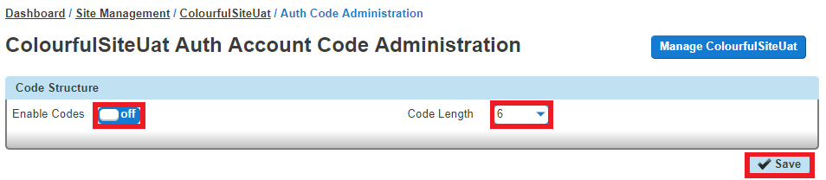
Step 6
Now you should select to use Account Codes and then select "Manage Codes" once this has been selected.
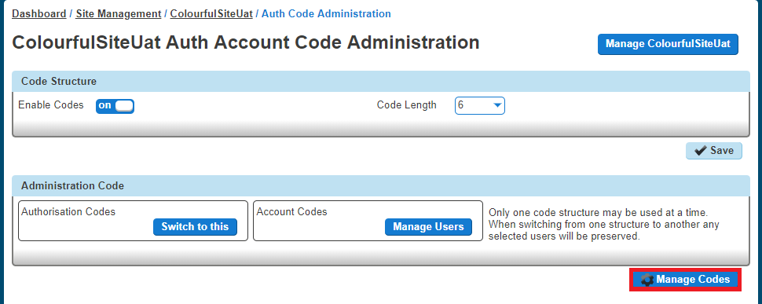

Step 7
From here you can add and delete codes.
To Add an Account Code you add the details in the "Code" and the "Description" text boxes.
To Delete an Account Code you simply select the code from the table and press "Delete Selected".
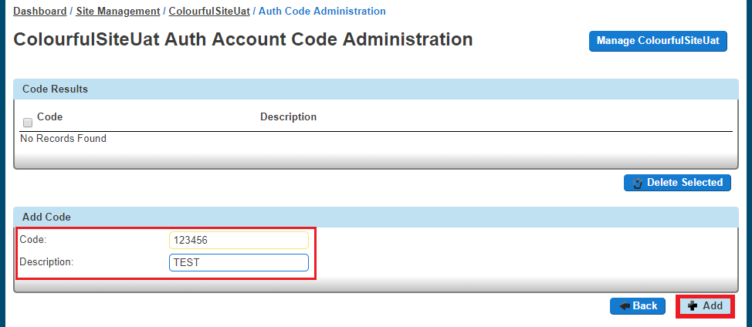

Once you've clicked "Add", you can go "Back" and then you can save your changes by clicking the "Save" button.
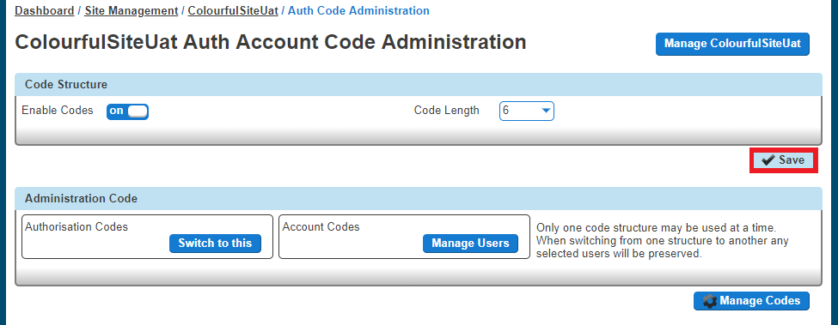

Manage Account Code Users
Step 1
Log into the Gamma Portal and go to Provisioning and Service Management, Hosted, Horizon and Horizon Manage Company.
Step 2
Select your account and locate the company that you want to update the Account Codes for. Using the "Actions" button select "Login to Horizon".
Step 3
Select "Site Management" and then click the "Manage" button of the site that you wish to switch Account Codes on or off for.

Step 4
Select "Authorisation Codes"

Step 5
Select "Manage Users" and then you can add your Mandatory and Optional users in the relevant tables.
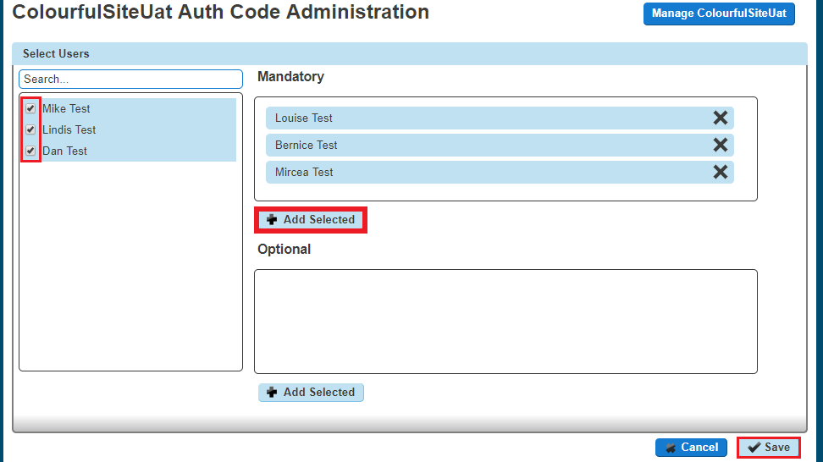
To remove a user you just simply have to click the "X" next to the user. Once you've finished making all your changes you just need to click "Save".

Switch Authorisation Codes On/Off
Step 1
Log into the Gamma Portal and go to Provisioning and Service Management, Hosted, Horizon and Horizon Manage Company.
Step 2
Select your account and locate the company that you want to update the Authorisation Codes for. Using the "Actions" button select "Login to Horizon".
Step 3
Select "Site Management" and then click the "Manage" button of the site that you wish to switch Authorisation Codes on or off for.

Step 4
Select "Authorisation Codes"

Step 5
To switch off the authorisation codes then you should make sure that the "Enabled Codes" button is set to "Off".
To switch on account codes then you should set "Enable Codes" to "On", and select how many digits you want before clicking "Save." The code length can be between 2 and 14 digits.

Step 6
Now you should select to use Authorisation Codes and then select "Manage Codes" once this has been selected.
Step 7
From here you can add and delete codes.
To Add an Authorisation Code you add the details in the "Code" and the "Description" text boxes.
To Delete an Authorisation Code you simply select the code from the table and press "Delete Selected".
Once you've clicked "Add", you can go "Back" and then you can save your changes by clicking the "Save" button.

Manage Authorisation Code Users
Step 1
Log into the Gamma Portal and go to Provisioning and Service Management, Hosted, Horizon and Horizon Manage Company.
Step 2
Select your account and locate the company that you want to update the Authorisation Codes for. Using the "Actions" button select "Login to Horizon".
Step 3
Select "Site Management" and then click the "Manage" button of the site that has the Authorisation Codes you wish to edit the users for.

Step 4
Select "Authorisation Codes"
Step 5
Select "Manage Users" and then you can add your Mandatory and Optional users in the relevant tables.
To remove a user you just simply have to click the "X" next to the user. Once you've finished making all your changes you just need to click "Save".

Horizon Shortcodes
Please see the below table of Horizon shortcodes:
Anonymous Call Rejection Activation | *77
Anonymous Call Rejection Deactivation | *87
Anonymous Call Rejection Interrogation | *52*
Call Bridge | *15
Call Forwarding Always Activation | *72
Call Forwarding Always Deactivation | *73
Call Forwarding Always Interrogation | *21*
Call Forwarding Always To Voice Mail Activation | *21
Call Forwarding Always To Voice Mail Deactivation | #21
Call Forwarding Busy Activation | *90
Call Forwarding Busy Deactivation | *91
Call Forwarding Busy Interrogation | *67*
Call Forwarding Busy To Voice Mail Activation | *40
Call Forwarding Busy To Voice Mail Deactivation | #40
Call Forwarding No Answer Activation | *92
Call Forwarding No Answer Deactivation | *93
Call Forwarding No Answer Interrogation | *61*
Call Forwarding No Answer To Voice Mail Activation | *41
Call Forwarding No Answer To Voice Mail Deactivation | #41
Call Forwarding Not Reachable Activation | *94
Call Forwarding Not Reachable Deactivation | *95
Call Forwarding Not Reachable Interrogation | *63*
Call Forwarding Selective Activation | #76
Call Forwarding Selective Deactivation | #77
Calling Line ID Delivery Blocking Interrogation | *54*
Calling Line ID Delivery Blocking per Call | *67
Calling Line ID Delivery Blocking Persistent Activation | *31
Calling Line ID Delivery Blocking Persistent Deactivation | #31
Calling Line ID Delivery per Call | *65
Call Park | *68
Call Park Retrieve | *88
Call Pickup | *98
Call Retrieve | *11
Call Return | *69
Call Return Number Deletion | #92#
Call Waiting Interrogation | *53*
Call Waiting Persistent Activation | *43
Call Waiting Persistent Deactivation | #43
Cancel Call Waiting | *70
Clear Voice Message Waiting Indicator | *99
Connected Line Identification Restriction Interrogation | *56*
Directed Call Pickup | *97
Directed Call Pickup with Barge-in | *33
Direct Voice Mail Transfer | *55
Diversion Inhibitor (this feature cannot be controlled via GUI) | *80
Do Not Disturb Activation | *78
Do Not Disturb Deactivation | *79
Escalate Call to Supervisor | #83
Group Call Park | #58
Last Number Redial | *66
Mobility (CONNECT) Calling Line ID Activation | *23
Mobility (CONNECT) Calling Line ID Activation Per Call | *28
Mobility (CONNECT) Calling Line ID Deactivation | *24
Mobility (CONNECT) Calling Line ID Deactivation Per Call | *29
Music On Hold Per-Call Deactivation | *60
No Answer Timer | *610
Per Call Account Code | *71
Selective Call Rejection Interrogation (Blacklist) | *51*
Speed Dial 100 | *75
Speed Dial 8 | *74
Voice Mail Retrieval | *86
Voice Portal Access | *62

Anonymous Call Rejection
Anonymous Call Rejection enables a user to reject calls from anonymous parties who have explicitly restricted their Caller ID. By activating the service via a web interface, callers without available caller ID are informed that the user is not accepting calls at that time. The user’s phone does not ring and the user sees or hears no indication of the attempted call. This service does not apply to calls from within the group.
 If a user in a Call Queue Group has Anonymous Call Rejection enabled and a "withheld" caller reaches the front of the queue, the call will not be delivered to the user with Anonymous Call Rejection, even if that user is available.
The call will wait until another user without Anonymous Call Rejection enabled becomes available.
Only a Company Administrator can set up a user with Anonymous Call Rejection.

Shortcodes
Activate: *78
Deactivate *87

Activating / Deactivating Anonymous Call Rejection for a User
Step 1
Log into the Gamma Portal and go to Provisioning and Service Management, Hosted, Horizon and Horizon Manage Company.
Step 2
Select your account and locate the company that you want to update Anonymous Call Rejection for using the "Actions" button select "Login to Horizon"
Step 3
Select "Users" and "List Users" and using the search screen identify the user you want to activate / deactivate Anonymous Call Rejection for and click "Edit".

Step 4
Click "Call Setup" and then under the Incoming Calls section select "Settings".
Use the button next to "Reject Withheld Number" to either switch this feature on or off. Click Save.
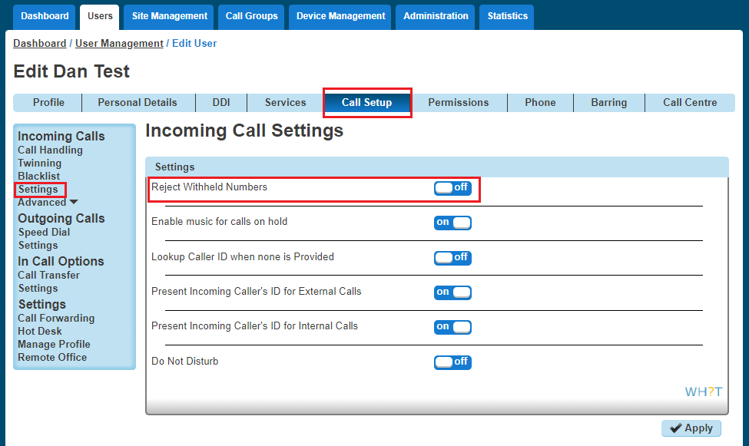

Auto Attendant
The Auto Attendant feature allows callers to your company to be automatically transferred to a person or group without the intervention of an operator or receptionist.

There is no limit on the number of Auto Attendants a Company can have, however there is a limit of up to 3 levels of Auto Attendants (for example you can have one auto attendant going to another auto attendant three times).
You can record the Auto Attendant messages using either your Horizon phone, or create a sound file on your computer and upload this. See our guide on the Knowledgebase on how to "Convert Audio File".

Setup Auto Attendant
Before you start to set up your Auto Attendant, you need to make sure that you have an Auto Attendant Add-on to do this. This is done by completing the following actions:

Log into the Gamma Portal and go to Provisioning and Service Management, Hosted, Horizon and Horizon Manage Company.
Select your account and locate the company that you want to setup an Auto Attendant.
Using the "Actions" drop down select "Manage Bolt Ons".
From here you can see what bolt ons you have and how many are currently in use. If you need to add any more Auto Attendant add-ons if you scroll to the bottom of the page and click "Add More Bolt Ons" and then you can add as many bolt ons as you need.

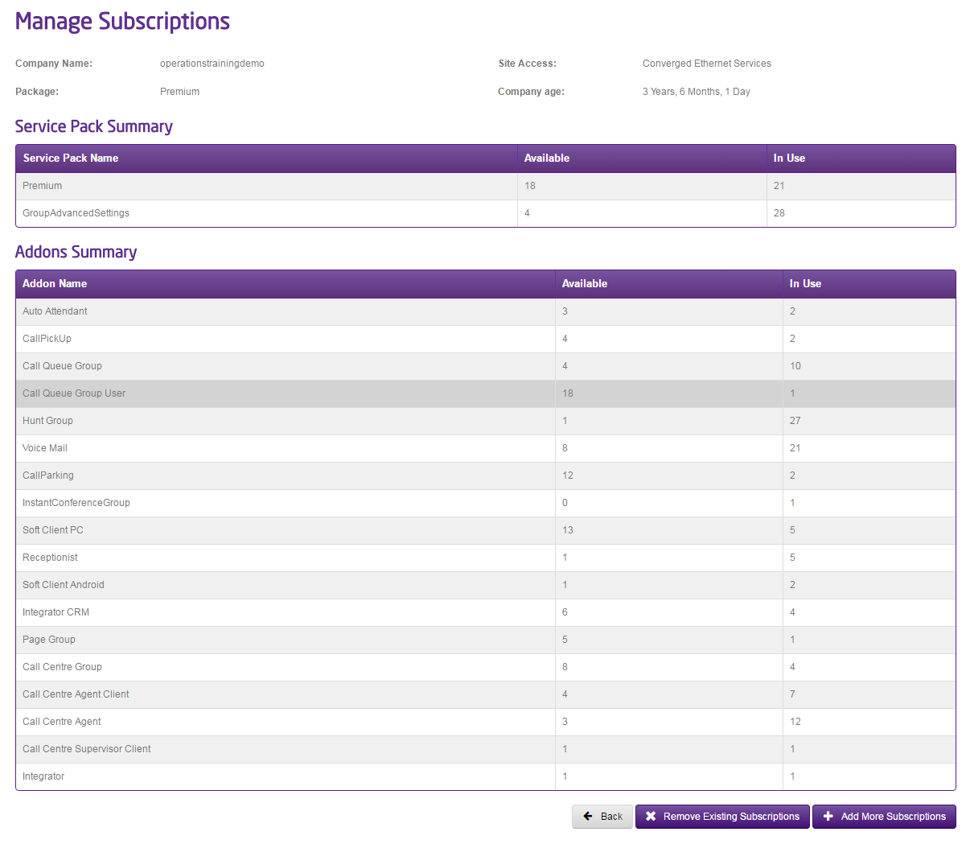
Step 1
Log into the Gamma Portal and go to Provisioning and Service Management, Hosted, Horizon and Horizon Manage Company.
Step 2
Select your account and locate the company that you want to setup an Auto Attendant for by using the "Actions" button select "Login to Horizon".
Step 3
Once you're in the Horizon Portal select "Call Groups" and then "Auto Attendant".
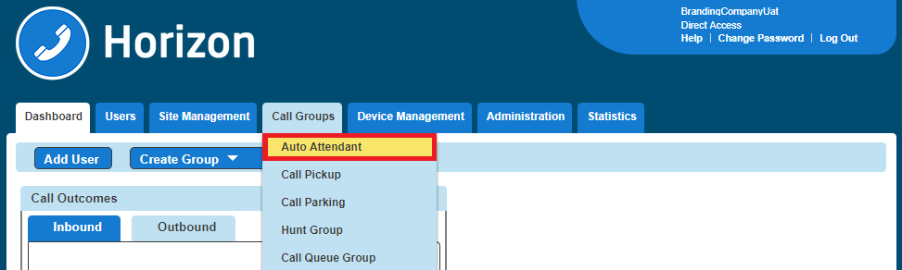

Step 4
From here you can add a new Auto Attendant by clicking the "Add" button. This will load up the wizard to set up the Auto Attendant.
From here you should:

select the Site you want your Auto Attendant to be on
Give the Auto Attendant a name and username
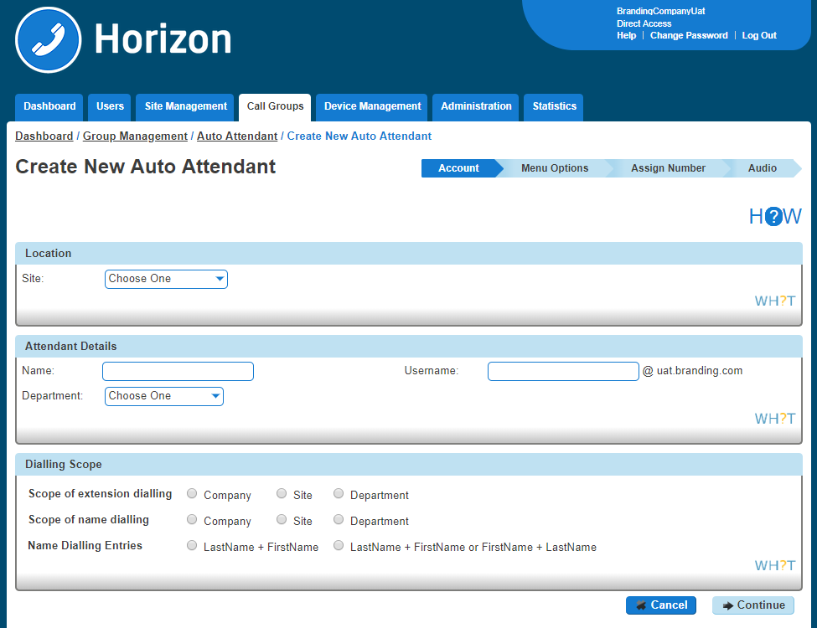

The Dialling Scope is:

Scope of extension dialling
If extension dialling is selected as an option, this specifies where Horizon should limit its search to for the entered extension - either the department, site or company.

Scope of name dialling
If name dialling is selected as an option, this specifies where Horizon should limit its search to for the entered name - either the department, site or company.

Name dialling entries
If name dialling is selected as an option, what format must the caller enter the name of the user they wish to speak to.

Step 5
The top half of the screen is there in order to ensure the auto attendant links to the right “Schedule” for your company. You can either select "Use the same menu all the time" or "Use different menus during and after business hours".
If you select "Use different menus during and after business hours", you can then select from the drop down menu the “Schedules” that defines open and closed hours.
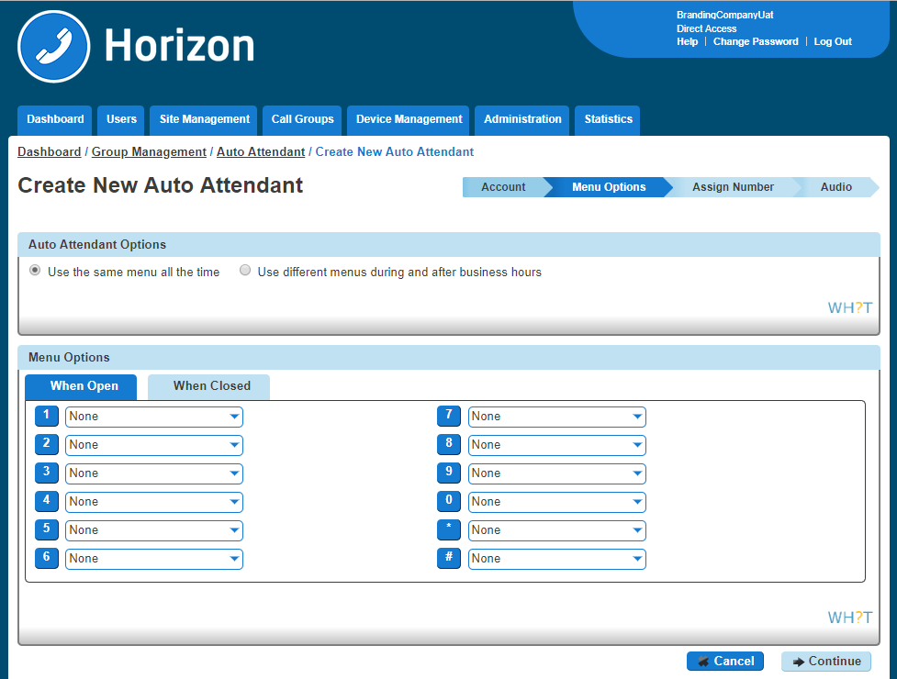

The second half of the Menu Options screen is a grid which corresponds to the buttons on a telephone keypad, and you've got two options: Open Hours and Closed Hours.
The options for each button is:

Menu Option | Description
Transfer with prompt | This will allow the user to hear a recorded message played once they have selected a menu item ("Please hold whilst we connect you"). This option also plays the recorded voicemail message that a user sets. If your user has recorded more than their name for the voicemail greeting, then this message will play here.
Transfer without prompt | This will forward the call to the required destination once a menu item is selected. This destination could be a user, hunt group or new auto-attendant.
Transfer to operator | This will forward the call to a set telephone number / extension after ten seconds.
Name Dialling | This will allow the caller to type in a name based on your dialling scope through the Horizon handset, i.e. my name Chris would be typed from the handset as 222447774447777
Extension Dialling | This will allow the caller to type in a user’s extension, allowing the call to connect to this extension based on your dialling scope.
Repeat Menu | This option will replay the call recording associated to this auto attendant to effectively replay the menu items to the caller.
Exit | This will terminate the call on behalf of the calling party.

The "Transfer" options will load up the "Search Directory" screen so you can search for the exact number you want to transfer the call to.

Step 6
You then need to define a number for the auto attendant, an extension number for internal call routing and a display name for presentation once the call is delivered.
Step 7
The final step is to upload an audio file to be played when the call is connected. If you are going to record the message with your Horizon phone then you don't need to upload anything here and go to the Recording an Auto Attendant message with my Horizon Phone.
You can use our guides "Create Audio Files to use with Horizon" and "Convert Audio Files to use with Horizon" on the Knowledgebase.

Recording an Auto Attendant message with my Horizon Phone
If you have set up your Auto Attendant without adding an audio file you can use a Horizon Phone that is allocated to the same site as your Auto Attendant to record your Auto Attendant message. You will also need to have the extension number of the Auto Attendant to hand.
To do this you need to make sure that you have your Company Voice Portal set up.
Dial your Company Voice Portal
At the prompt you should
Enter the Voice Portal digit extension if dialling from an external phone
Press the * button and then enter the Voice Portal digit extension if dialling from a Horizon handset.
Enter the Voice Portal passcode
Select option 1 (Change Auto Attendant Greeting)
Enter the extension number of the Auto Attendant
Press 1 if you want to record the business hours greeting
Press 2 if you want to record the out of hours greeting
Save the recording
- This will add the recording(s) to the Auto Attendant you selected.

Automatic Call Back
If you call another Horizon user within your company and they are busy, Automatic Call back allows you to be notified when they are off the phone.
Once the Automatic Call Back feature is enabled, when you call an internal extension [1234 for example], and it's busy - you will hear an announcement:
"The line you are calling is busy, please press 1 if you would like to be notified when the line becomes available"
Press 1 on the phones keypad in order to activate this. You will then hear the following announcement:
"The line will be monitored for 30 minutes; you will be notified by a special ringtone when the line becomes available"
Once the internal extension becomes available, you will shortly get a call back to your phone - the calling number will be the extension you originally contacted [the ring tone will be different from your standard one, - you cannot amend this], when you answer you will get a message:
"Call back to [dialled extension e.g. 1234], in progress, hang-up to cancel call-back. Press any key or hold the line to proceed with call-back"
Your phone will then ring the originally dialled extension [1234 in this example]

Shortcodes
Menu Access: #9
Deactivate #8

Setup Automatic Call Back for a User
Automatic Call Back can only be set up by a Company Administrator.

Step 1
Log into the Gamma Portal and go to Provisioning and Service Management, Hosted, Horizon and Horizon Manage Company.
Step 2
Select your account and locate the company that you want to setup Automatic Call Back for by using the "Actions" button select "Login to Horizon".

Step 3
Go to "Users" and "List Users" and locate the user that you want to add Automatic Call Back for and then click the "Edit" button.
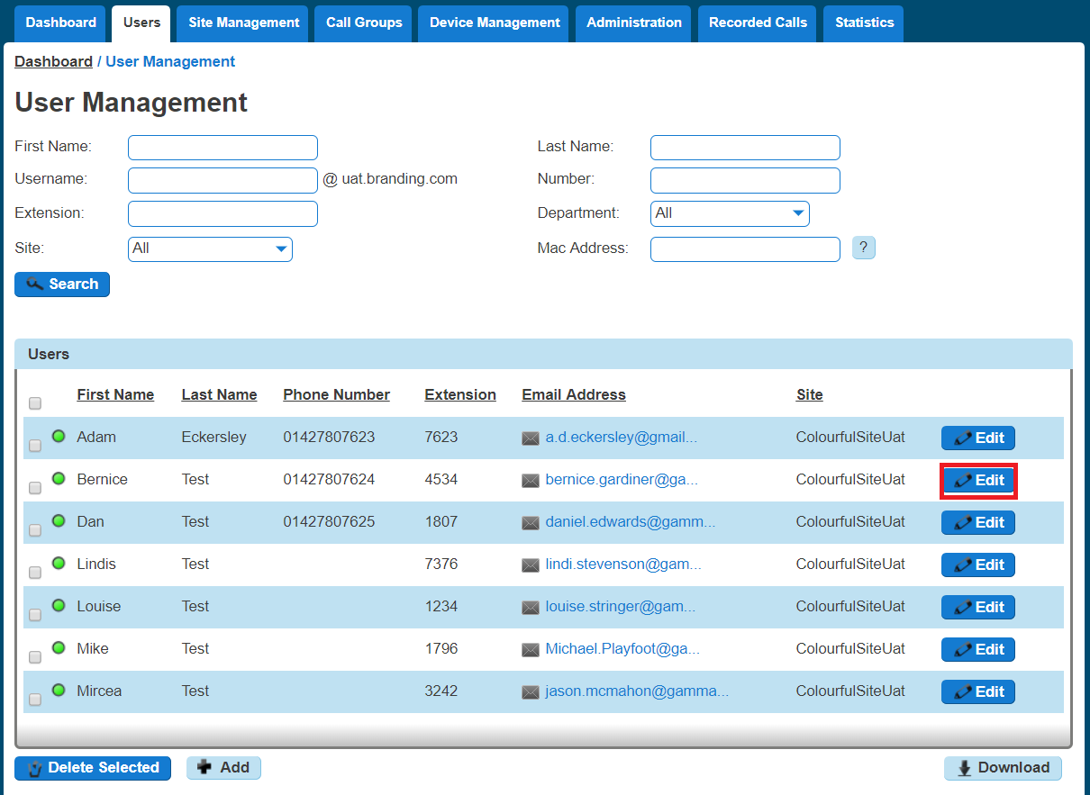
Step 4
Select the "Call Setup" tab and then click "Settings" under the Outgoing Calls tab. From here you can turn Automatic Call Back on or off. Click "Apply" to save your changes.
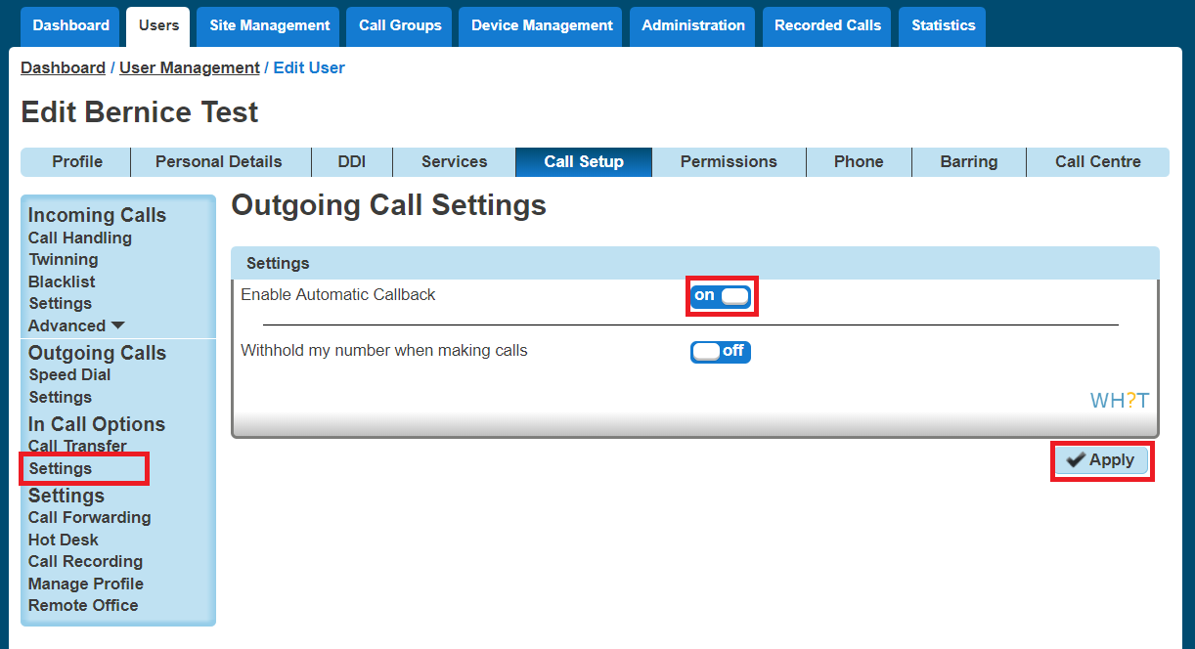Bulk Speed Dial
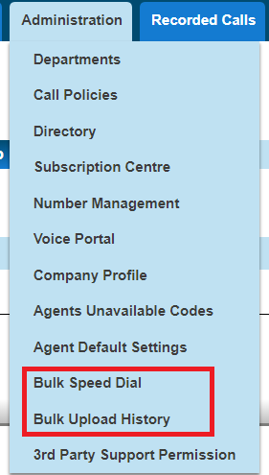
Under the Administration tab of the GUI there will be two new menu options for a Company Administrator to use. When setting up a new company you will be able to create a set of 1 and 2 digit speed dials and then copy those details to one, some or all the users within the organisation. We recommend that all users are created before using this service.
When an Administrator accesses the Administration menu they will be presented with two new options
Bulk Speed Dial - option create speeds dial and apply to multiple users
Bulk Upload History - Historical log of an Administrators changes

To create a new speed dial list select Administration>Bulk Speed Dial and you'll then be presented with the following screen, where you can add the 1 and 2 digit speed dials to a group of users by toggling between the 1 and 2 Digit Dialling tabs
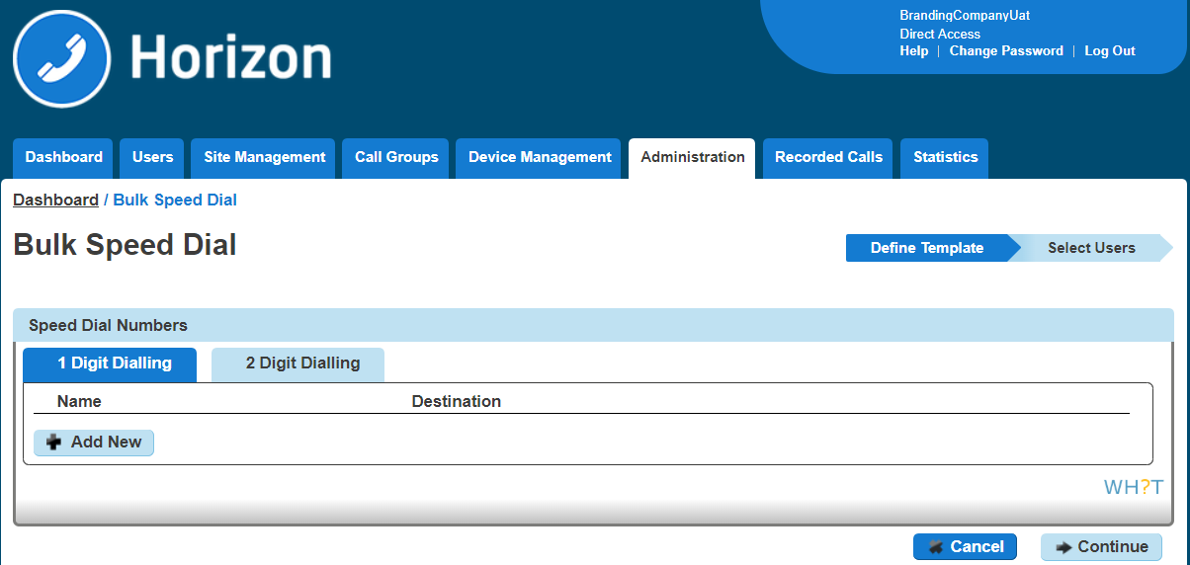
Enter the speed dial details freehand or select from the Company's directory by clicking the icon, then search for the user details you wish to add. To delete a row hit the icon.
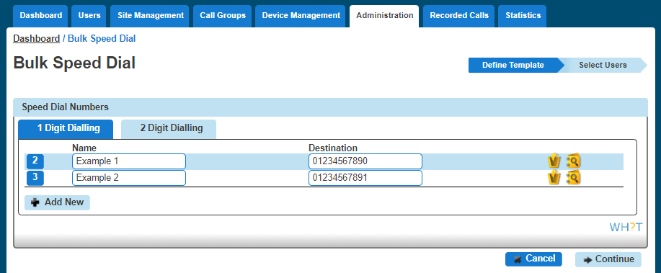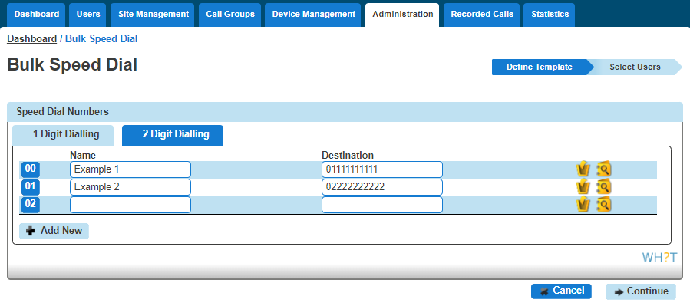
Once you are happy that you have correctly created the speed dials hit the icon, after which you will be presented with the option to either 'Update all users' or 'select users to update'.
By selecting all users then finish and save will add the speed dials to all users.
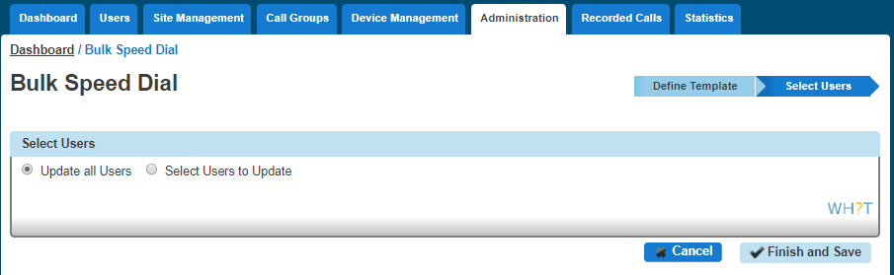
If you want to add to specific users then click select user to update then you will be presented with the below screen where to you can select the users you wish to apply the list(s) to, simply check the box and click the +Add selected button, to apply the speed dial lists to the selected user(s) now select the Finish and save option.
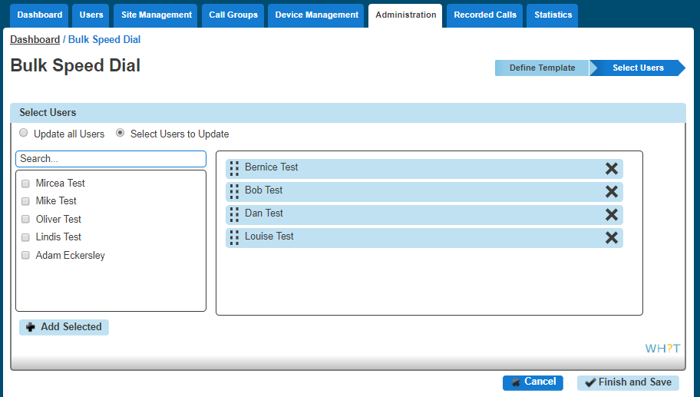
You'll be asked to acknowledge the following implication after which the speed dials will be created against the selected users.

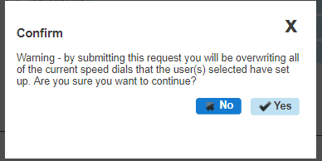
The service has been designed to assist with the initial set up of company and isn't suitable for the for the ongoing management of a company's speed dial list, as it:
Doesn’t retain any record of previously provisioned speed dials
Will overwrite the personal amendments made by a user
Will delete records where a blank is left basically meaning you cannot bulk update a single entry
The Bulk Upload History tab will show the event type, who requested the change, when they requested it, the status and when it completed as an audit log of activity.
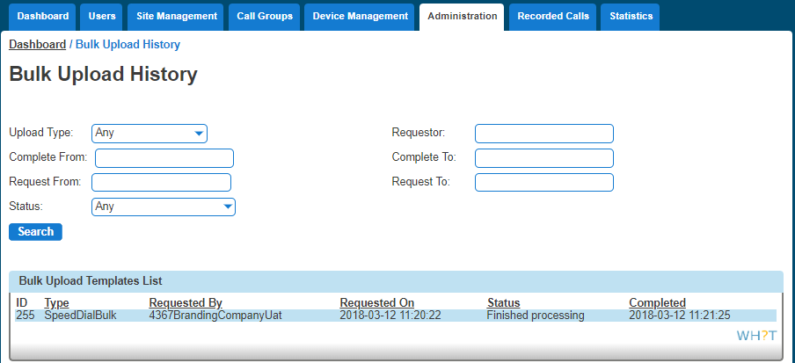

Busy Lamp Field (BLF)
A Busy Lamp Field (BLF) gives you the ability to monitor a fellow colleague's line to see if they are available to take a call that you may transfer to them, or to enable you to pick up their calls.
When implemented the phone will show the user’s caller id on the pre-defined line keys on your device. This line key can also be used as a speed dial to contact your colleague's number quickly when transferring a call or when needing to speak to them directly.
Please note: We allow a maximum of 50 Busy Lamps to be configured if a sidecar is present. The remaining line keys can then be used for other available entries

Devices | Line Keys Available with no Sidecar | Line Keys Available with Monochrome Sidecar | Line Keys Available with Colour Sidecar
Cisco 501 | 6 | N/a | 36
Cisco 504 | 2 | N/a | 32
Cisco 509 | 10 | N/a | 40
Cisco 525 | 3 | N/a | 33
Cisco MPP 8841 | 10 | N/a | N/a
Cisco MPP 8851 | 10 | N/a | 72**
Cisco MPP 8861 | 10 | N/a | 108**
Polycom SoundPoint 650 | 4 | 44 | 92
Polycom VVX250 | 4 | N/a | N/a
Polycom VVX310 | 4 | 44 | 92
Polycom VVX411 | 10 | 50 | 94
Polycom VVX450 | 12 | N/a | 102
Polycom VVX500 | 14 | 54 | 98
Polycom VVX600 | 14 | 54 | 98
Yealink W52P DECT | N/a | N/a | N/a

*Please note the VVX150, Trio 8500 and 8800's do not support Busy Lamp Fields
** This is the maximum number of line keys available as the Cisco 8851 supports up to 2 KEM’s and the 8861 device supports up to 3 KEM’s. The Cisco 8841 does not support a KEM. Each KEM has 18 line keys per page and 2 pages (36 line keys in total). So up to 72 additional line keys can be supported on the 8851 device and 108-line keys for the 8861 device.
Note: In order for the device to be able to power up the KEM’s either a POE+ switch must be used or the power adaptor (CP-PWR-CUBE-4=).

 If you are experiencing issues with Busy Lamp Fields please see the Network Configuration Guidelines document and the Horizon Technical Support document on the Knowledgebase.

Setup and Edit Busy Lamp Fields (BLFs)
Busy Lamp Fields can only be set up by a Company Administrator.
Step 1
Log into the Gamma Portal and go to Provisioning and Service Management, Hosted, Horizon and Horizon Manage Company.
Step 2
Select your account and locate the company that you want to setup Busy Lamp Fields for by using the "Actions" button select "Login to Horizon".
Step 3
Go to "Users" and "List Users" and locate the user that you want to add Busy Lamp Fields for and then click the "Edit" button.
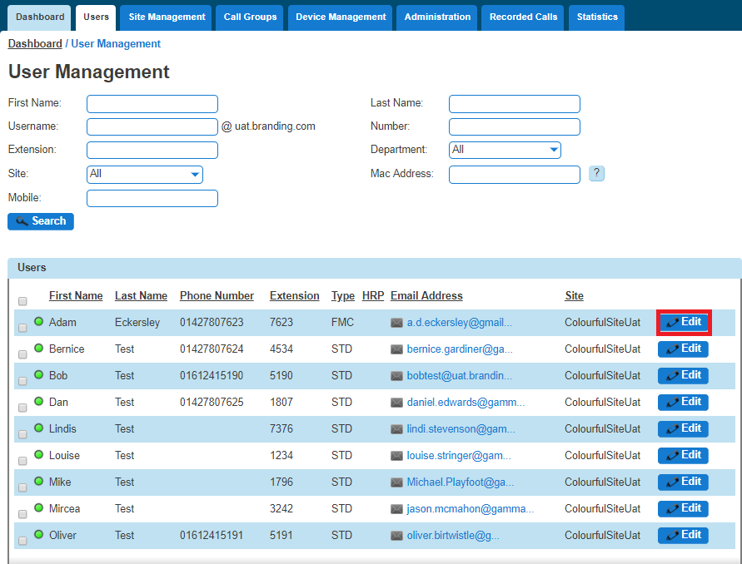
Step 4
Select the "Call Setup" tab and then "Advanced" and "Busy Lamp" under the "Incoming Calls" tab.
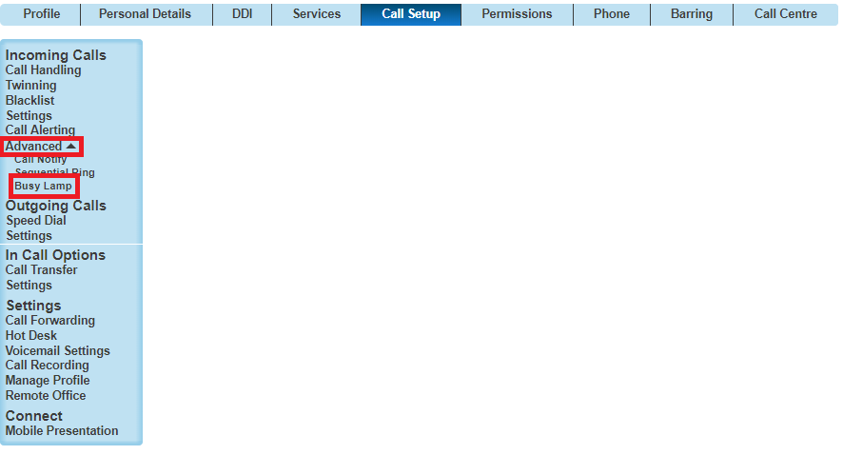
Step 5
Horizon will detect to see if the user's device is compatible for Busy Lamp. If not, you'll be returned with an error message.

If the handset is compatible for Busy Lamp, select if you have a Sidecar installed, and then what users you want to be "monitored".
You can remove Busy Lamp Fields (BLFs) by clicking the "X" next to the user you want to remove. Click Save.
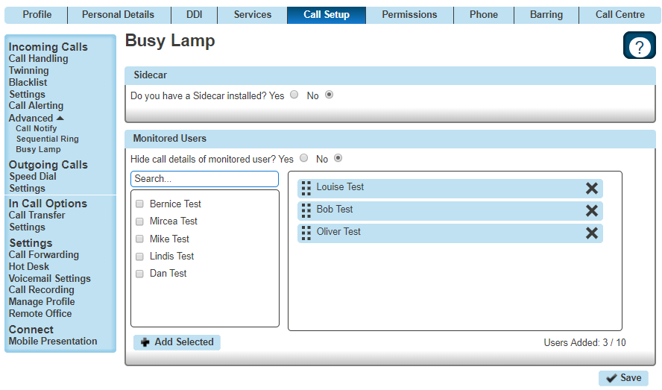
To ensure that the BLFs do not interfere with incoming calls to that handset, please ensure that “hide call details of monitored users” is ticked ‘yes’.

Busy Lamp Field (BLF) Name Searching
The portal has been updated to improve the searching for a user when editing a BLF, previously users were only searchable by the full username
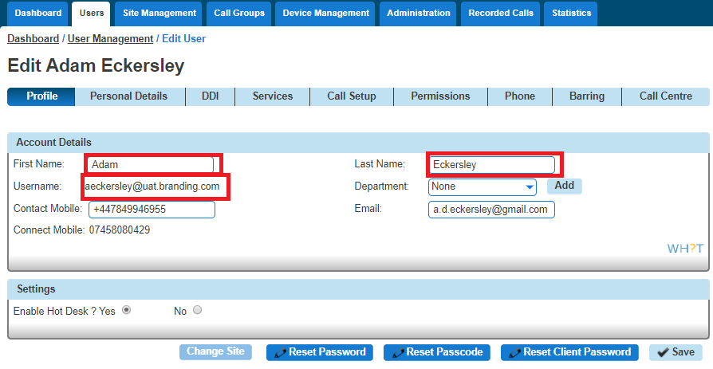
The search has been improved to now include the First and Last Name fields and will return results on partial matches of the user first and/or last name.
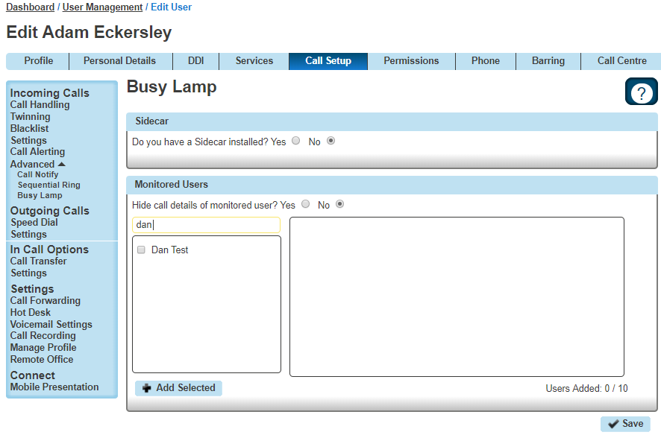

Call Barge
Call Barge allows specified users to "barge" into an active call and set up a three-way call. Every Horizon Company will have one Call Barge Group set up and does not require a Call Centre subscription to use.

Setup & Edit Call Barge
Call Barge can only be set up and edited by a Company Administrator.
Step 1
Log into the Gamma Portal and go to Provisioning and Service Management, Hosted, Horizon and Horizon Manage Company.
Step 2
Select your account and locate the company that you want to setup or amend Call Barge for by using the "Actions" button select "Login to Horizon".
Step 3
Select "Call Groups" and then "Call Barge".
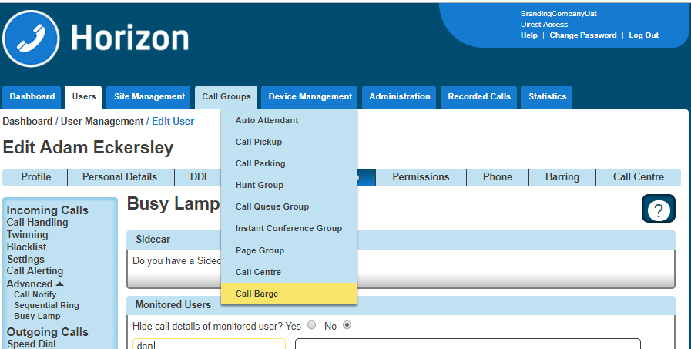
Step 4
You will now have the Call Barge set up screen. All Horizon Users will be in the left hand table that are currently not set up as a Monitored or Managing User. Select all the users that you want to be monitored or managing and select the relevant "Add Selected" button.

Only Managing Users can barge into calls, and they can only barge into calls of Monitored Users.
A Call Centre Agent or Supervisor that has the Call Barge service subscribed will automatically appear in the appropriate list on this screen and cannot be removed or unassigned using the "Remove All" or "Unassigned All Users" buttons. The Call Centre Barge feature is classed as a higher priority.
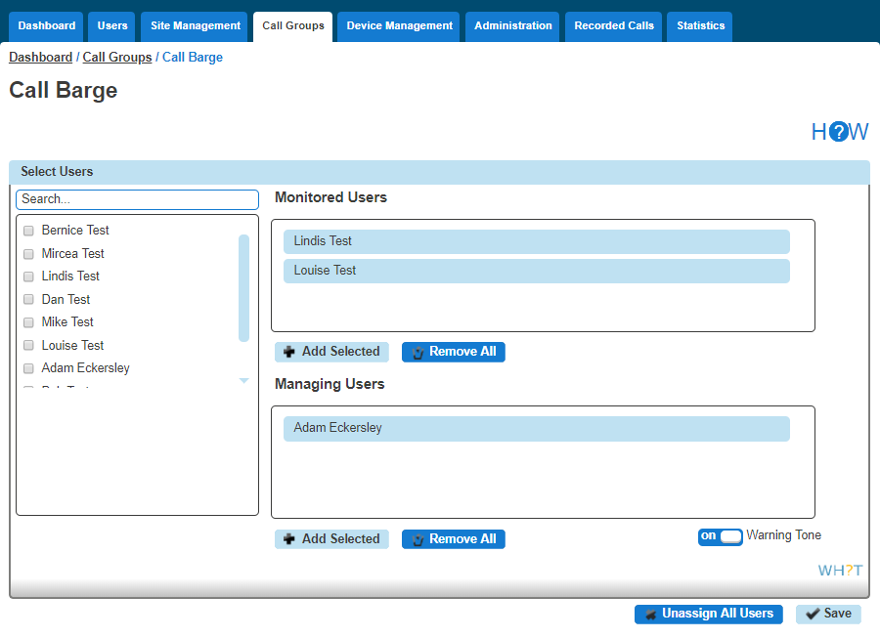
Once you've made all the changes, click Save.

Barging into a call
A user has to be set up as a Managing User to be able to barge into a monitored users call. To barge into the call, the Managing User should dial *33. Once the managing user hears the stuttered dial tone they should enter the monitored user's extension number.
When a barge happens, the Monitored Users hears a Barge-in warning tone. The other party is briefly put on hold for 1 second and will hear silence while the Monitored User is receiving the warning tone.
There is no limit on how many Managing Users can barge in on a single call of a monitored use
If a call is unanswered by a Monitored User and a Managing User barges in on this call, then the call will be answered by the Managing User and this won't invoke a three-way call.

Call Barring
You can control Call Barring at either Site Level, or at User Level. There are seven call barring options. These are:
Allow free phone calls
Allow national calls
Allow international calls
All chargeable directory services calls
Allow premium calls
Allow mobile calls
Allow 084 calls
Allow 087 calls
There are two categories that need consideration:
When making a call - call barring that is applied to any call the user makes directly via their calling device or software, including a consultative transfer.
When transferring/diverting a call - call barring that is applied to call when a user attempts to blind transfer a call to an alternative station or a divert attempt as a result of the call forwarding feature being invoked, a divert on busy for example. The call barring under this heading does not apply to consultative transfers. Consultative transfers are covered under ‘when making a call’.
You can quickly view what call bars a user has set up, both on their site and if they are overriding the site settings by using the Horizon Health Check.

Setup and Manage Site Call Barring
Site Call Barring can only be set up by a Company Administrator.
Step 1
Log into the Gamma Portal and go to Provisioning and Service Management, Hosted, Horizon and Horizon Manage Company.
Step 2
Select your account and locate the company that you want to setup Site Call Barring for by using the "Actions" button select "Login to Horizon".
Step 3
Select "Site Management" and then click the "Manage" button next to the site you want to add or manage Call Barring for.

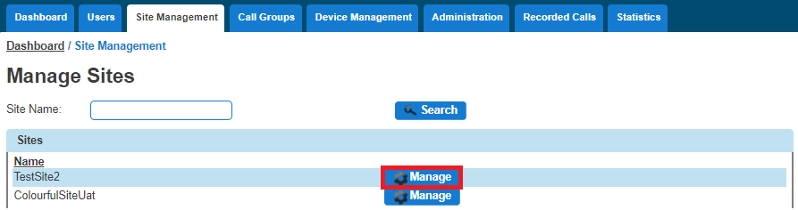

Step 4
Select "Call Plan" and this will then load up the available options you have for site call barring. This can be done for making a new call or transferring a call.
Once you've made your changes you should click "Save".

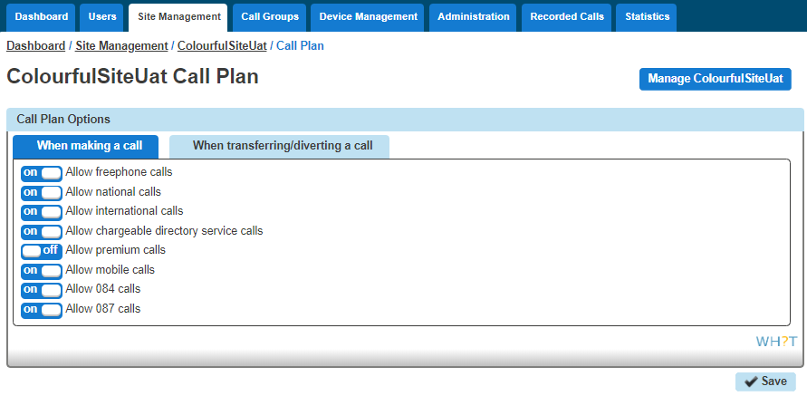

Override Site Call Barring for a User
Overriding Site Call Barring for a user can only be done by a Company Administrator.
Step 1
Log into the Gamma Portal and go to Provisioning and Service Management, Hosted, Horizon and Horizon Manage Company.
Step 2
Select your account and login to the company that you want by using the "Actions" button select
"Login to Horizon".
Step 3
Go to "Users" and "List Users" and locate the user that you want to override site call barring for and then click the "Edit" button.
Step 4
Go to "Users" and "List Users" and locate the user that you want to override site call barring for and then click the "Edit" button.
Select the Call Barring tab and then you toggle the "Override site call plan" button. The default options are what the site the user is located on has set up.
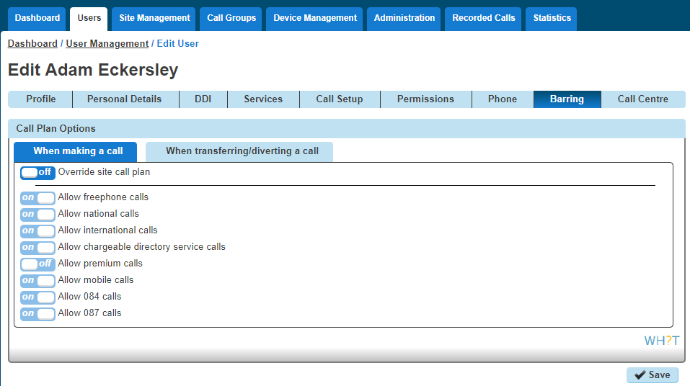

Call Forwarding
The Call Forwarding feature allows you to forward incoming calls to a number of your choice, or to a voicemail message box. Users have the option to activate and deactivate the service by dialing a feature access code or configuring the service via their web interface or simply pressing a key on the phone. If activated a user must specify the forwarding number.
If a user has Connect they will be able to control how calls are forwarded depending on whether someone called their mobile or fixed number. This is referred to as Call Forwarding Selective.
If a user is also using a soft client then the Call Forwarding button on their device will no longer work (Polycom VVXs) or disappear (Polycom SoundPoint or Cisco's).
Call Forward Not reachable is designed to forward a call in the event that the subscribers device is not registered with the Horizon platform. In the case of a call group, all devices associated with the call group need to be unregistered for the unreachable divert to be applied. The unreachable divert only occurs in the event that the device or devices become unregistered from the Horizon platform, typically due to an issue with connectivity between Horizon and the site/device being hard down, unreachable should not be considered as a DR feature for any other scenario outside of this.

Shortcodes

Action | Shortcode
Call Forwarding Always Activation | *72
Call Forwarding Always Deactivation | *73
Call Forwarding Always Interrogation | *21*
Call Forwarding Always to VM Activation | *21
Call Forwarding Always to VM Deactivation | #21
Call Forwarding Selective Activation | #76
Call Forwarding Selective Deactivation | #77
Call Forward Busy Activation | *90
Call Forward Busy Deactivation | *91
Call Forward Busy Status Check | *67*
Call Forward Busy to VM Activation | *40
Call Forward Busy to VM Deactivation | #40
Call Forward No Answer Activation | *92
Call Forward No Answer Deactivation | *93
Call Forward No Answer Status Check | *61*
Call Forward No Answer to VM Activation | *41
Call Forward No Answer to VM Deactivation | #41
Call Forward Not Reachable Activation | *94
Call Forward Not Reachable Deactivation | *95
Call Forward Not Reachable Status Check | *63*

Turn Call Forwarding On/Off as a Company Administrator
Step 1
Log into the Gamma Portal and go to Provisioning and Service Management, Hosted, Horizon and Horizon Manage Company
Step 2
Select your account and login to the company that you want by using the "Actions" button select "Login to Horizon".
Step 3
Go to "Users" and "List Users" and locate the user that you want to set up Call Forwarding for and then click the "Edit" button.
Step 4
Click the "Call Setup" tab and then under Incoming Calls select "Call Handling". You can now set up the following options:

When I'm Busy - you can forward calls to voicemail or a specific number when you are on another call.
When I Don't Answer - you can forward calls to voicemail or a specific number when you don't answer after a certain amount of rings. To do this you should leave the number box blank, tick the tick box and state the amount of rings before the call reaches voicemail
When I'm Unreachable - you can forward calls to a specific number (not voicemail) when your handset is not registered or powered on (e.g. If your internet access is down, incoming calls would go to this number).
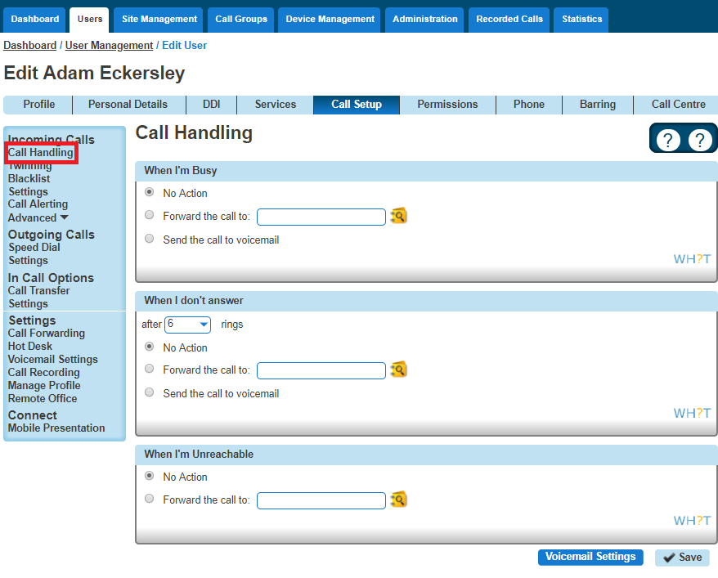
Step 5
If you would prefer to forward calls all the time, or (for Connect users) would like to forward them depending on which number was dialled, then you need to visit the Call Forwarding screen:

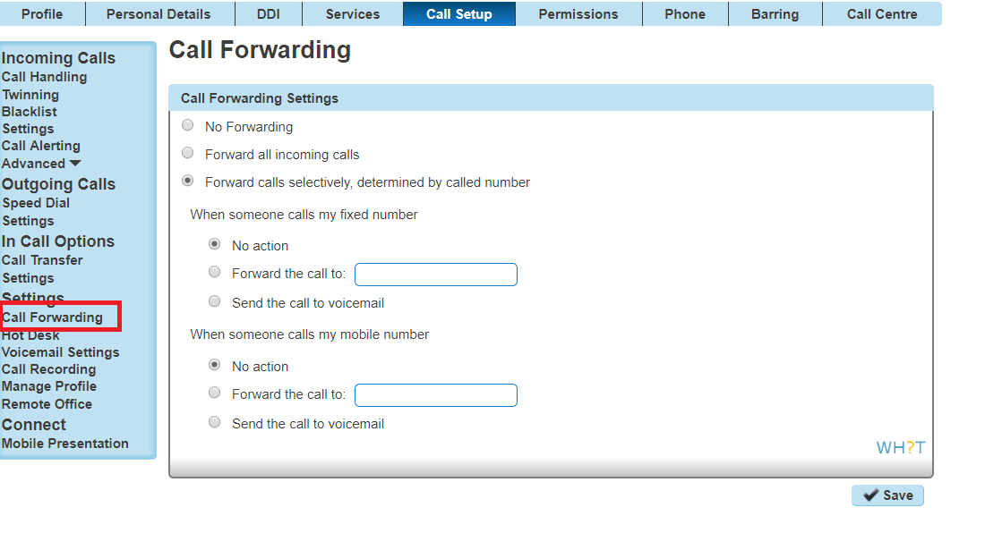
The 'Send the call to voicemail' option will only appear if the Voicemail add-on has been given to the user.

Turn Call Forwarding On/Off as a User using the Horizon Portal
A user can set their own Call Forwarding rules when logging into www.unlimitedhorizon.co.uk. Once a user is logged in they can select the "Call Setup" option and the Incoming Call Handling option is selected.

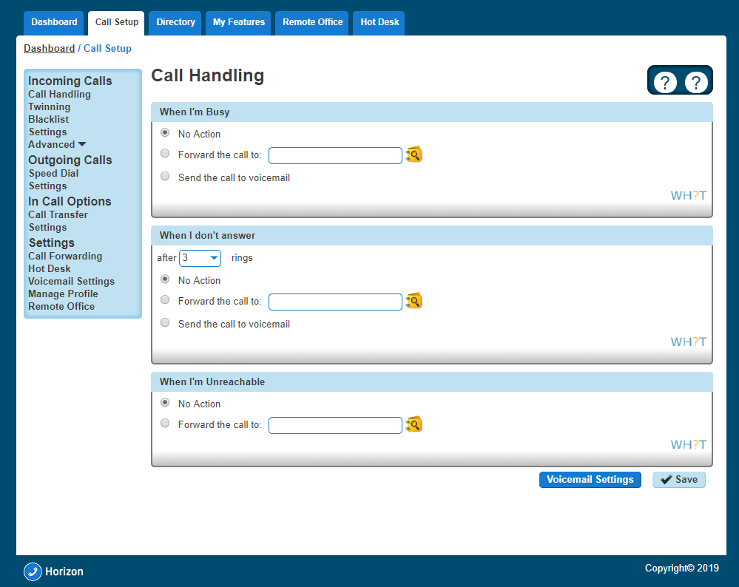

Turn Call Forwarding On/Off as a User using a Soft Client
Gamma offer different Soft Clients that can be used instead of a handset. A user also has the ability to change some of their settings directly from the soft client. For full information on how to turn call forwarding on or off using the Soft Client please refer to the relevant soft client guide on the Knowledgebase.

Call Notify by Email
Call Notify by Email enables a user to define criteria that cause certain incoming calls to trigger an e-mail notification. If an incoming call meets user-specified criteria an e-mail is sent to the notify address informing the user of the details of the incoming call attempt. A criteria set is based on incoming calling line identity, time of day and day of week. Multiple criteria sets can be defined.

Turn Call Notify by Email On/Off
Call Notify by Email can only be set up for a user by the Company Administrator.
Step 1
Log into the Gamma Portal and go to Provisioning and Service Management, Hosted, Horizon and Horizon Manage Company.
Step 2
Select your account and login to the company that you want by using the "Actions" button select "Login to Horizon".
Step 3
Go to "Users" and "List Users" and locate the user that you want to set up Call Notify by Email for and then click the "Edit" button.
Step 4
Click the "Call Setup" tab and then under Incoming Calls select "Call Notify" under the "Advanced" option in Incoming Calls.
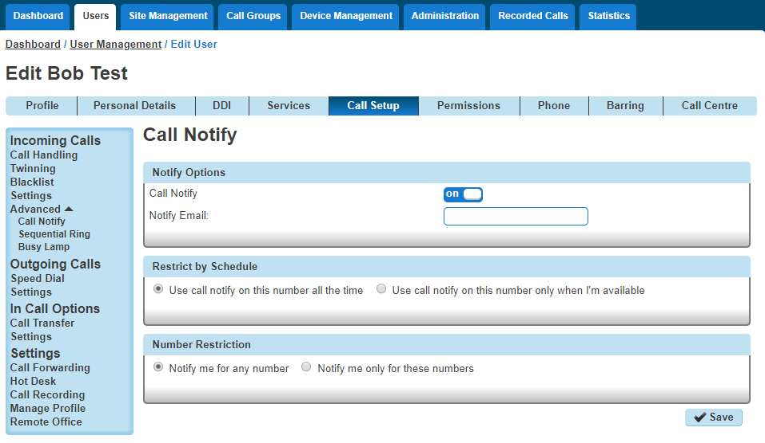

Step 5
From here you can switch Call Notify by Email on or off.
If you select "On", you'll get some more options. You should enter your email address into the Notify Email text box.
You can change the email address that gets the notifications at any time by editing the Notify Email text box and clicking "Save".
If you want it to notify you at certain times, you can set up a Schedules and select this by using the "Use call notify on this number only when I'm available".
If you want to be notified by email of a call from a certain number(s) within your directory, you can do this as well by selecting "Notify me only for these numbers" and using the textbox and the Add button, or you can search your directory by clicking the directory icon.

Call Paging
Call Paging is a feature within Horizon that allows a user to call numerous users all at the same time with one-way audio (i.e. only the caller can speak). Once a call is placed then all handsets set up to receive a call in the call paging group will be answered automatically on loud speaker.
Call paging only works for users that use handsets and not soft clients.

Polycom devices will announce the message instantaneously if the user is not on a call.
Cisco devices will announce the message instantaneously if the user is not on a call. If a user's is on a call, the Call Page will announce and put the current call on hold.
Yealink devices will display the page as a call that needs to be answered. If the user is on a call, then it will display the Call Page as a call waiting. If there are other users that are in the group that are available to receive the call page, the user that is on the call will lose the page.

Setup Call Page Group
Call paging is set up by the Company Administrator for a user.
Before you start to set up your Call Page Group, you need to make sure that you have Call Page Group Add-on to do this. This is done by completing the following actions:
Log into the Gamma Portal and go to Provisioning and Service Management, Hosted, Horizon and Horizon Manage Company.
Select your account and locate the company that you want to setup a Call Page Group.
Using the "Actions" drop down select "Manage Bolt Ons".
From here you can see what bolt ons you have and how many are currently in use. If you need to add any more Call Page Group add-ons if you scroll to the bottom of the page and click "Add More Bolt ons" and then you can add as many bolt ons as you need by adding against "Page Group".
Step 1
Log into the Gamma Portal and go to Provisioning and Service Management, Hosted, Horizon and Horizon Manage Company.
Step 2
Select your account and login to the company that you want by using the "Actions" button select "Login to Horizon".
Step 3
Click the "Call Groups" option and then select "Page Group". On the Page Group page click "Add".
Step 4
You will now be in the wizard for Call Page Groups. The first page you will be setting up the following:

Site - the site that the Call Page will be used for. All the users of the Call Page Group will be on this site.
Group Details - enter the name, username and department that you'd like the group to be assigned to. This is so that you can quickly identify the group if you ever need to edit or delete the group.
Caller ID - this will be what is displayed on the handset when the Call Page Group is used.
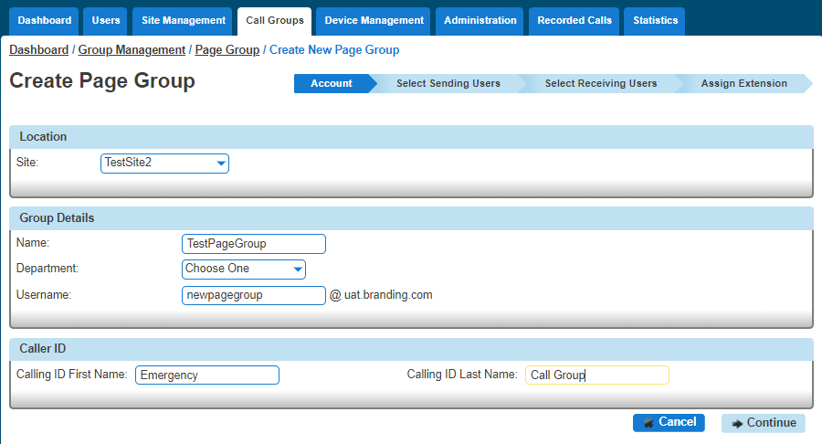

Step 5
You can now select your "Sending users". These are you users that can make a call from this group to those "Receiving User" (see next step).
Add everyone that you want to be able to send a call page and then "+Add Selected" and once all users are in the right hand table you can click "Continue"
If you have added a user in error you can use the white "X" next to the user's name.

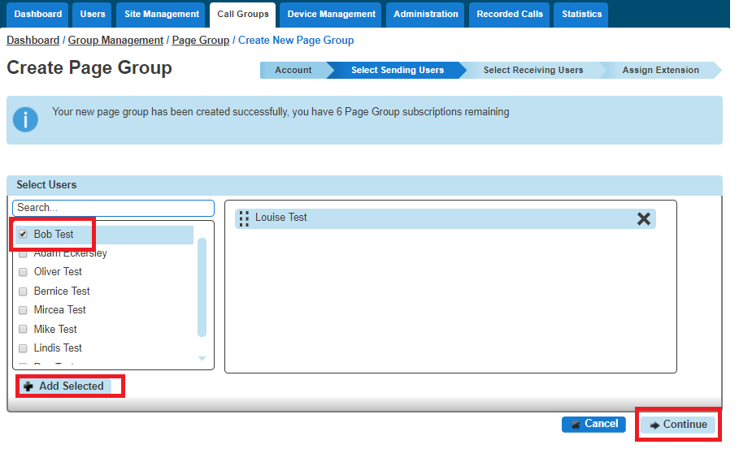
Step 6
You can now select the "Receiving Users", these will be the people that get the call page when the call page extension is dialled.

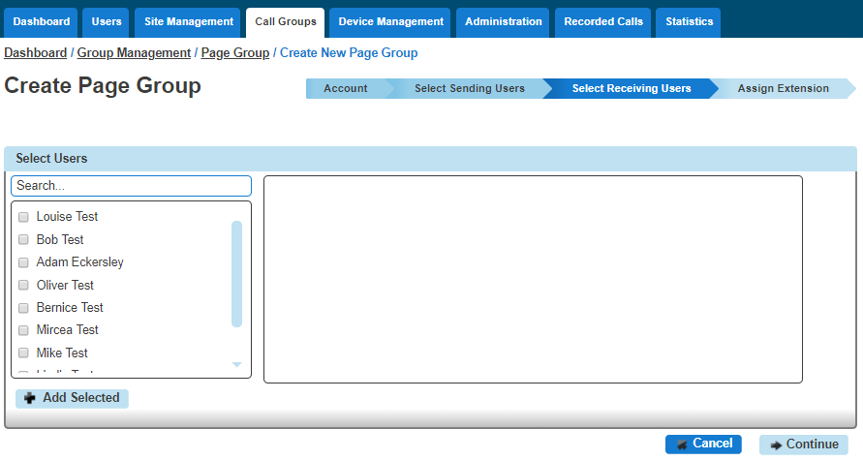

Step 7
Now you should give the group a unique extension number so that when it is dialled by one of the "Sending Users" a call is initiated to all the "Receiving Users" in the group.
If you click "Finish and Edit" this will save the Call Page Group that you've just configured and take you back to the start of the wizard "Account" so you can edit the group as you see fit.
If you click "Finish and Show List" this will take you back to the Page Group page within the Horizon Portal and you will now see your new Call Page Group.

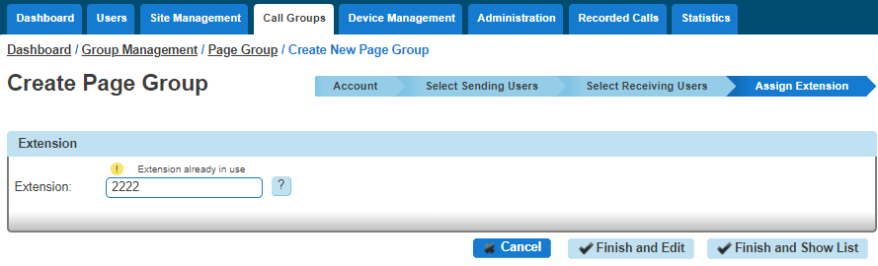

Edit a Call Page Group (including Add/Removing Users)
You are unable to edit the Site or the Username of the Call Page group.
Step 1
Log into the Gamma Portal and go to Provisioning and Service Management, Hosted, Horizon and Horizon Manage Company.
Step 2
Select your account and login to the company that you want by using the "Actions" button select "Login to Horizon".
Step 3
Click the "Call Groups" option and then select "Page Group". On the Page Group page click "Edit" next to the Call Page Group that you wish to edit.
Step 4
Using the links at the top of the page you can edit the following:

Account
Group Details - you change the name and department
Caller ID - this will be what is displayed on the handset when the Call Page Group is used.

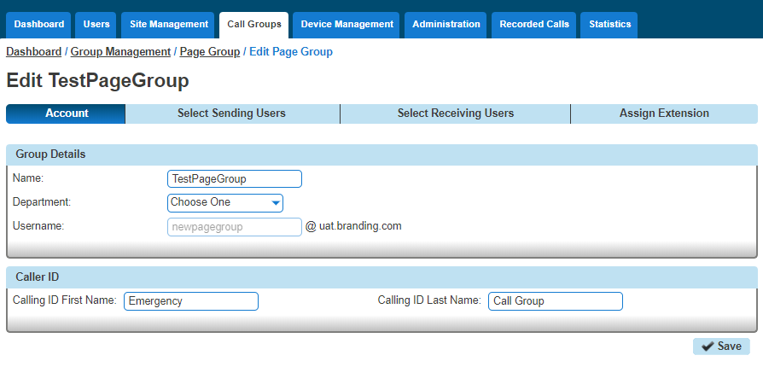
Select Sending Users
Add new users by clicking the "+Add Selected" button.
Remove users by clicking the white "X" next to the user.
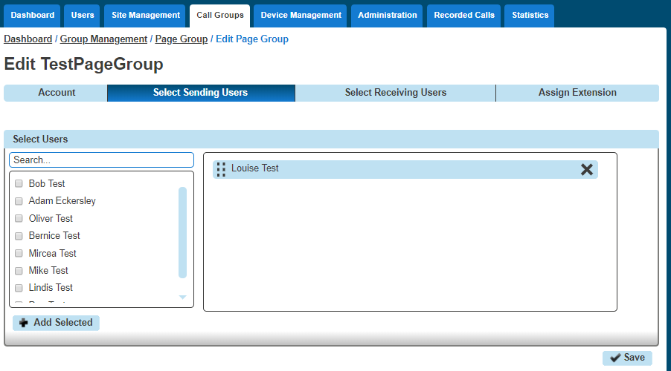
Select Receiving Users
Add new users by clicking the "+Add Selected" button.
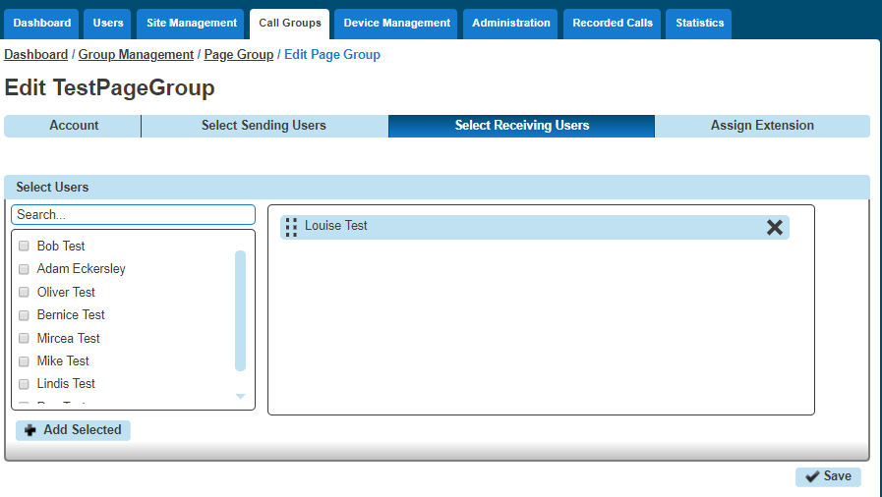
Remove users by clicking the "X" next to the user.
Assign Extension
Change the Extension number of the Call Page Group.

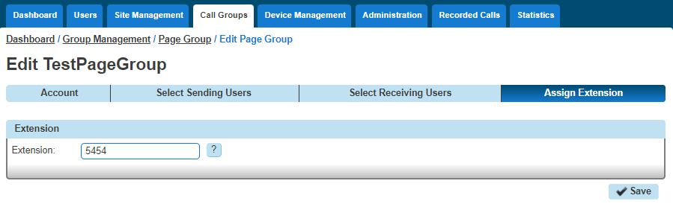
Step 1
Log into the Gamma Portal and go to Provisioning and Service Management, Hosted, Horizon and Horizon Manage Company.
Step 2
Select your account and login to the company that you want by using the "Actions" button select "Login to Horizon".

Step 3
Click the "Call Groups" option and then select "Page Group". From here select the Call Page Group that you want to delete (you can select multiple call page groups to delete) and then hit the "Delete Selected" button. Click on the "Confirm" button to confirm the deletion.

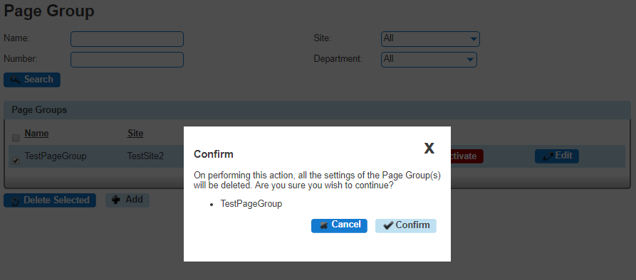

Call Park
The Call Park service allows a user to hold the call for an extended period of time, allowing them access to other features and calls as well as making the call available to other users who are notified. A Call Park group is site specific and each user can only be part of one call park group.

Shortcodes
Park a call | User presses transfer when on a call and then dials *68 (or pressed "Park") followed by the extension number of the user the call is to be parked against
Group Park | Users within a group press ‘GrPark’ and the handset will randomly allocate against another user’s extension. Each user can only be in one group.
Retrieve a parked call | User dials *88 from handset (or presses ‘GetPark’) and dials the extension of the handset the call is parked against.

Device Customisation on Polycom and Cisco devices are different. On Polycom 'Get Park' on the soft keys and 'Call Retrieve' on line keys can be used to retrieve a parked call. On Cisco 'Get Park' on soft keys (also appearing as 'Parked Call Retrieve' on Device Customisation) can be used to retrieve a parked call. Cisco handsets do not allow this to be provisioned on line keys.

Setup Call Park Group
Call Pickup is setup by the Company Administrator
Before you start to set up your Call Park Group, you need to make sure that you have Call Park Group Add-on to do this. This is done by completing the following actions:
Log into the Gamma Portal and go to Provisioning and Service Management, Hosted, Horizon and Horizon Manage Company.
Select your account and locate the company that you want to setup a Call Park Group.
Using the "Actions" drop down select "Manage Bolt ons".
From here you can see what bolt ons you have and how many are currently in use. If you need to add any more Call Park add-ons if you scroll to the bottom of the page and click "Add More Bolt ons" and then you can add as many bolt ons as you need by adding against "Call Park ".
Step 1
Log into the Gamma Portal and go to Provisioning and Service Management, Hosted, Horizon and Horizon Manage Company.

Step 2
Select your account and login to the company that you want by using the "Actions" button select "Login to Horizon".
Step 3
Click the "Call Groups" option and then select "Call Parking". On the Call Park page click "Add".
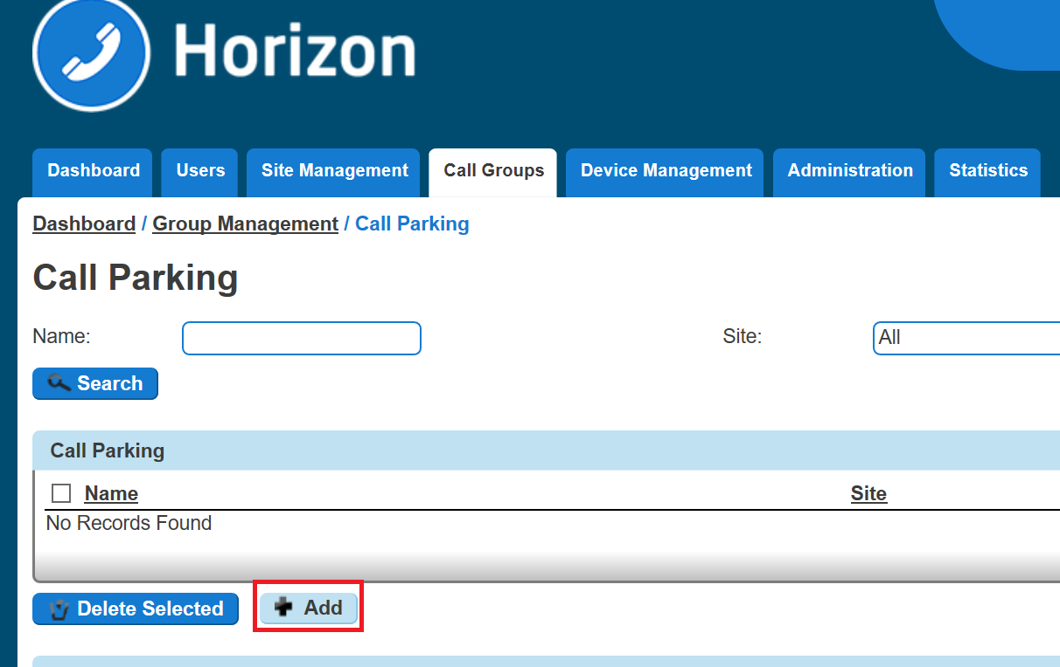
Step 4
On the Create Call Park page you will be able to enter the Name of the Call Park Group and the Site that you want the Call Park Group to be assigned to.
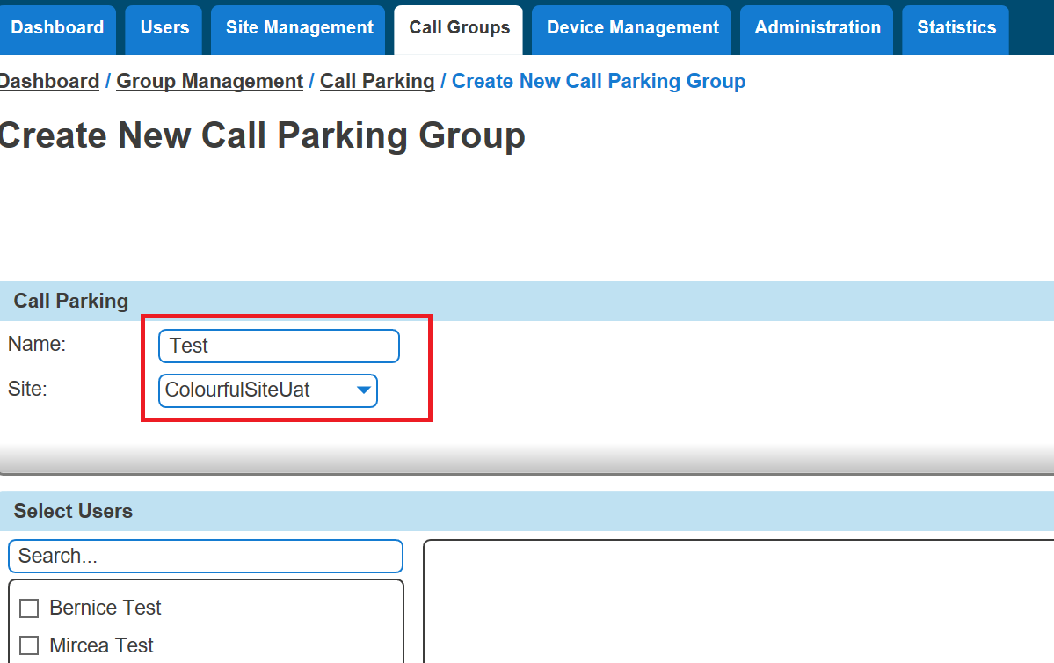

Step 5
Once you've selected the site, the "Select Users" table will auto-populate all the users listed against that site. Select the users you wish to have access to Call Park and then click "Add Selected".
Click "Create" to finish your Call Park Group
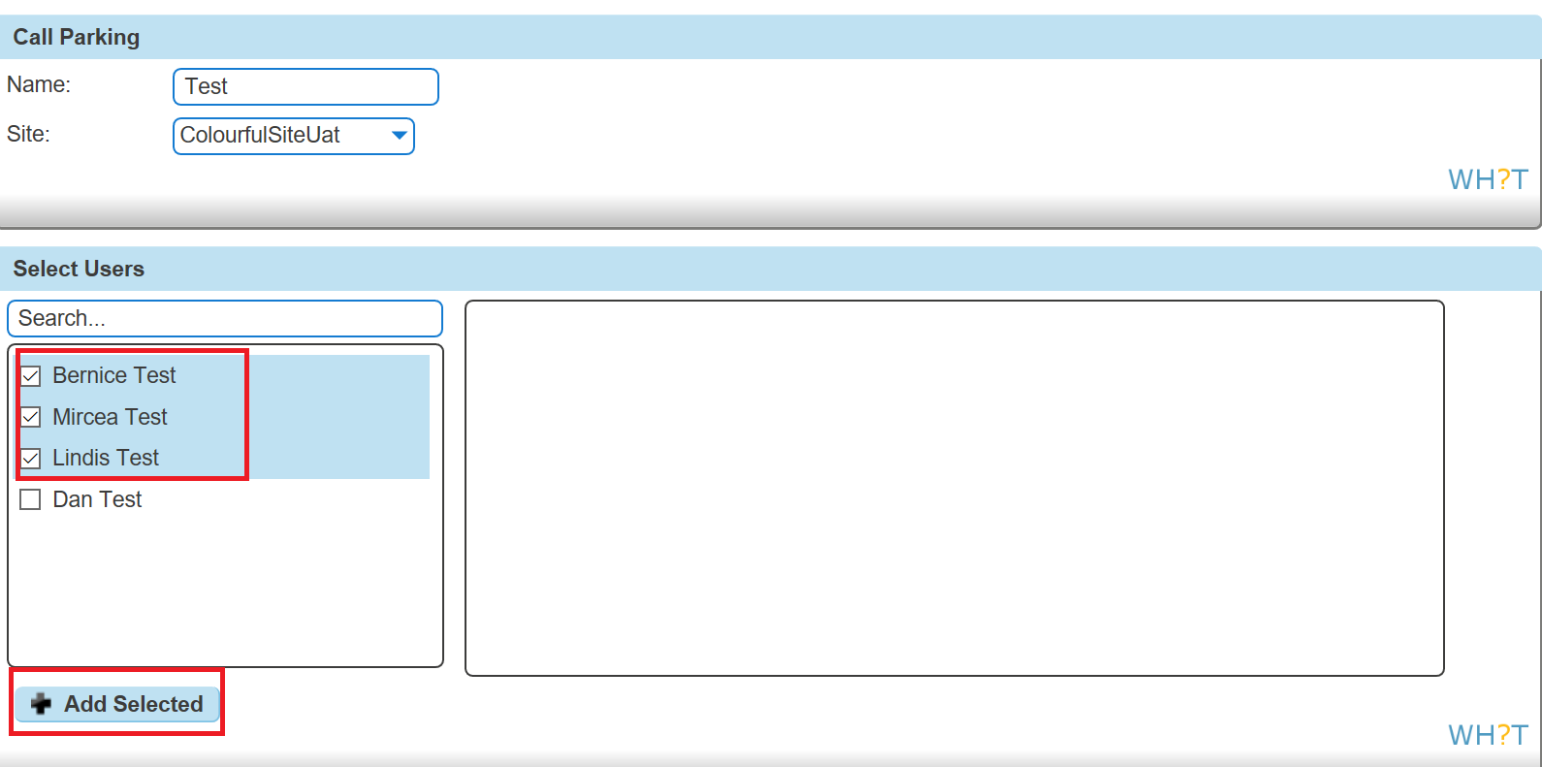

Delete Call Park Group
Step 1
Log into the Gamma Portal and go to Provisioning and Service Management, Hosted, Horizon and Horizon Manage Company.
Step 2
Select your account and login to the company that you want by using the "Actions" button select "Login to Horizon".
Step 3
Click the "Call Groups" option and then select "Call Parking". On the Call Pickup page click "Add".
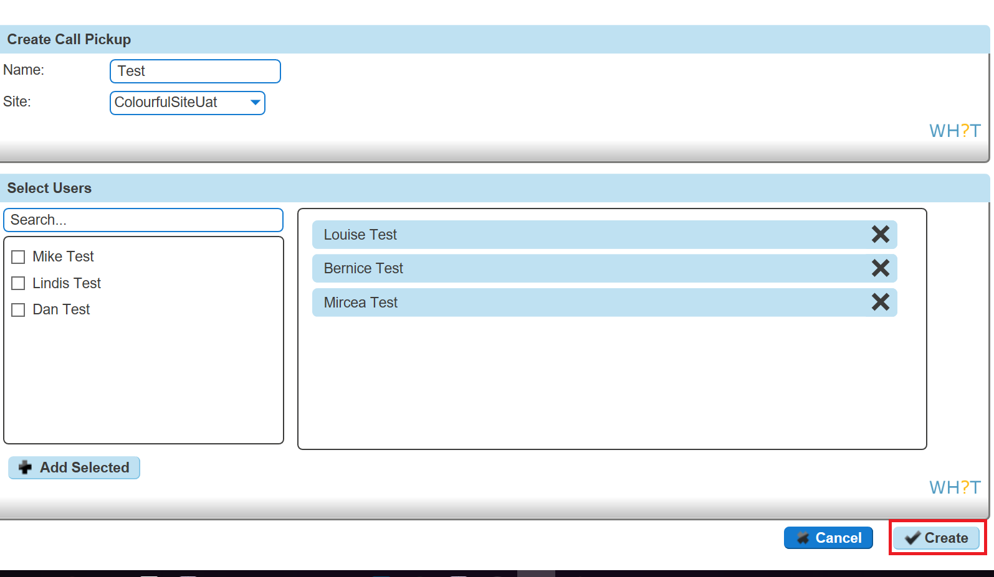

Call Pickup
A Call Pickup Group allows you to answer any phone ringing within the defined call-pickup group. If part of a group, then the user will be able to pick up the call by dialing *98 which will connect that call to them. Please note that if there are multiple calls ringing within a group the call which has been ringing the longest will be picked up first.
Each user is only able to be in one call pickup group and these can be created through the “Call Pickup” button.
There is also "Directed Pickup", which is the Horizon Shortcode *97 followed by the extension number. For example, *973354 will direct call pickup on extension 3354. A user does not need to be in a Call Pickup group for Directed Pickup. The "Pick Up" button on a handset also follows this format.

Setup Call Pickup Group
Call Pickup is setup by the Company Administrator
Before you start to set up your Call Pickup Group, you need to make sure that you have Call Pickup Group Add-on to do this. This is done by completing the following actions:

Log into the Gamma Portal and go to Provisioning and Service Management, Hosted, Horizon and Horizon Manage Company.
Select your account and locate the company that you want to setup a Call Page Group.
Using the "Actions" drop down select "Manage Bolt ons".
From here you can see what bolt ons you have and how many are currently in use. If you need to add any more Call Pickup add-ons if you scroll to the bottom of the page and click "Add More Bolt ons" and then you can add as many bolt ons as you need by adding against "CallPickUp".
Step 1
Log into the Gamma Portal and go to Provisioning and Service Management, Hosted, Horizon and Horizon Manage Company.
Step 2
Select your account and login to the company that you want by using the "Actions" button select “Login to Horizon".
Step 3
Click the "Call Groups" option and then select "Call Pickup". On the Call Pickup page click "Add".

Step 4
On the Create Call Pickup page you will be able to enter the Name of the Call Pickup Group and the Site that you want the Call Pickup Group to be assigned to.
You can also assign that users that you want to be assigned to the Call Pickup Group by selecting them and clicking the "Add Selected" button.
Once you've selected all the users you click the "Created" button.

Add/Remove users from an existing Call Pickup Group
Step 1
Log into the Gamma Portal and go to Provisioning and Service Management, Hosted, Horizon and Horizon Manage Company.
Step 2
Select your account and login to the company that you want by using the "Actions" button select "Login to Horizon".
Step 3
Click the "Call Groups" option and then select "Call Pickup". On the Call Pickup page click "Edit" next to the Call Pickup group that you wish to add or remove the user(s) from.

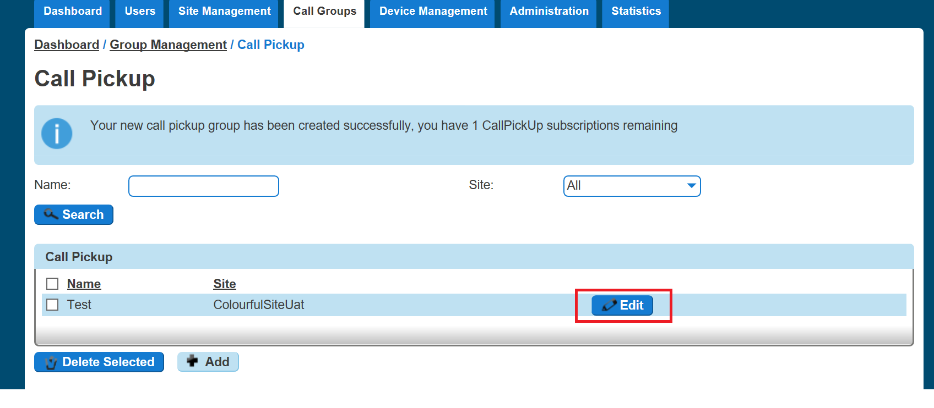
Step 4
To add users select them in the left table and click "Add Selected".
To remove users, click the white "x" next to the user name in the right table. Click "Save".
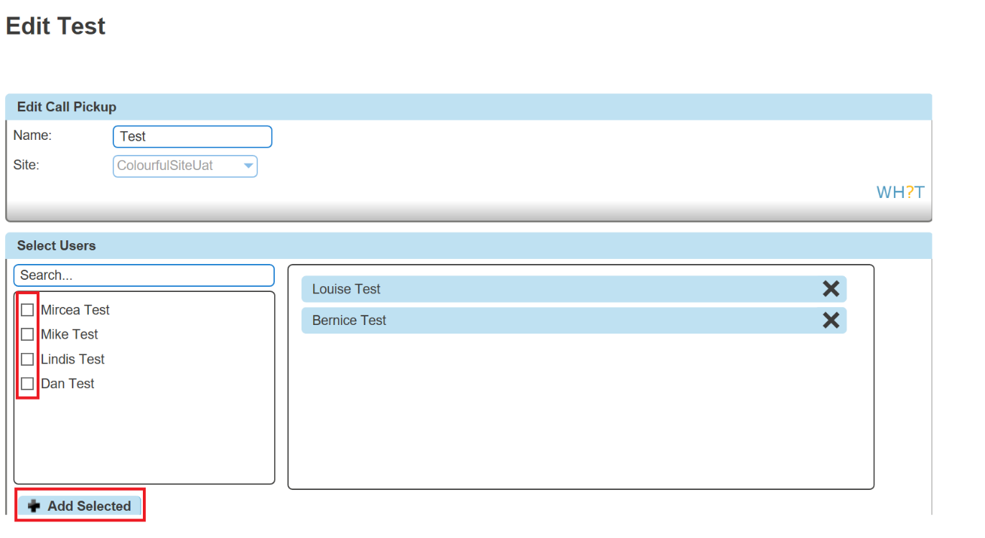

Delete Call Pickup Group
Step 1
Log into the Gamma Portal and go to Provisioning and Service Management, Hosted, Horizon and Horizon Manage Company.
Step 2
Select your account and login to the company that you want by using the "Actions" button select "Login to Horizon".
Step 3
Click the "Call Groups" option and then select "Call Pickup".
On the Call Pickup page select the group(s) that you wish to delete and click the "Delete" button. You will then be presented with a confirmation box asking if you're sure that you want to delete the Call Pickup Group. Clicking "Confirm" will delete the group.
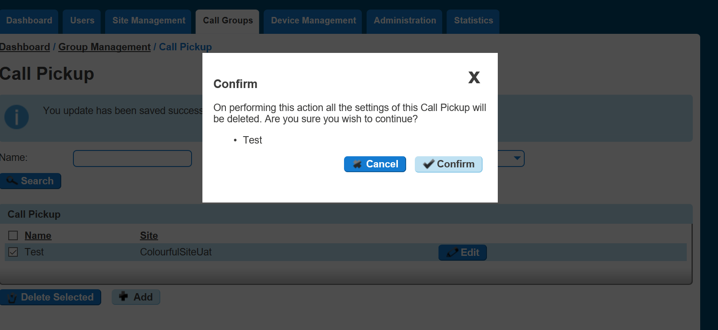

Call Queue Groups
A call queue group is a basic simultaneous Hunt Group with the ability to queue up to 25 calls at network level should all users be busy. Each Call Queue Group can be customised with its own welcome and comfort message as well as its own hold music and has the added capability of a user breakout.
Charge is only applied to a user who can be part of a Call Queue Group. Therefore, you could have 3 users over multiple groups and only be charged for those 3 users, rather than users per group.

If a user in a Call Queue Group has Anonymous Call Rejection enabled and a withheld caller reaches the front of the queue, the call will not be delivered to the user with Anonymous Call Rejection, even if that user is available. The call will wait until a user without Anonymous Call Rejection enabled becomes available.

Setup a Call Queue Group
Call Queue Groups are setup by the Company Administrator
Before you start to set up your Call Queue Group, you need to make sure that you have Call Queue Group Add-ons to do this. This is done by completing the following actions:

Log into the Gamma Portal and go to Provisioning and Service Management, Hosted, Horizon and Horizon Manage Company.
Select your account and locate the company that you want to setup a Call Queue Group.
Using the "Actions" drop down select "Manage Bolt ons".
From here you can see what bolt ons you have and how many are currently in use. If you need to add any more Call Queue Group add-ons if you scroll to the bottom of the page and click "Add More Bolt ons" and then you can add as many bolt ons as you need by adding against "Call Queue Group User"
Step 1
Log into the Gamma Portal and go to Provisioning and Service Management, Hosted, Horizon and Horizon Manage Company.
Step 2
Select your account and login to the company that you want by using the "Actions" button select "Login to Horizon".
Step 3
Click the "Call Groups" option and then select "Call Queue Group". On the Call Queue Group page click "Add".
Step 4
Click the "Call Groups" option and then select "Call Queue Group". On the Call Queue Group page click "Add".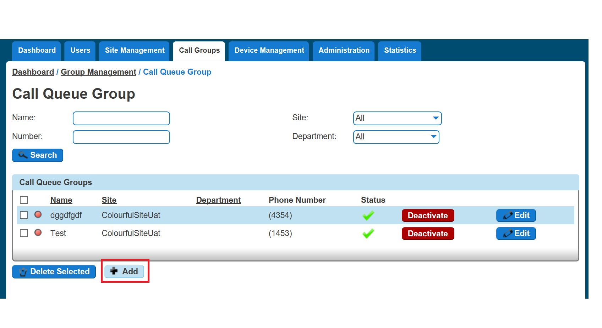
Step 5
You will now be in the wizard for Call Queue Groups. The first page you will be setting up the following:
Site - the site that the Call Queue Group will be used for. All the users of the Call Queue Group will be on this site.
Group Details - enter the name, username and department that you'd like the group to be assigned to. This is so that you can quickly identify the group if you ever need to edit or delete the group.
Caller ID - this will be what is displayed on the handset when the Call Queue Group is used.
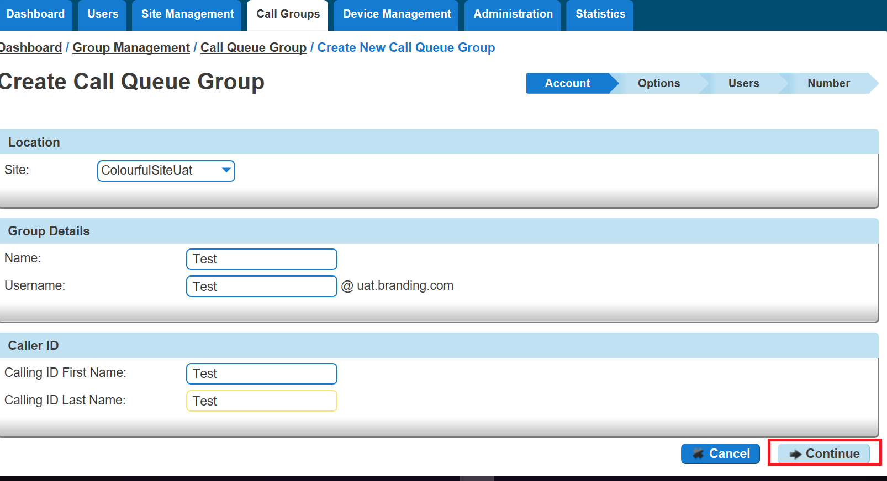
Step 6
Now you can configure the options for the Call Queue Group. The available options during the setup of the Call Queue Group are:
Queue Settings:
Queue Length is how many calls you would like in the Call Queue Group, up to a maximum of 25 calls.
If you want the call to play a ring tone when offering the call to a user
If you want to reset the wait time for the Statistics when a call enters the group or not.
User Settings
If you want to allow users to be able to sign in or out of a Call Queue Group using the users Horizon Portal access
If Call Waiting is allowed for users
Please Note: If “Allow call waiting on users” is on as well as “Play ringing when offering call” is on – the call will present on the phone and the calling party will hear ringing – even if no agent is free to answer. This is the nature of Call Waiting and we would recommend having one or the other on, rather than both.
Overflow Settings
If you want to enable overflow for calls that have been waiting for a defined number of seconds, and if this is to
Play busy tone
Transfer to a different phone umber
If you want to pay the default announcement before overflow processing
Additional Options
If you would like Distinctive Ringing for external calls.
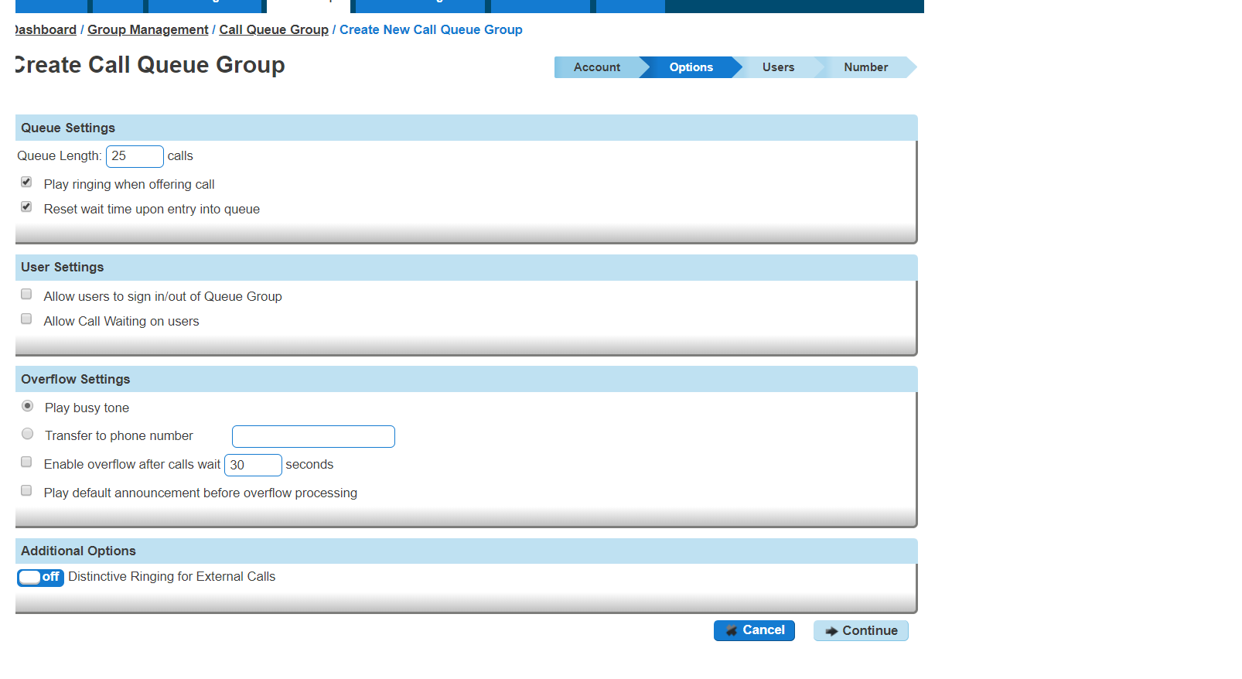
Step 7
Select the users which you want in the Call Queue Group, click "Add Selected" so that they move to the box on the right hand side of the screen and then click "Continue".
A user needs to have the Call Queue Group User add-on associated to their Services. To do this go to edit a user and select the "Services" tab and tick "Call Queue Group User" option and click Save.

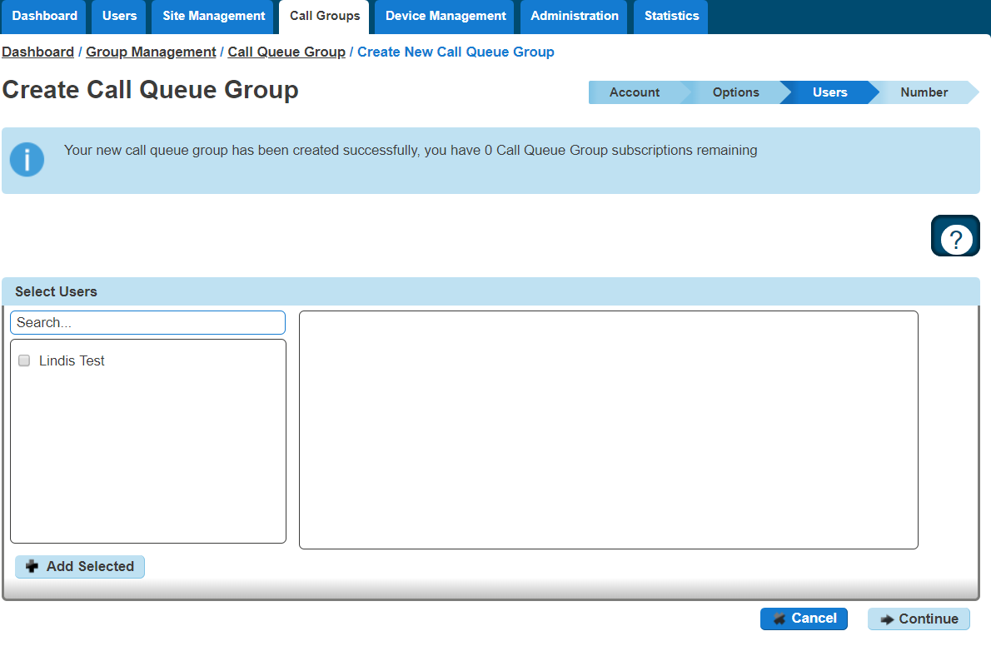
Step 8
Find an available number that you have on your Horizon Company to assign to and type in a free extension.
"Finish and Show List" will finish the set up with basic settings of the Call Queue Group.
"Finish and Edit" will finish the setup with the basic settings of the Call Queue Group and allow you to edit some of the more advanced options. These include:

Announcements
Entrance Message (this is a message placed to the user when their call reaches the Call Queue Group)
Comfort Message
Music on Hold
Call Recording
Voicemail
What announcement should be used for the voicemail
If you want voicemail notifications to be sent to an email address
If you want all calls to be sent to voicemail
Change Voicemail Passcode for the Call Queue Group
Scheduling (Advanced Settings)
Call Forwarding (Advanced Settings)
Call Forwarding when Busy (Advanced Settings)
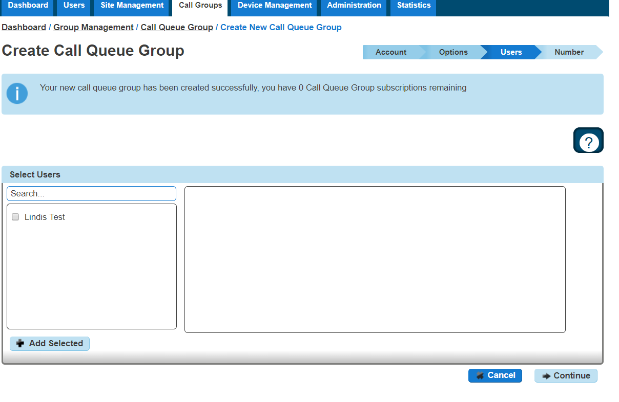

Add/Remove Users to/from a Call Queue Group
A user needs to have the Call Queue Group User add-on associated to their Services. To do this go to edit a user and select the "Services" tab and tick "Call Queue Group User" option and click Save.
Step 1
Log into the Gamma Portal and go to Provisioning and Service Management, Hosted, Horizon and Horizon Manage Company.
Step 2
Select your account and login to the company that you want by using the "Actions" button select "Login to Horizon".
Step 3
Click the "Call Groups" option and then select "Call Queue Group". On the Call Queue Group page click "Edit".

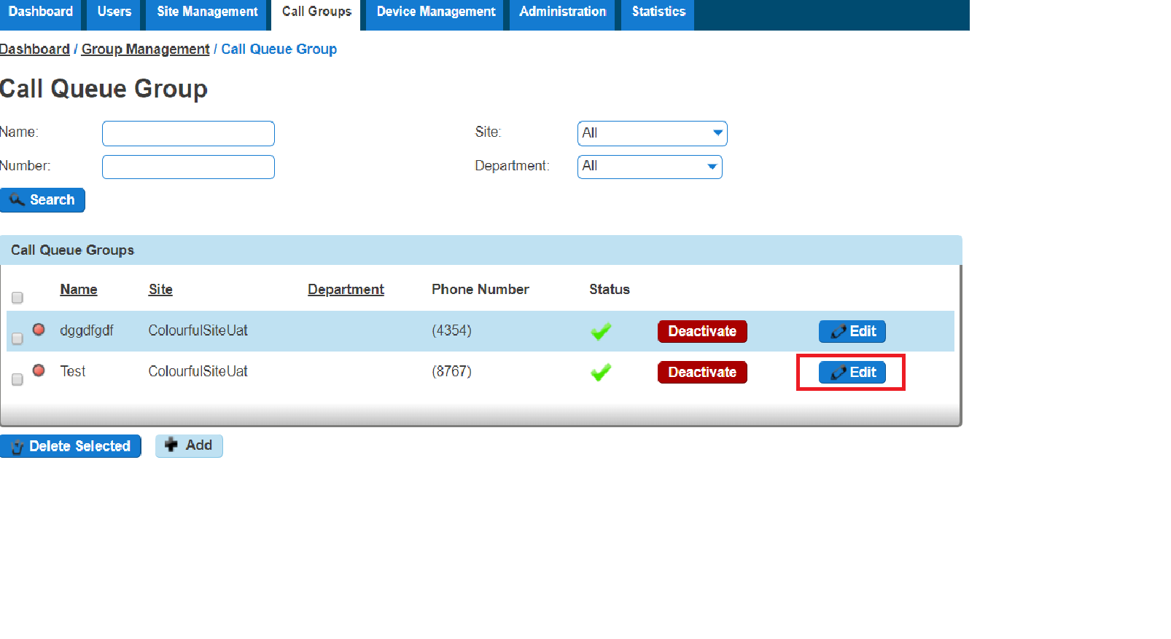
Step 4
Select the "Users" tab. From here you can add new users from the table on the left hand side and clicking "Add Selected", and remove users by clicking the white "X" next to the user you want to remove.
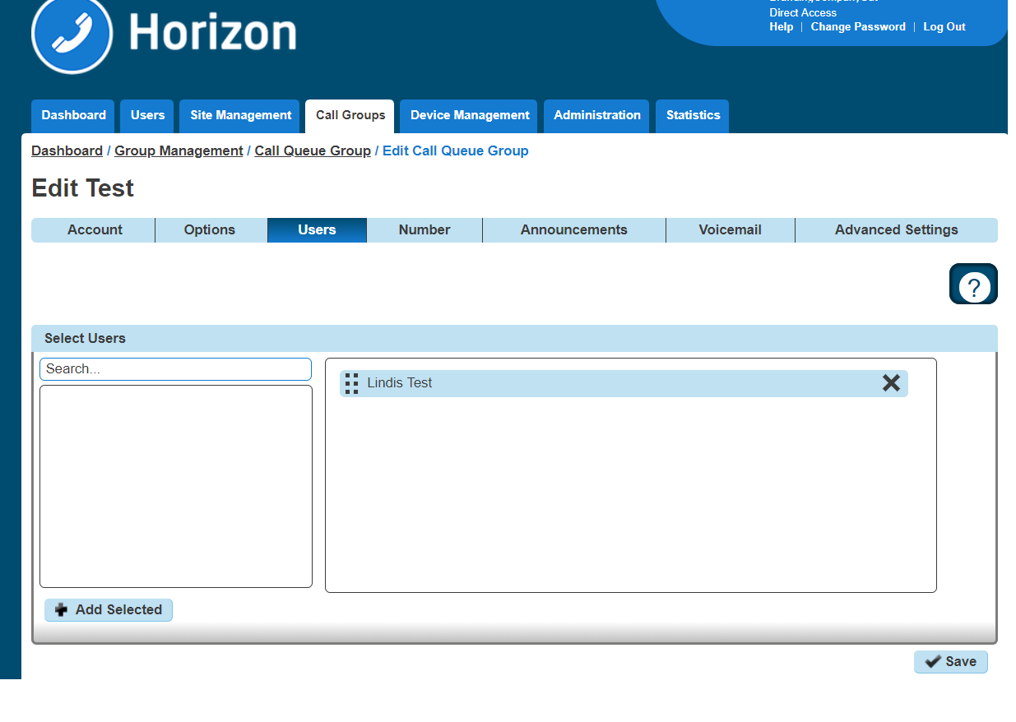

Edit a Call Queue Group Settings
Step 1
Log into the Gamma Portal and go to Provisioning and Service Management, Hosted, Horizon and Horizon Manage Company.
Step 2
Select your account and login to the company that you want by using the "Actions" button select "Login to Horizon".
Step 3
Click the "Call Groups" option and then select "Call Queue Group". On the Call Queue Group page click "Edit".

Step 4
From here you will be presented with the following options:

Account
Change the name and Caller ID settings

Options
Change the Queue Settings, including:
Queue Length
Play ringing when offering a call
Allow users to dial a number to leave a message
Reset the wait time when a call enters the call queue group
Change the user settings:
Allow users to sign in/out of a Call Queue Group
Allow call waiting for users
Overflow settings
Enable overflow after call is waiting for a defined amount of seconds
To send the call to voicemail or transfer to another phone number
Play a default announcement before overflow processing
  - Switch on Distinctive Ringing for external calls

Users
  - Add or remove users from the Call Queue Group

Number
  - Change the telephone number of the Call Queue Group
  - Change the extension number of the Call Queue Group

Announcements
  - Entrance Message (this is a message placed to the user when their call reaches the Call Queue Group)
  - Comfort Message
  - Music on Hold

Call Recording

Voicemail
  - What announcement should be used for the voicemail
  - If you want voicemail notifications to be sent to an email address
  - If you want all calls to be sent to voicemail
  - Change Voicemail Passcode for the Call Queue Group

Scheduling (Advanced Settings)

Call Forwarding (Advanced Settings)

Call Forwarding when Busy (Advanced Settings)

Delete a Call Queue Group
Step 1
Log into the Gamma Portal and go to Provisioning and Service Management, Hosted, Horizon and Horizon Manage Company.
Step 2
Select your account and login to the company that you want by using the "Actions" button select "Login to Horizon".
Step 3
Click the "Call Groups" option and then select "Call Queue Group". On the Call Queue Group page select the Call Queue Group(s) that you want to delete and then click the "Delete Selected" option.
Click "Confirm" when asked if you are sure that you want to continue in deleting the Call Queue Group.
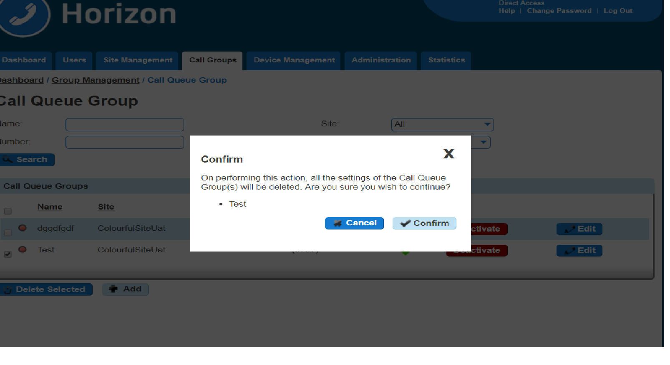

User logging in and out of a Call Queue Group
A user can log in and out of a Call Queue Group in their Horizon Portal using their log in details if the Call Queue Group has the "Allow users to sign in/out of a Call Queue Group" option selected in the Call Queue Group Options (see Editing Call Queue Group)
Once this option is selected then when a user logs into the Horizon Portal they will see "Queue Groups" in the menu. They will then be able to click "Sign In" or "Sign Out" depending on what their status with the Call Queue Group is.
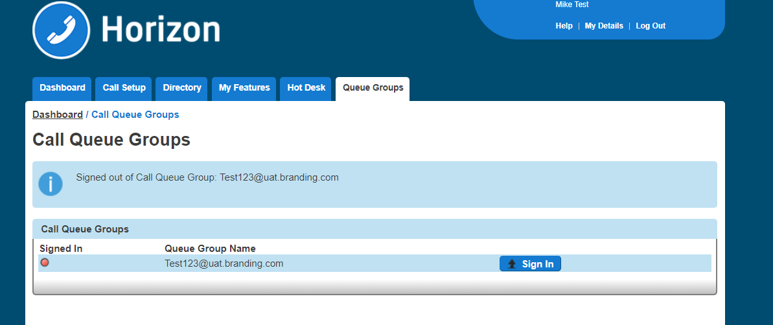

Call Recording
The Call Recording feature allows you to record your Inbound, Outbound or both Inbound and Outbound calls. This can be done at a user level or on a whole hunt group, and you and set call recording up to record a percentage of calls, record on demand or to not record calls at all.
For Call Recording to fully work a user or group needs to have a DDI assigned to it.
When a user is deleted or the number is unassigned from a user or call group, the administrator is limited when searching for their recordings. You are unable to search for numbers recordings using either the number or the username fields.
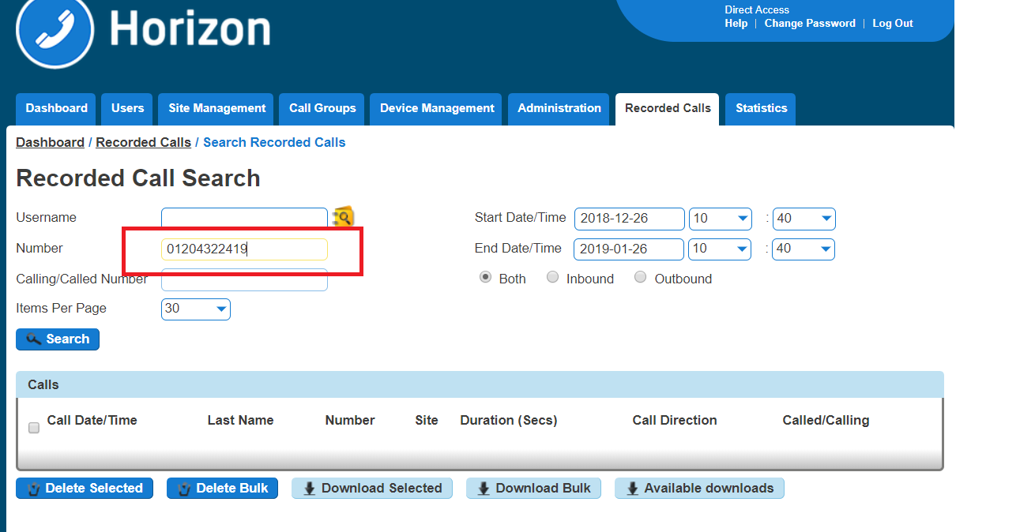
The recordings will only be visible when searching against:
Calling/Called Number
Start Date/Time
End Date/Time
Direction
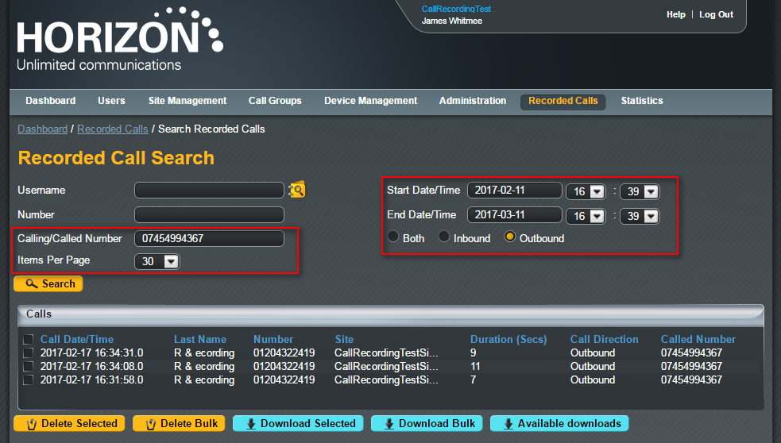
A recording of a call will take up approximately 200kilobytes per 1 minute of recording.

Horizon to Horizon calls, including internal calls, currently are not recorded. Please see the Known Behaviours Document for more information.
Advanced Call Recordings will only search for a 3-month range to help with performance. If you are looking for a full 6 months, you will have to run two 3 month searches to get all the results.

Call Recording Retention Period
A Channel Partner will be able to set the retention period of call recordings to either 3, 6 or 12 months. The default setting of any new Horizon Company created from the 9th March 2017 will be 3 months, to modify a Companies retention policy please follow these simple steps:
Please Note: Following the introduction of the 12-month storage facility on Horizon last year we are finding that some Company's are now exceeding the maximum storage threshold that we have in place for the Legacy Horizon Call Recording Storage bands. To ensure that costs are fully covered, for use beyond the 360000 meg band, we will be introducing a 0.14p per meg charge for storage beyond the maximum threshold. This charge will come into effect from the 1st March 2018.
The 0.14p per meg rate is derived from the 360,000 band being fully utilised. (£500 / 360,000)
As an example if a Company has stored 500,000 MB the months charge would be: £500 + (500,000-360,000)*£0.0014 = £696.00

Step 1
Log into the Gamma Portal and go to Provisioning and Service Management, Hosted, Horizon and Horizon Manage Company.
Step 2
Select your account and login to the company that you want by using the "Actions" button select "Manage Company".
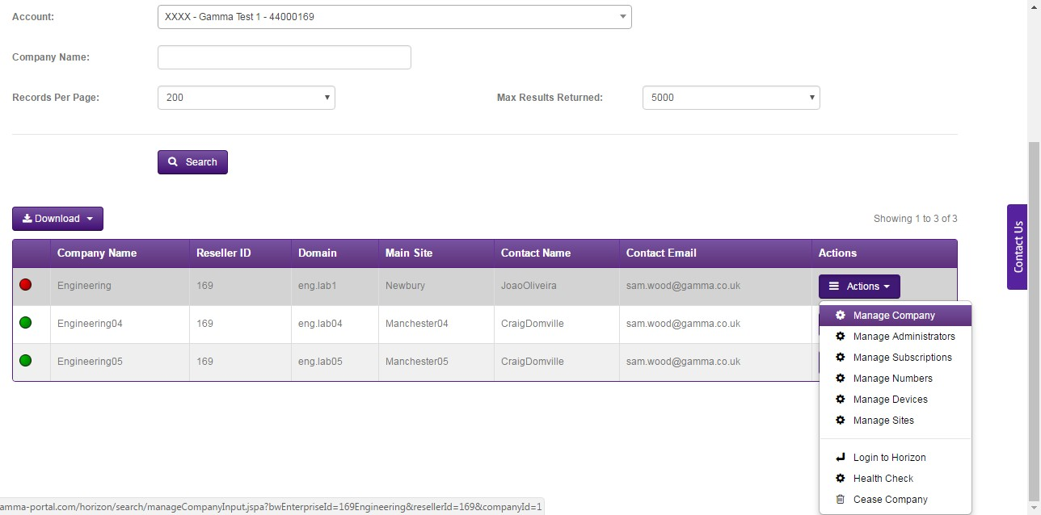

Step 3
Select the Settings tab and you will see the new retention options. Select your new retention period and click Save.
If the retention period of a Company is reduced, then any call recordings outside of the new retention period will be automatically deleted. For example, if on the 31st March 2017 a company with a call recording retention policy of 12 months was reduced to a 3-month retention policy then all call recordings prior to the 1st January 2017 would be deleted. Along with the embedded warning on the portal page, the below advice will appear to warn a user:
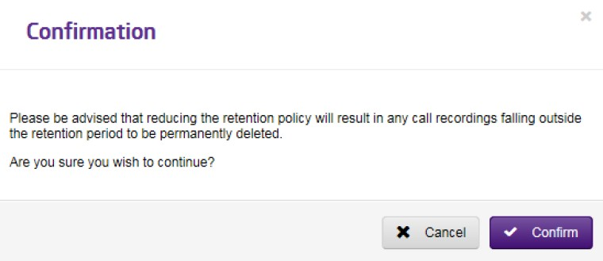

Once confirmed then a call recording cannot be easily retrieved, and retrieval cannot be guaranteed. Requests to retrieve recordings that are deleted in error will carry a one-off restoration charge of £250 per company instance.
Should you need to request a restoration of call recordings in the 1st instance please send an email to iam@gamma.co.uk, providing the Company name and the time period that you would like us to attempt to restore.

Call Recording Options
Record x% of calls: this will record a defined percentage of your calls at random
Record on demand: this will allow a user to record a call whenever they deem appropriate
Pause / Resume call recording: this will record all calls, but allow a user to pause the recording before resuming the call
Do not record calls

Shortcodes
Record on demand - *1
Pause call recording - *3
Resume call recording - *7

Call Recording for a User
Step 1
Log into the Gamma Portal and go to Provisioning and Service Management, Hosted, Horizon and Horizon Manage Company.
Step 2
Select your account and login to the company that you want by using the "Actions" button select "Login to Horizon".
Step 3
Click the "Users" option and then select "List Users" so you can search for the user that you want Call Recording set up for.
Locate the user and click the "Edit" button.
Step 4
In the User Management page click "Call Setup" and then under the Settings header select "Call Recording"
From here you can select the recording type for the user. Select the recording type and click "Save" for your changes to take effect.

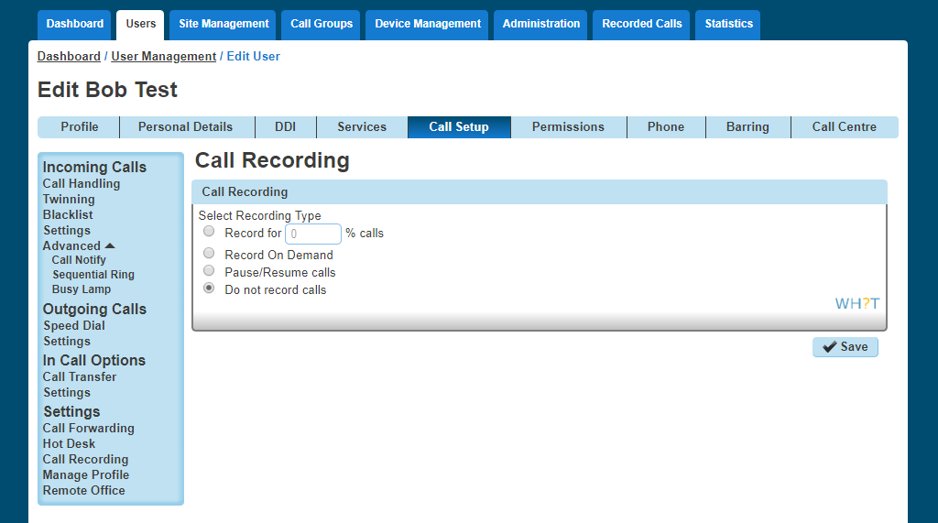

Call Recording for a Hunt Group
Step 1
Log into the Gamma Portal and go to Provisioning and Service Management, Hosted, Horizon and Horizon Manage Company.
Step 2
Select your account and login to the company that you want by using the "Actions" button select "Login to Horizon".
Step 3
Click the "Call Groups" option and then select "Hunt Groups" so you can search for the Hunt Group that you want Call Recording set up for.
Locate the Hunt Group and click the "Edit" button.
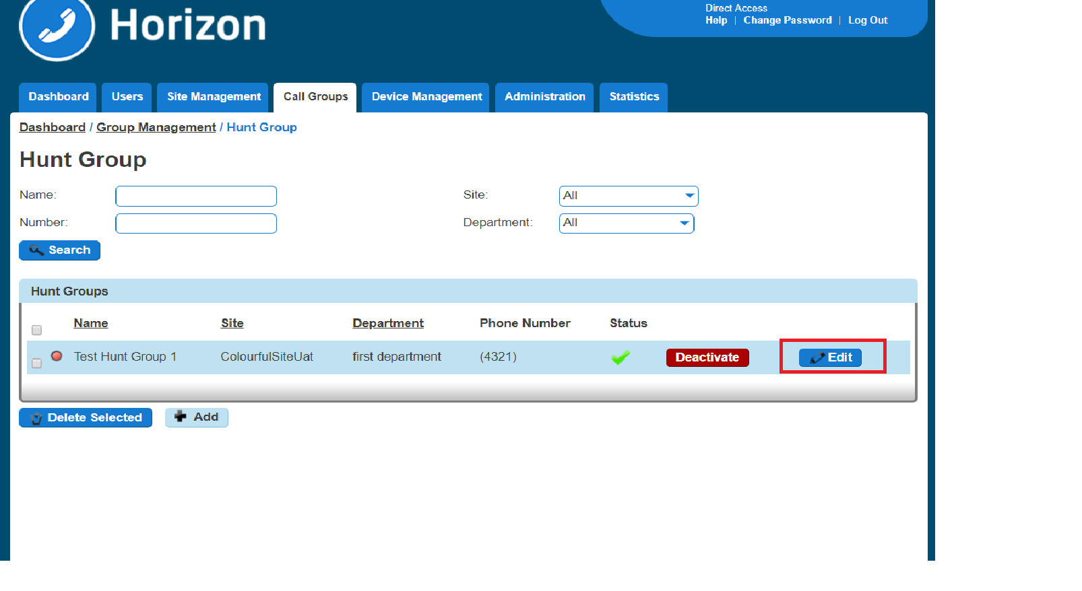
Step 4
In the Edit Hunt Group page click "Call Recording".
From here you can select the recording type for the user. Select the recording type and click "Save" for your changes to take effect.

Call Recording for a Call Queue Group
Step 1
Log into the Gamma Portal and go to Provisioning and Service Management, Hosted, Horizon and Horizon Manage Company.
Step 2
Select your account and login to the company that you want by using the "Actions" button select "Login to Horizon".

Step 3
Click the "Call Groups" option and then select "Call Queue Groups" so you can search for the Call
Queue Group that you want Call Recording set up for.
Locate the Call Queue Group and click the "Edit" button.
Step 4
In the Edit Call Queue Group page click "Call Recording".
From here you can select the recording type for the user. Select the recording type and click "Save" for your changes to take effect.

Bulk Call Recording with delete.
Step 1
Log into the Gamma Portal and go to Provisioning and Service Management, Hosted, Horizon and Horizon Manage Company.
Step 2
Select your account and login to the company that you want by using the "Actions" button select "Login to Horizon".
Step 3
Click the "Recorded Calls" option and select "Bulk Download"
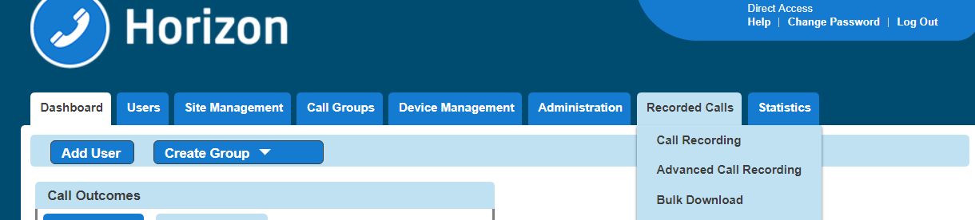

Step 4
This will then take you to the main Bulk Download page where the user can request downloads. To request downloads, enter a 2 week date range and select Bulk Download. If you try to select more than a two-week date frame you will receive an error.
Please note: If during the bulk request there are missing files (technical problem at Gamma’s end), then the request would previously fail. Moving forward, there will be a dummy file with the naming convention “dummy_file_date_time.dummy” – this will let a user know that there was a call recording at that date / time but it’s not been downloaded.
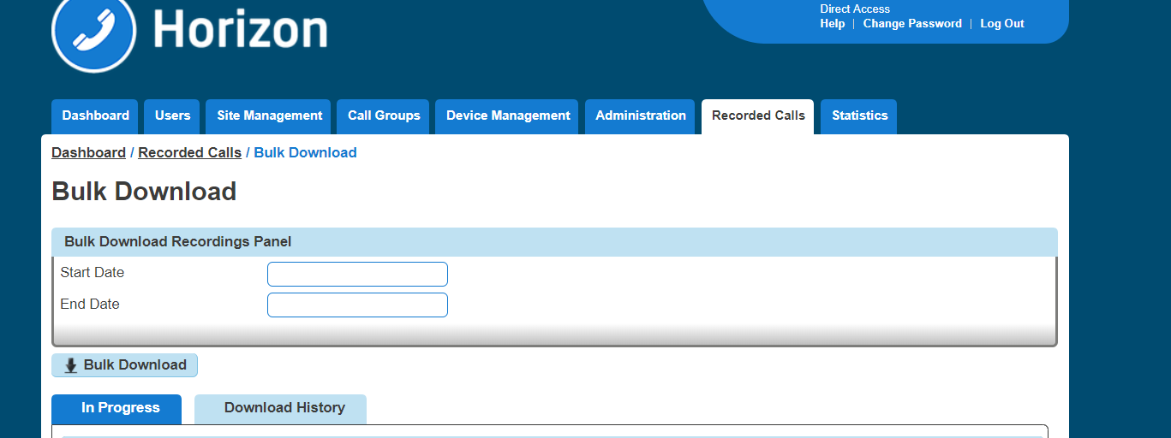
Step 5
If the download is successful you will see the download start within your browser, if this doesn’t happen please select the 'Download History' tab.
The download pop up will provide information on the file size and the time outstanding to complete the download.
Once the downloaded has completed the ZIP file can be extracted and saved to a location of the Administrators choice.

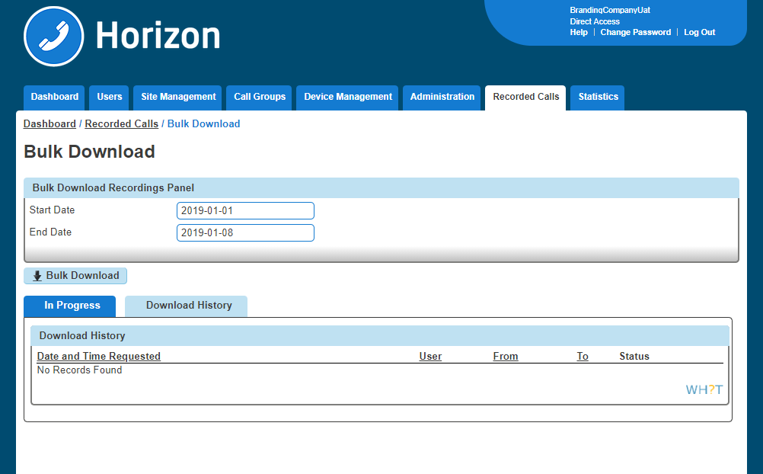
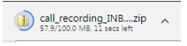
Step 6
We have also provided a Download History section that will provide key information about the date and time a Bulk Download request was made, who made it, the date range selected and status. An administrator is also given option to delete the recordings from the storage facility should they wish to. To delete recording between the From and To dates simply click the delete button.
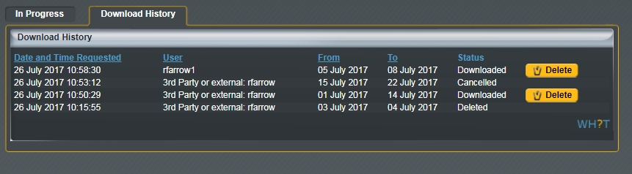
Step 7
Any download that has been requested by a user parsing in via the Gamma portal will be prefixed by "3rd Party or External" followed by the users Gamma Portal username.
If access was directly via the Horizon GUI then only the GUI username will be displayed

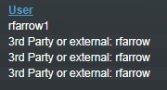

Please Note: A user will not be able to download the current day recordings, this is too ensure that recordings that have not been downloaded and saved cannot be accidently deleted.
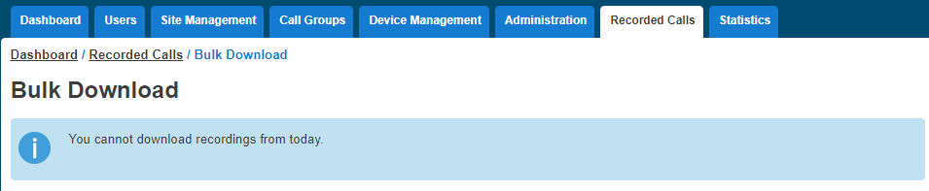
To protect system performance there is limit to the number of concurrent call recording that will be allowed across the platform, when this limit is reached the user will receive a message stating "We are currently experiencing a high demand for call recording downloads on Horizon. Please try again later"
It is possible for a different administrator to delete a downloaded batch recording to the user that requested the original download. In this use case the username displayed on the GUI will always be the original requestor. The backend history database will capture the details of the user who deleted the recordings and this information can be made available upon request via the IAM team.

Searching for a Call Recording
Step 1
Log into the Gamma Portal and go to Provisioning and Service Management, Hosted, Horizon and Horizon Manage Company.
Step 2
Select your account and login to the company that you want by using the "Actions" button select "Login to Horizon".
Step 3
Click the "Recorded Calls" option and select "Call Recording"
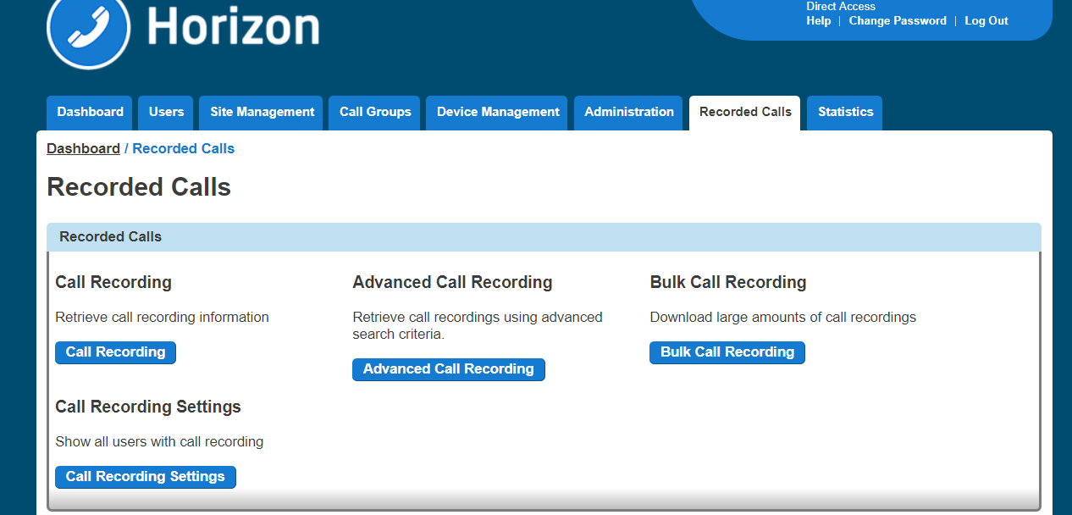
Step 4
From here you can search for the user you are wanting to listen to the calls of. You can search using one of the following criteria:
First Name
Last Name
Number (this is the full telephone number and not the extension number)
Site
A number will only appear in this list if they have call recording set up.

Searching for a Call Recording using Advanced Call Recording
Using Advanced Call Recording you can:
Download up to 1000 inbound calls at once
Download up to 1000 outbound calls at one
Delete up to 1000 calls at one.

Step 1
Log into the Gamma Portal and go to Provisioning and Service Management, Hosted, Horizon and Horizon Manage Company.

Step 2
Select your account and login to the company that you want by using the "Actions" button select "Login to Horizon".
Step 3
Click the "Recorded Calls" option and select "Advanced Call Recording"
Step 4
From here you can search for the user you are wanting to listen to the calls of. You can search using one of the following criteria:
Username (Directory search can be used by clicking the Directory icon)
Number
Extension
First Name
Last Name
Site
Number
Calling / Called Number
Start date/time
End date/time
Direction of call
Both directions
Inbound only
Outbound only

Step 5
Select the calls you want to download and click the "Download Selected" button. Alternatively, if you want to delete calls, select the "Delete Calls" button. You can download 100 recordings at a time.
You can download call recordings in bulk or download selected files. You can also delete selected files or files in bulk.

Access and notification control to call recordings
As a company administrator you will be able to prevent any support users using the log into Horizon pass through from the Gamma portal to a Companies Call Recording download and delete options, there will also be the option to notify all company administrators if a support user has entered a company's call recording area.
Any company administrator entering a valid username and password via the Horizon portal directly will always see the Recorded Calls tab and be presented with the 3rd Party Support Permission option under the Administration drop down.
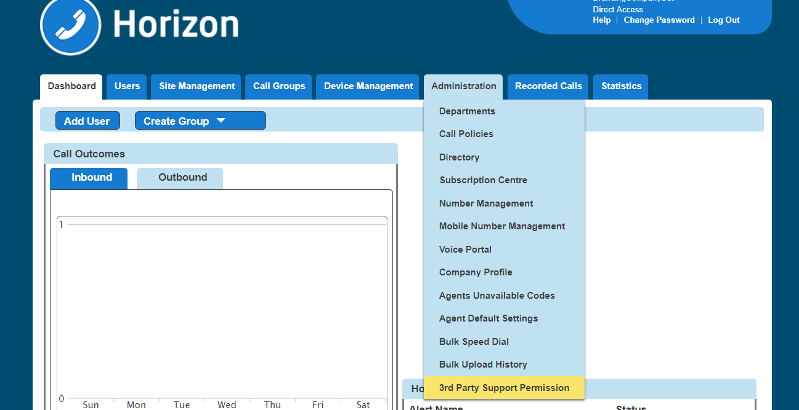
The Horizon portal will also provide an audit log of who is enabling and disabling the options.
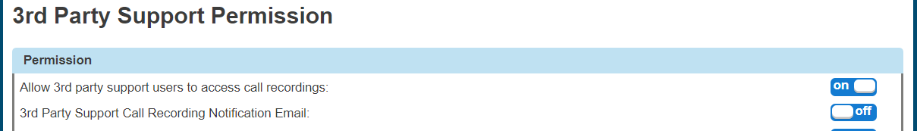

The service will be deployed as opt in to prevent any operational or support difficulties and unexpected emails being sent to company administrators
All existing and new companies created from the 16th November 2017 onwards will be defaulted to allow pass through login access to call recordings from the Gamma portal and the email notification will be set to off as indicated here. Please note these options will only appear on the Horizon portal if the company has call recording enabled on the Gamma portal.
This means any pass-through login from the Gamma portal will be able to access the companies call recordings and no notifications will be sent if they do. They will not have access to alter the 3rd party permission options, this can only be done by an administrator logging directly onto the Horizon portal. Pass through example with these option set
If an administrator chooses to enable the notification email, as below, then every time a support user passes through via the Gamma Portal and attempts to search, download or delete from within the call recordings area an email will be sent to all administrators as detailed below
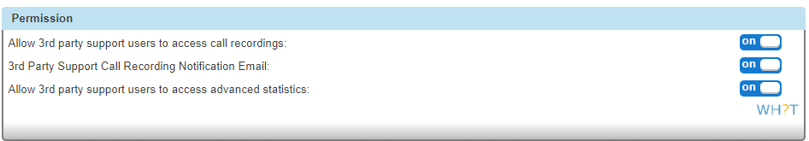
The email will detail the Gamma portal ID of the user, what action they performed and the date it happened.
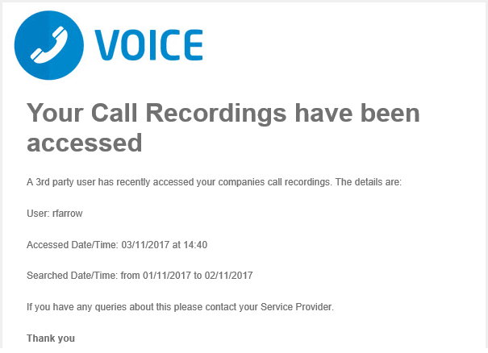
We recommend that all companies are built and handed over in a fashion that ensure your customers/end users make a conscious decision as to whether they allow access to the call recording data to support users via the Gamma portal.

Call Transfer
Call Transfer gives you various options when transferring a call. These options include having a call being transferred back to yourself if the person you are transferring it to is engaged or doesn't answer the call. When a call is recalled to your handset, it just rings as it normally would when you receive a call.
The options that you have available are:
Call transfer recall - this will return the call to you if it hasn't been answered within a defined amount of rings
Use Diversion Inhibitor for Blind Transfer - this is where you want to transfer a call to an extension number, removing all redirections in place, without going through to the extension first.
Use Diversion Inhibitor for Consultative Calls - this is where you want to transfer a call to an extension number, removing all redirections in place, speaking to the user who owns the extension number first.

Activate/Deactivate Call Transfer as a Company Administrator
Step 1
Log into the Gamma Portal and go to Provisioning and Service Management, Hosted, Horizon and Horizon Manage Company.
Step 2
Select your account and login to the company that you want by using the "Actions" button select "Login to Horizon".
Step 3
Click the "Users" option and then select "List Users" so you can search for the user that you want Call Transfer set up for.
Locate the user and click the "Edit" button.
Step 4
In the User Management page click "Call Setup" and then under the In Call Options header select "Call Transfers"
From here you can set up your Call Transfer options.
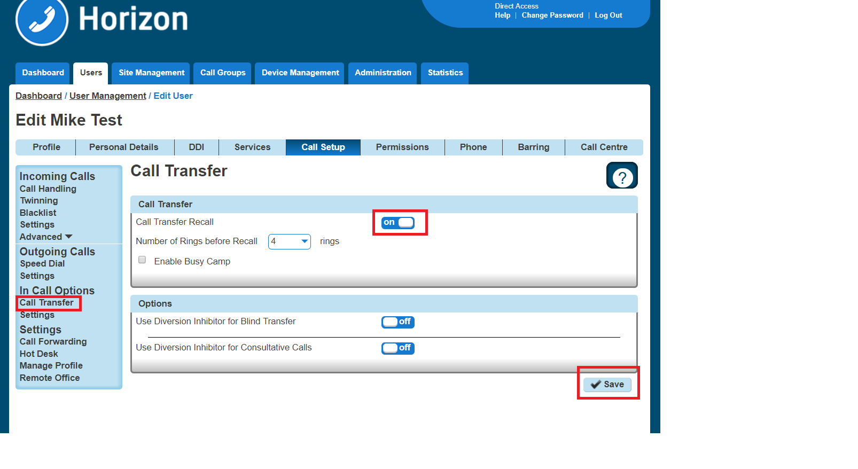

Privacy on Transfer and/or Forwarding
Currently there are few behaviours where a display update (e.g. an updated CLI and/or name) is sent mid call but are not passed through to the receiving party. The following services do not receive a display update:
Attended Call Transfer
Blind Call Transfer (transferred party)
Call Forwarding (Always, No Answer, Busy, Unreachable)
Call Barge
Call Pickup (Group and Directed)
Call Park / Retrieve
Sequential Ring
Setting “Privacy on Transfer and / or forwarding” to “Off” will allow this update to be passed to users within the same Horizon Company and provide a display update on the above services. Please note all new Companies created from the 15th March 2018 onwards will have the Privacy setting turned/ off so that the CLI update will occur by default but we will not be updating any existing company user settings. These will need to updated manually as required.
For clarity we will not be sending the CLI / Name details through to PSTN or other Horizon Companies and PSTN / external Parties will always see the CLI that they either dialled or received a call from.
All new Companies created from the 15th March 2018 onwards will have the Privacy setting set to off so that the CLI update will occur by default but we will not be updating any existing company user settings. These will need to updated manually as required.
To update the users setting head to User Management Edit User DDI Caller ID Number Presented
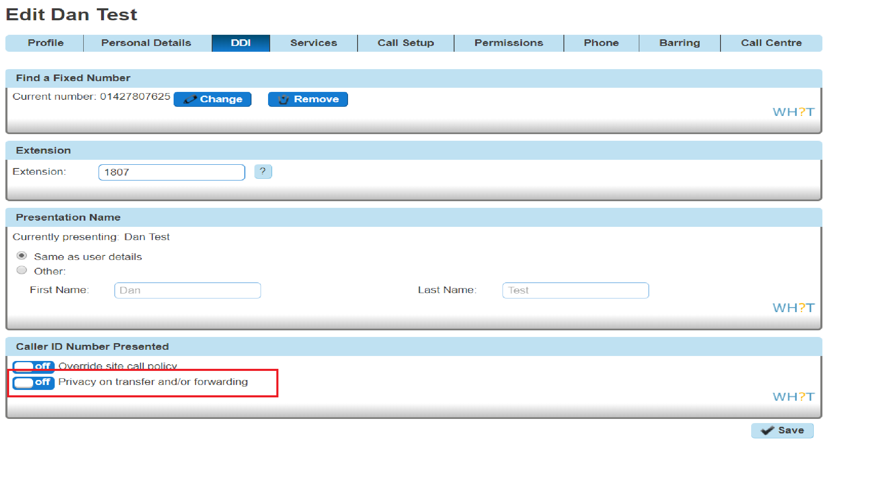

Privacy on Transfer Service Interaction Impacts
The display enhancements affect several different types of redirection services on the Horizon platform and the following section fully details our results from testing. In nearly all instances whether or not parties involved in these redirections receive display updates is determined by the privacy settings of one single party. Below is a table which advises which party this is in each affected service:
Redirection Service | Party who can affect display updates
Call Barge | Barger
Call Park / Group Call Park | Call Retriever
Directed Call Pickup / Group Call Pickup | Call Retriever
Attended Call Transfer | Call Transferer
Blind Call Transfer | Call Transferer
Call Forward (Busy,NA,Unreachable,Always) | Call Forwarder
Sequential Ring | Called Party

The effects of the privacy changes are described in more detail along with examples below.
There are instances where services can be combined, and multiple different parties privacy settings can affect display outcome, these cases are covered below.

Examples / Findings
Call Barge findings
The major change to this service is that the bargee will now see their display update to that of the barger. The party whose privacy settings dictate who receives display updates is the barger:
Example 1.CB – On net call barge – User C has privacy disabled
User A receives a call from User B
User C barges in on User B’s call
User A and User B’s display will update to reflect User C’s details
User C leaves User B’s call
User A’s display updates to User B
User B’s display updates to User A
This may pose an issue for people who use the barge service silently, i.e. managers who wish to monitor their agents without them being aware of the barge.
We also see the display update on the non-bargee/barger party of the call, providing they are on the same enterprise as the other users.
There is a slight change to this behaviour if User C has privacy enabled, in that User A (ie the bon barged target) does not see their display update, and User B does not see their display update back to User A after User C has left the call:
Example 2.CB – On net call barge – User C has privacy enabled
User A receives a call from User B
User C barges in on User B’s call
User B’s receives display update with User C’s details
User A continues to see User B’s display details
User C leaves User B’s call
User A continues to see User B’s display details
User B continues to see User C’s display details
In the event that the barged call involved a PSTN user, only users on the same enterprise as the barger will receive display updates:
Example 3.CB – PSTN call barge – User C B has privacy disabled
User A receives a call from PSTN party
User B barges in on User A’s call
User A’s receives display update with User B’s details
PSTN party continues to see User A’s display details
User B leaves User A’s call
User A’s display updates to PSTN’s displayed details
PSTN party continues to see User A’s display details
Example 4.CB – PSTN call barge – User C B has privacy enabled
User A receives a call from PSTN party
User B barges in on User A’s call
User A’s receives display update with User B’s details
PSTN party continues to see User A’s display details
User B leaves User A’s call
User A’s display updates to PSTN’s displayed details
PSTN party continues to see User A’s display details
Call Park / Group Call Park findings
Call park behaviour also changes, but only if the caller who is parked is on the same enterprise as the call park retriever. If this is the case and the call park retriever has no privacy set, then the parked caller will have their display update to the retriever:
Example CP.1 – Retrieval of parked call – User C has privacy disabled
User A calls User B
User A parks User B against an extension
User C retrieves User B’s call
User B’s display will update to User C’s
The above example demonstrates what will happen if User C has privacy disabled. If User C has privacy enabled, then User B’s display will continue to show User A’s details:
Example CP.2 – Retrieval of parked call – User C has privacy enabled
User A calls User B
User A parks User B against an extension
User C retrieves User B’s call
User B will not receive a display update and will continue to see User A’s display details
If a PSTN call is parked then the behaviour remains unchanged, i.e. the PSTN caller will never get a display update regardless of privacy settings for any of the parties involved:
Example CP.3 – Retrieval of parked PSTN call – User B has privacy disabled
PSTN party calls User A
User A parks PSTN party against an extension
User B retrieves the PSTN call
The PSTN party will not receive a display update and will continue to see User A’s display details
Call Pickup findings
This enhancement also affects the call pick up service, including both group pick up and directed pick up. Similarly, to call park, the privacy setting here that matters is that of the user who is picking up the call. If they have no privacy set, then the user who is making the call has their display updated to the party who picks up the call.
Example CP.1 Call Pick up – User C has privacy disabled
User A attempts to call User B
User C picks up the call using call pick up
User A’s display will update to User C
If User C does have privacy enabled, then User A’s display will continue to show User B’s details:
Example CP.2 Call Pick up – User C has privacy enabled
User A attempts to call User B
User C picks up the call using call pick up
User A does not receive a display update and continues to see User B’s display details
If the call being picked up is an external party, then the behaviour remains unchanged and the PSTN’s display is not updated regardless of privacy settings of the parties involved.

Call Groups – Auto Attendants, Hunt Group, Call Centre & Call Queue Groups findings
The display behaviour for callers making calls into these call groups will not change. They will continue to see the call group they detail rather than the user who answers the call. There is a slight change to some call transfer scenario’s however this is covered in section 8.2.
The recipient user in these call groups continues to see the calling parties details.

Call Transfer – Attended findings
Attended call transfers are the most notably affected feature with this display enhancement.
When a call is transferred with attended consultation before answer, both parties receive a display update with the new remote party. The new remote party is also provided when the AS reconnects both users together. Only users on the same enterprise will receive display updates.
When a call is transferred with attended consultation after answer, both parties receive display updates with the new remote party. The new remote party is provided when the AS reconnects both users together. Only users on the same enterprise will receive display updates.
Example CTA.2 – On net attended transfer – User B has privacy disabled
User A calls User B
User B calls User C
User B then transfers User A to User C
User A’s display will then update to User C’s details
User C’s display will then update to User A’s details
Again, this is the case regardless of whether the call was transferred before or after answer (dependant on the user’s device, see section XXX).
The key privacy setting in this scenario is that of the transferrer, if they have privacy disabled then all the parties involved in the transfer will receive a display update.
If the transferrer decides to enable privacy however this then starts supressing the CLI updates to the other parties:
Example CTA.3 – On net attended transfer – User B has privacy enabled
User A calls User B
User B calls User C
User B then transfers User A to User C
User A and User C will only see User B’s details on their display

As we are setting privacy to ‘privacy for external calls’ only any external or PSTN parties involved in a transfer will not see a display update. Only parties on the same enterprise as the transferrer will see display updates:
Example CTA.3 – Transfer of PSTN party – User A has privacy disabled
PSTN caller calls User A
User A places PSTN caller on hold
User A calls User B
User A transfers PSTN caller to User B
User B receives a display update with the PSTN caller’s details
The PSTN caller does not receive any form of display update and will continue to see User A’s details
Example CTA.4 – Transfer to PSTN – User A has privacy disabled
User A calls User B
User A places User B on hold
User A calls a PSTN party
User A transfers User B to PSTN party
User B receives display update with PSTN party’s details
PSTN party does not receive any form of display update and will continue to see User A’s details
In the above 2 examples if User A has privacy enabled, then User B will not receive the display update with the PSTN party’s details and will instead continue to see User A’s details, shown below:
Example CTA.3 – Transfer of PSTN party – User A has privacy enabled
PSTN caller calls User A
User A places PSTN caller on hold
User A calls User B
User A transfers PSTN caller to User B
User B does not receive a display update and continues to see User A’s details
The PSTN caller does not receive any form of display update and will continue to see User A’s details

Example CTA.4 – Transfer to PSTN – User A has privacy enabled
User A calls User B
User A places User B on hold
User A calls a PSTN party
User A transfers User B to PSTN party
User B does not receive a display update and continues to see User A’s details
PSTN party does not receive any form of display update and will continue to see User A’s details
Blind Transfer findings
Blind transfers remain largely the same, in that the transfer target will continue to see the transferee rather than the transferrer (current behaviour on production). Once we disable privacy for users however the transferred party will now get a display update with the transfer targets display details.
Example CTB.1 – On net blind transfer - User B has privacy disabled
User A calls User B
User B blind transfers User A to User C
User C receives call with A’s details
User A receives a display update with User C’s details
In the above example User B does not have privacy enabled, therefore allowing User A to receive the display update. If User B had privacy enabled, then User A would continue to see User B’s details rather than User C’s:
Example CTB.2 – On net blind transfer - User B has privacy enabled
User A calls User B
User B blind transfers User A to User C
User C receives call with A’s details
User A does not receive a display update and continues to see User B’s details
In production, at present if a call is blind transferred to a PSTN party, then the PSTN party always receives the display details for the transferred party rather than the transferrer. This is regardless of any privacy settings.
If however a PSTN party is the transferred party and is blind transferred to another user, the PSTN party never receives a display update, again regardless of any privacy settings for any of the parties involved in the transfer:

Example CTB.3 – Blind transfer of PSTN - User A has privacy disabled
User A calls PSTN party
User A blind transfers PSTN party to User B
User B receives call with the PSTN parties details
The PSTN party does not receive any form of display update
Call Forwarding – No Answer / Busy / Unreachable / Always findings
If a user calls another user who has a call forwarding enabled and has disabled privacy, then the user making the call will receive the forward destination:
Example CF.1 – Call Forward Always – User B has privacy disabled
User B has call forward always to User C
User A calls User B
User B receives User C’s display details
User C receives User B’s display details
If user B were to enable privacy, then the User A would not receive the forward destination and instead will just see User B’s number:
Example CF.2 – Call Forward Always – User B has privacy enabled
User B has call forward always to User C
User A calls User B
User B receives User B’s display details
User C receives User B’s display details
The same scenarios apply if the forwarded number is a PSTN number:
Example CF.3 – Call Forward Always – User B has privacy disabled
User B has call forward always to PSTN
User A calls User B
User B receives the PSTN’s display details
PSTN receives User B’s display details

Example CF.4 – Call Forward Always – User B has privacy enabled
User B has call forward always to PSTN
User A calls User B
User B receives User B’s display details
PSTN receives User B’s display details
All the above examples apply regardless of what the call forward type is, whether it be call forward always (as shown above), call forward on busy, call forward on no answer or call forward on unreachable.
These display updates only apply to users who are calling other users on the same enterprise with a forward enabled. If a PSTN party calls a user with a call forward, they do not receive a display update:
Example CF.5 – PSTN to Call Forward Always – User B has privacy disabled
User A has call forward always to User B
PSTN calls User A
User B receives the PSTN’s display details
PSTN does not receive a display update and continues to see User A’s display details
Example CF.6 – PSTN to Call Forward Always – User B has privacy enabled
User A has call forward always to User B
PSTN calls User A
User B receives the PSTN’s display details
PSTN does not receive a display update and continues to see User A’s display details
Sequential Ring findings
The calling parties display is now updated if a sequential ring party answers the call. This is providing that the user with the sequential ring enabled does not have privacy enabled. If they do have privacy enabled, then the calling party does not receive a display update.
The calling party receives a display update regardless of whether or not the sequential ring destination is internal or external.

Example SR.1 – Sequential Ring – User B has privacy disabled
User B has Sequential Ring setup to call User C
User A calls User B
User B does not answer call
Call rolls over to User C
User C answers the call
User A receives User C’s display details
Example SR.2 – Sequential Ring – User B has privacy enabled
User B has Sequential Ring setup to call User C
User A calls User B
User B does not answer call
Call rolls over to User C
User C answers the call
User A does not receive a display update and continues to see User B’s details
If the calling party is not on the same enterprise as the user who has sequential ring setup then the PSTN party does not receive a display update:
Example SR.3 – PSTN call to Sequential Ring – User B has privacy disabled
User A has Sequential Ring setup to call User B
PSTN calls User A
User A does not answer call
Call rolls over to User B
User B answers the call
PSTN does not receive a display update and continues to see User A’s display details
Example SR.4 – PSTN call to Sequential Ring – User B has privacy enabled
User A has Sequential Ring setup to call User B
PSTN calls User A
User A does not answer call
Call rolls over to User B
User B answers the call
PSTN does not receive a display update and continues to see User A’s display details

Service Combinations
There are some customer setups that mix redirection services, such as call transfers to parties with a call forward enabled. Below are some examples of the most common of these combinations.

Attended Call Transfer to User with Call Forward
Example CTF.1 – Call Transfer to User with Call Forward – User B and User C have privacy disabled
User C has call forward to User D
User A calls User B
User B transfers User A to User C which is forwarded to User D
User A will receive display update with User D’s display details
User D will receive display update with User A’s details
The updated CLI is carried through in the above example all the way to User D. However, if one affecting users, User B and User C in this instance then we see altered behaviour. I.e. if the call forwarder has privacy enabled, then the transferred party will not receive a display update. Likewise, if the transferrer has privacy enabled, then the forward destination and the transferee will not get a display update:
Example CTF.2– Call Transfer to User with Call Forward – User B have privacy disabled. User C has privacy enabled
User C has call forward to User D
User A calls User B
User B transfers User A to User C which is forwarded to User D
User A will not receive any display updates and will continue to see User B’s display details
User D will receive display update with User A’s details
Example CTF.3– Call Transfer to User with Call Forward – User B have privacy enabled. User C has privacy disabled.
User C has call forward to User D
User A calls User B
User B transfers User A to User C which is forwarded to User D
User A will not receive any display updates and will continue to see User B’s display details
User D will receive any display updates will continue to see User B’s display details

Attended call transfer to call group
In the event a user is transferred to a call group (i.e. a hunt group), providing the transferred user is on the same enterprise they will receive a display update with the call group’s details. They will not however receive a display update when the call is answered by another user within the call group.
Example CTFCG.1– Attended Call Transfer to Hunt Group – User B have privacy disabled.
User A calls User B
User B transfers User A to Hunt Group #1
User C answers call from Hunt Group #1
User A will receive display update to see Hunt Group #1’s display details
User C will receive display update on answer with User A’s display details
Note that in the above example if the call is transferred before answer then User C does not get a display update until they have answered the call. More information on this can be found known issue section 12.
As this is primarily an attended call transfer scenario, if the transferrer has privacy disabled then no parties get a display update:
Example CTFCG.2– Attended Call Transfer to Hunt Group – User B have privacy enabled.
User A calls User B
User B transfers User A to Hunt Group #1
User C answers call from Hunt Group #1
User A does not receive a display update and continues to see User B’s details.
User C does not receive a display update and continues to see User B’s details.

Redirection service display of call received via a call group
If a call is received into a call group, the caller will only ever see the call group display details whenever a call transfer, call pick up, call barge or park call retrieval is made. This is regardless of any privacy settings that other users that may be in the call flow.
Other users in the call flow however will receive the relevant display updates, privacy settings permitting. Examples below:
Example CGS.1– Attended call transfer of call group call – User B has privacy disabled
User A calls Hunt Group #1
User B answers call
User B transfers call to User C
User A does not receive a display update and continues to see Hunt Group #1’s display details
User C receives a display update with User A’s display details
Example CGS.2– Call pickup of incoming call group call – User B has privacy disabled
User A calls Hunt Group #1
User B picks up call using call pickup
User A does not receive a display update and continues to see Hunt Group #1’s display details
User B receives a display update with User A’s display details
Example CGS.3– Call park/retrieval call group call – User C has privacy disabled
User A calls Hunt Group #1
User B answers call
User B parks call against extension
User A does not receive a display update and continues to see Hunt Group #1’s display details
User B receives a display update with User A’s display details
Example CGS.4– Call barge of call group call – User C has privacy disabled
User A calls Hunt Group #1
User B answers call
User C barges in on User B’s and User A’s call
User A does not receive a display update and continues to see Hunt Group #1’s display details
User B receives a display update with User A’s display details

Test Results for Hardware and Clients
A set of tests covering the affected services as well as general acceptance tests were run on the following devices/clients:
BTBC Android
BTBC iOS
BTBC PC
IP450, IP650, IP7000
VVX150, VVX250, VVX310, VVX410, VVX450 VVX600
SPA504G
SPA525G
Cisco MPP 8841, 88851, 8861
Yealink W52P
Receptionist Client
Call Centre Client
Integrator Client
Trio 8500 & 8800 conference units

Receptionist, Call Centre and Integrator Clients
The Receptionist, Call Centre and Integrator clients all receive the same display updates as the handsets would in the examples detailed in the previous section
No problems were found with the Receptionist and Call Centre clients however there were some issues found with the Integrator client which are detailed in the known issues section

Akixi and Horizon GUI CDR’s
Akixi have been contacted about this display update and do not believe this change will affect their service. At the time of writing they have not however carried out any testing.

Known Behaviours

Cisco devices and Soft Clients fail to update display attended transfers before answer and transfer of call on hold scenarios
In the scenario where an attended transfer is made to a Cisco or soft clients before the Cisco / client answers the call the display on the Cisco is not updated. Instead the display is only updated when the Cisco / client answers the transferred call.
Likewise, if a Cisco or a client has placed a call on hold and then that call is transferred whilst on hold by the other party then the display is not updated.
This is because the Cisco’s and the soft client does not act on the updated PAID within the UPDATE message that it receives upon transfer. It only acts on updated PAID headers within re-INVITEs and 18x messages.
This issue will likely require a firmware update to resolve and we are not looking at updating the Cisco firmware at any point in the current future.

Mobile clients do not see a display update in attended transfer before answer scenarios
As calls are delivered to mobile clients using push notifications the display is only updated on the mobile clients when the user answers the call. This is due to there being no push notification which changes the CLI information on incoming calls. The client must wait until the call is answered when it sends an INVITE into the AS to retrieve the incoming call.

Attended transfer before answer to call group does not update display
Any recipient of a call which is transferred to a call group will not see a display update if the transfer is completed before answer. They will need to answer the call before they receive the new display details.

Integrator does not update display when updated display information is anonymous
The Integrator fails to change the display whenever it receives a display update for an anonymous party. For example, if an attended transfer of an anonymous call was made to an Integrator user.

Integrator doesn’t update display correctly on attended transfers when remote party is set to originator
In call transfer scenario’s where the remote party value in the XSI update to the Integrator is set to originator then the Integrator updates the display to it’s own identity, ie if the Integrator user was called Mark Gooden, the display would update to Mark Gooden and would give the impression you are on a call to yourself.
The scenario that causes this is if the party doing the attended transfer to the Integrator user made the call to the transferred party then it will cause the remote party value to be ‘originator’ and thus invoke this issue.

No alpha tagging / loss of alpha tagging in some scenarios
Alpha tagging is lost in certain call scenarios.
If an external call is being transferred that was received from a hunt group, then alpha tagging is lost upon transfer.
If the call being transferred was an outbound call to an external number, then there is no alpha tagging upon transfer.

Cisco devices do not remove names on display if no name is provided in updated PAID
If a Cisco device receives a call containing both a name and a number, and then receives a display update mid call which contains a number only, it does not erase the original name from the display. Resulting in the old name and the new number being on the Cisco’s display at the same time.

Cisco devices show different name and number in call logs
In call display update scenario’s, the call logs will have a name which does not match the number. E.g. It will have User B’s name and User C’s number. More information on these scenarios can be found in Section 12 of this document.

Call Forwarding Selective and Connect App
Forwarding calls selectively is only configurable via the Horizon GUI, and not via the Connect App.
Therefore, if a user has chosen to Forward Calls Selectively e.g.
These changes will not be reflected in the Connect App, instead Always forward will be 'Disabled'
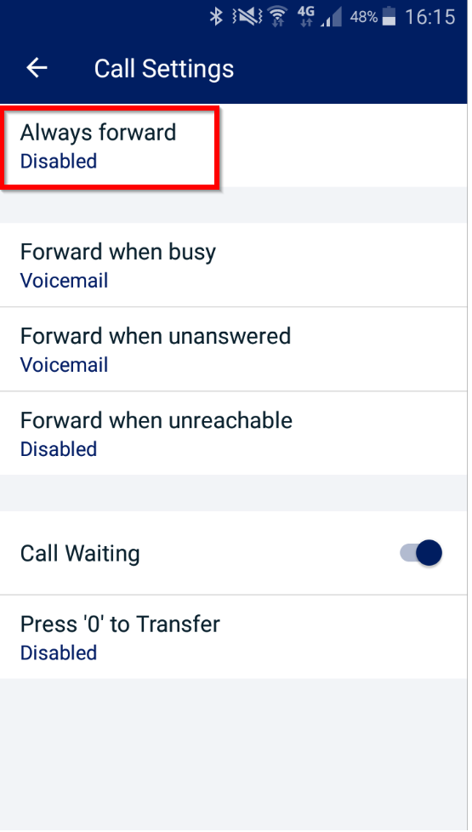
Additionally, if the user enables Always forward in the MyConnect app, this will disable Call Forwarding Selective and this change will be reflected in the GUI.
For further known issues/behaviours please see the Horizon Known Behaviours Guide on the Gamma Academy.

Device Call Log Impacts
Every device has a call log (placed, received, missed). As this enhancement changes the calling/called party display this can in some instances alter these call logs. Please see effects on these logs for each enhanced service below

Call Barge

Polycom
The call log will never update to reflect the barger, and it will always show the original called or calling party.

Cisco
If the barger leaves the call before the call is terminated then the call log will never reflect the barger, and it will always show the original called or calling party.
If the call is terminated before the barger leaves the call then the call log will update to reflect the bargers name, however the number will always be the original called or calling party.

Soft clients / Integrator
The call log will never update to reflect the barger, and it will always show the original called or calling party.

Yealink
The call log will never update to reflect the barger, and it will always show the original called or calling party.

Call Park / Group Call Park

Polycom
The call log will never update to reflect the party retrieving the call, and it will always show the original called or calling party.

Cisco
The name will update in the logs to reflect the retriever however the number will always show the original called or calling party.

Soft clients / Integrator
The call log will never update to reflect the party retrieving the call, and it will always show the original called or calling party.

Yealink
The call log will never update to reflect the party retrieving the call, and it will always show the original called or calling party.

Call Pickup

Polycom
The name in the call logs will update to the user who picked up the call, however the CLI will be the initial number that was called by the device.

Cisco
The name in the call logs will update to the user who picked up the call, however the CLI will be the initial number that was called by the Cisco.

Soft clients / Integrator
The call log will never update to reflect the party picking up the call, and it will always show the original called party.

Yealink
The call log will never update to reflect the party picking up the call, and it will always show the original called party.

Call Transfer Attended

Polycom
Transferrer – The call log is not updated and always reflects the original calling or called party
Transferee - The call log is not updated and always reflects the original calling or called party
Transfer target – The call log is not updated and always reflects the transferrer.

Cisco
Transferrer – The call log will show 2 logs, one for the first inbound/outbound leg and the second log for the transferred call.
Transferee – The name in the call log will update to the transferred party, however the number will always remain as the original calling or called party. If there is no name available for the transfer target, then the name remains the same as the original calling or called party.
Transfer target - The call log is not updated and always reflects the transferrer.

Soft clients / Integrator
Transferrer – The call log is not updated and the soft client records them as 2 separate calls
Transferee - The call log is not updated and always reflects the original calling or called party
Transfer target – The call log is not updated and always reflects the transferrer.

Yealink
Transferrer – The call log is not updated and the soft client records them as 2 separate call
Transferee - The call log is not updated and always reflects the original calling or called party
Transfer target – If the call is transferred before answer then the call log reflects the transferee, if it is transferred after answer then the log reflects that of the transferrer.

Blind Transfers
Only the transferee receives a display update with this change on blind transfers so only this scenario is described below.

Polycom
Transferee - The call log is not updated and always reflects the original calling or called party

Cisco
Transferee - The name in the call log will update to the transferred party, however the number will always remain as the original calling or called party. If there is no name available for the transfer target, then the name remains the same as the original calling or called party.
*Please note the Cisco MPP series does introduce blind call transfers

Soft clients / Integrator
Transferee - The call log is not updated and always reflects the original calling or called party

Yealink
Transferee - The call log is not updated and always reflects the original calling or called party

Call Forwarding – No Answer / Busy / Unreachable / Always

Polycom
It displays the original number dialled as well as the forwarded number. The forwarded number is recorded as the ‘name’ and the original dialled number is recorded as the ‘number’. Hitting redial will always dial the initial dialled number.

Cisco
It displays the original number dialled as well as the forwarded number. The forwarded number is recorded as the ‘name’ and the original dialled number is recorded as the ‘number’. Hitting redial will always dial the initial dialled number. If the forwarded number is an external number, then the call logs will just show the initial dialled number.

Soft clients / Integrator
The call logs always reflect the original dialled number.

Yealink
The call logs always reflect the original dialled number.

Sequential Ring

Polycom
It displays the original number dialled as well as the sequential ring number that answered the call. The sequential ring number is recorded as the ‘name’ and the original dialled number is recorded as the ‘number’. Hitting redial will always dial the initial dialled number.

Cisco
If the sequential ring party that picks up the call is on the same company, then it displays the original number dialled as well as the name of the sequential ring party that answered the call. The sequential ring name is recorded as the ‘name’ and the original dialled number is recorded as the ‘number’. Hitting redial will always dial the initial dialled number.
If the sequential ring party is an external number, then it displays the name and number of the original dialled party.

Soft clients / Integrator
The call log always reflects the original dialled party.

Yealink
The call log always reflects the original dialled party.

Call Waiting
Call Waiting allows a user to receive multiple calls at the same time. If you are on a call and you receive another call, it will display on your screen, and you'll also hear a beeping noise in the receiver. You can receive up to 3 external calls.
If you switch off Call Waiting and a call comes though whilst you're already on another call, then the new caller will get a busy tone.
Call Waiting is applicable to the individual user of a hunt group for calls made directly to their extension number. Therefore, clicking on Call Waiting will allow a call made to the user directly to be kept on hold until the user becomes free. Not selecting this option would be an engaged tone returned where the user is receiving or answered a call in the Hunt Group.

Shortcodes
Call Waiting persistent activation - *43
Call Waiting persistent deactivation - #43
Cancel Call Waiting - *70

Enable / Disable Call Waiting for a User
Step 1
Log into the Gamma Portal and go to Provisioning and Service Management, Hosted, Horizon and Horizon Manage Company.
Step 2
Select your account and login to the company that you want by using the "Actions" button select "Login to Horizon".
Step 3
Click the "Users" option and then select "List Users" so you can search for the user that you want Call Transfer set up for.
Locate the user and click the "Edit" button.
Step 4
In the User Management page click "Call Setup" and then under the In Call Options header select "Settings". From here you can enable / disable call waiting.
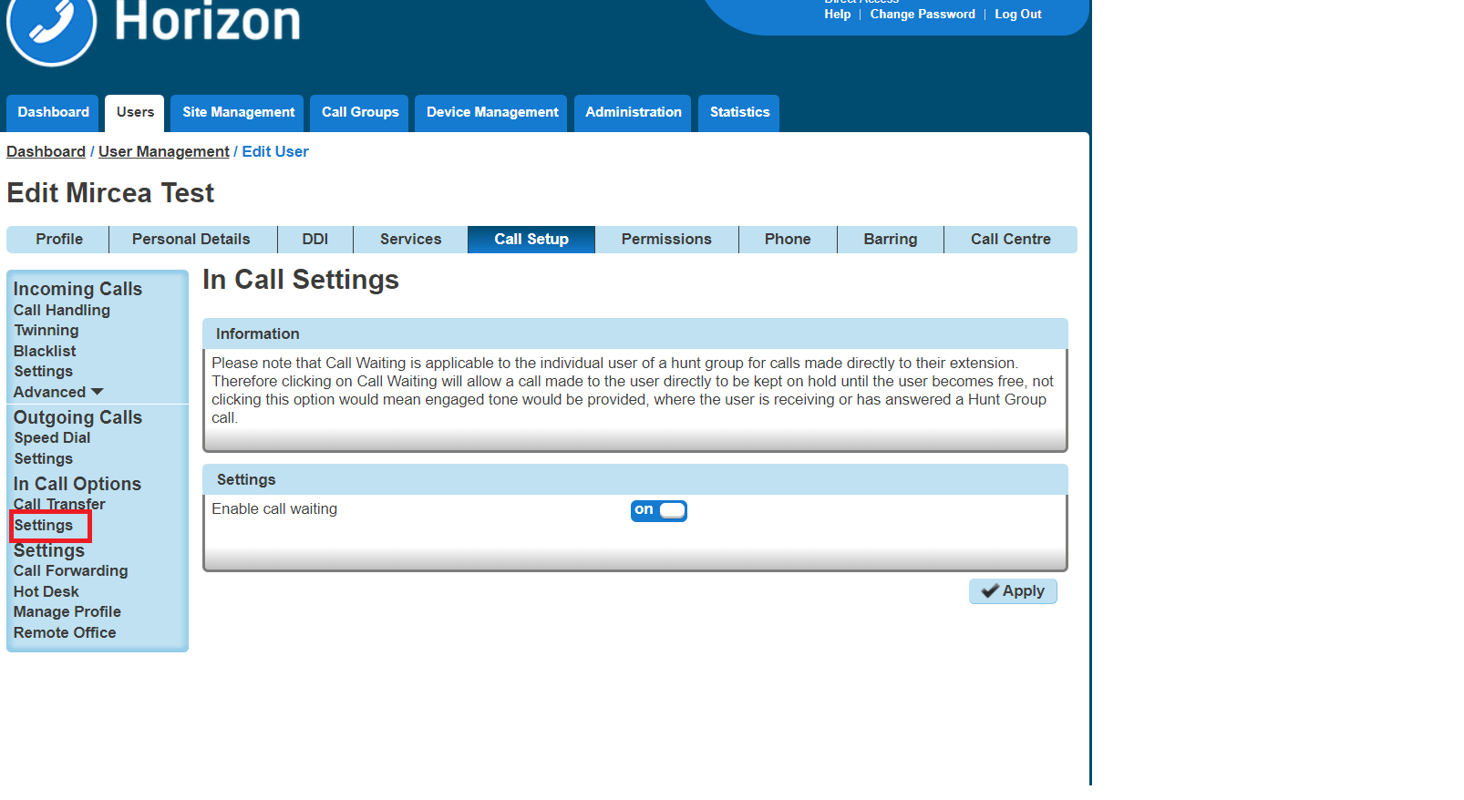

Enable / Disable Call Waiting for a Hunt Group
Step 1
Log into the Gamma Portal and go to Provisioning and Service Management, Hosted, Horizon and Horizon Manage Company.
Step 2
Select your account and login to the company that you want by using the "Actions" button select "Login to Horizon".
Step 3
Click the "Call Groups" option and then select "Hunt Groups" so you can search for the Hunt Group that you want Call Waiting set up for.
Locate the Hunt Group and click the "Edit" button.

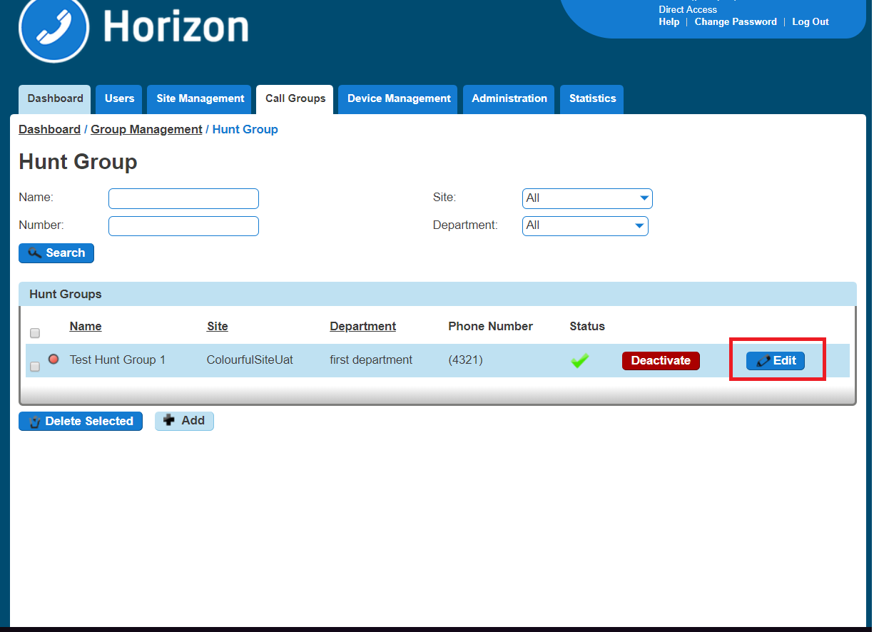
Step 4
In the Edit Hunt Group page click "Options". From here you can enable / disable call waiting.
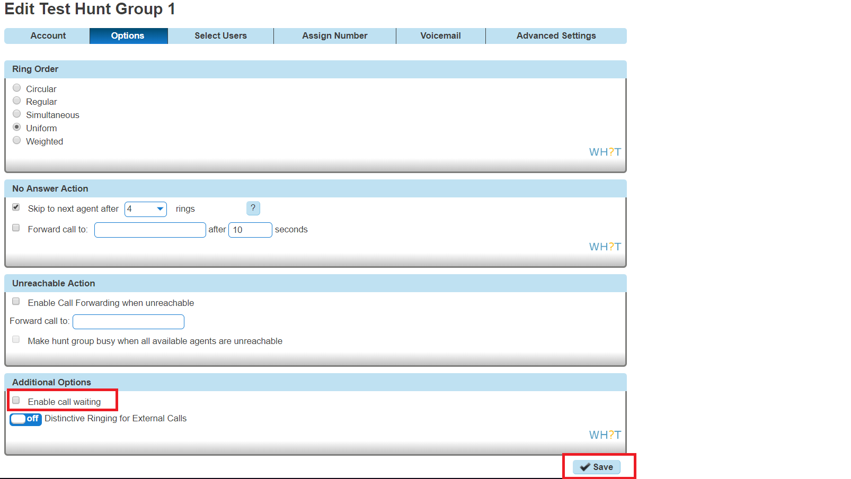

Enable / Disable Call Waiting for a Call Queue Group
Step 1
Log into the Gamma Portal and go to Provisioning and Service Management, Hosted, Horizon and Horizon Manage Company.
Step 2
Select your account and login to the company that you want by using the "Actions" button select "Login to Horizon".
Step 3
Click the "Call Groups" option and then select "Call Queue Groups" so you can search for the Call Queue Group that you want Call Recording set up for.
Locate the Call Queue Group and click the "Edit" button.

Step 4
In the Edit Call Queue Group page click "Options".
Within the Options page you can activate / deactivate the "Allow Call Waiting on users"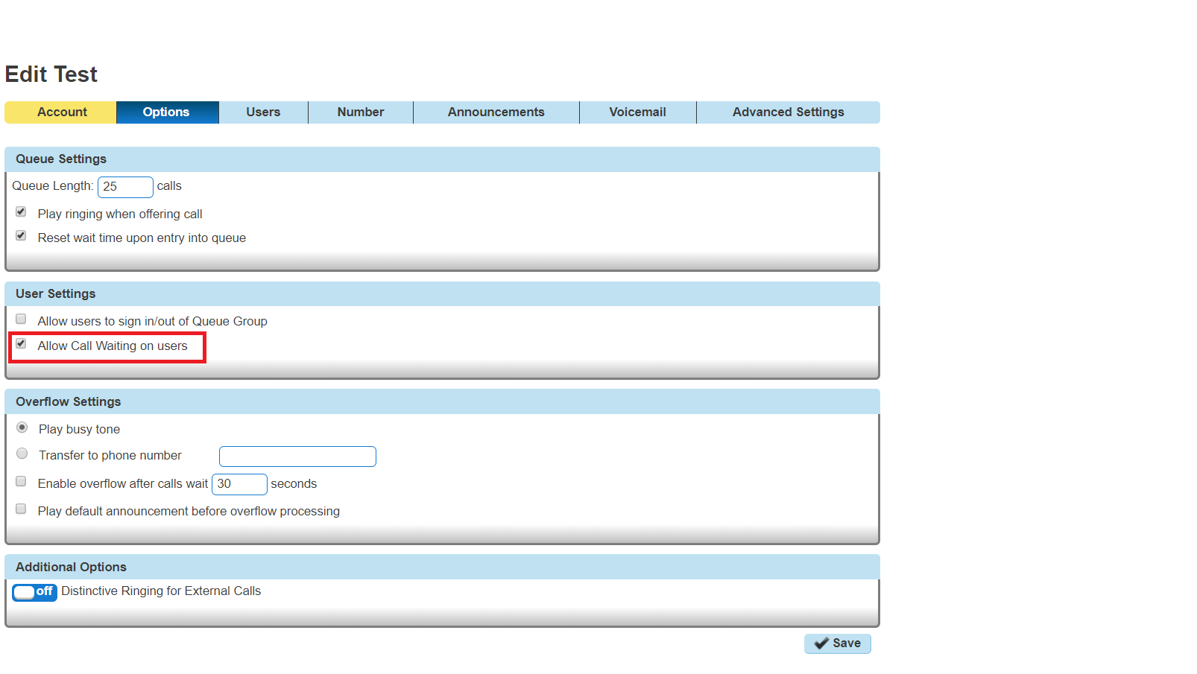

Click to Dial
Click to Dial enables a user to use the Horizon Portal to call someone within the Horizon directory. To do this, the user just clicks on the telephone icon that is next to the user.

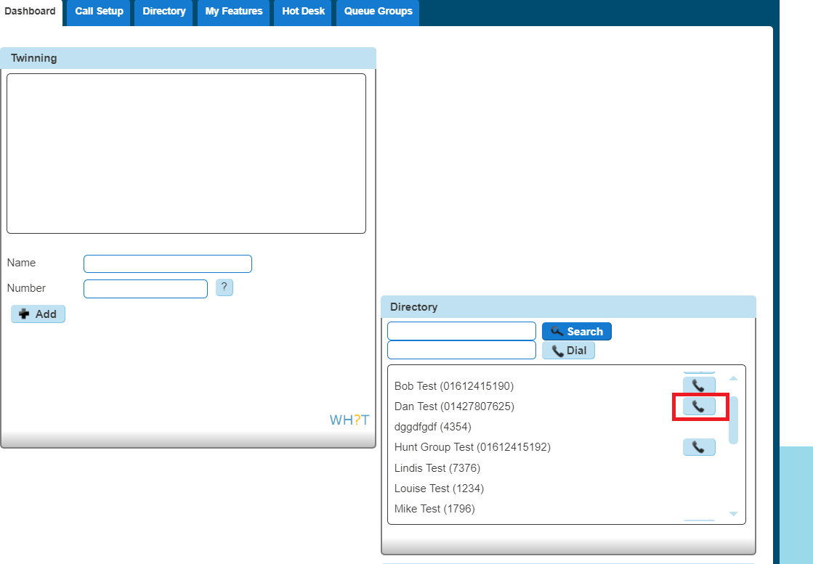
If you want to use Click-to-Dial outside of the Horizon Portal that you would need to look at using Integrator. Please see the Integrator guides on the Knowledgebase.

Site to site presentation policy
We will be introducing the option to present a user's extension details when a site to site call is made within the same Company, currently the users full DDI is presented. By default, from the 14th February 2018 onwards, all new companies will be provisioned to present the user's extension details on a site to site call within a company.
To enable or disable the service, head to the Administration tab of the Horizon GUI and select Call Policies from the drop-down menu.
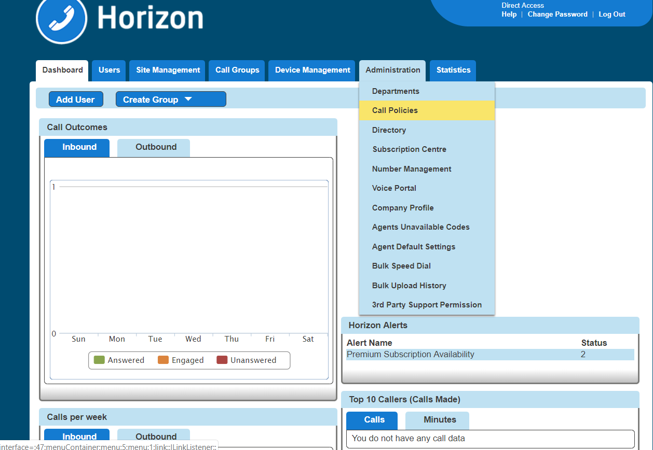
In the Call Policies page simply toggle the "Display Extension Number for all Company calls" toggle switch to on to enable or off to disable.
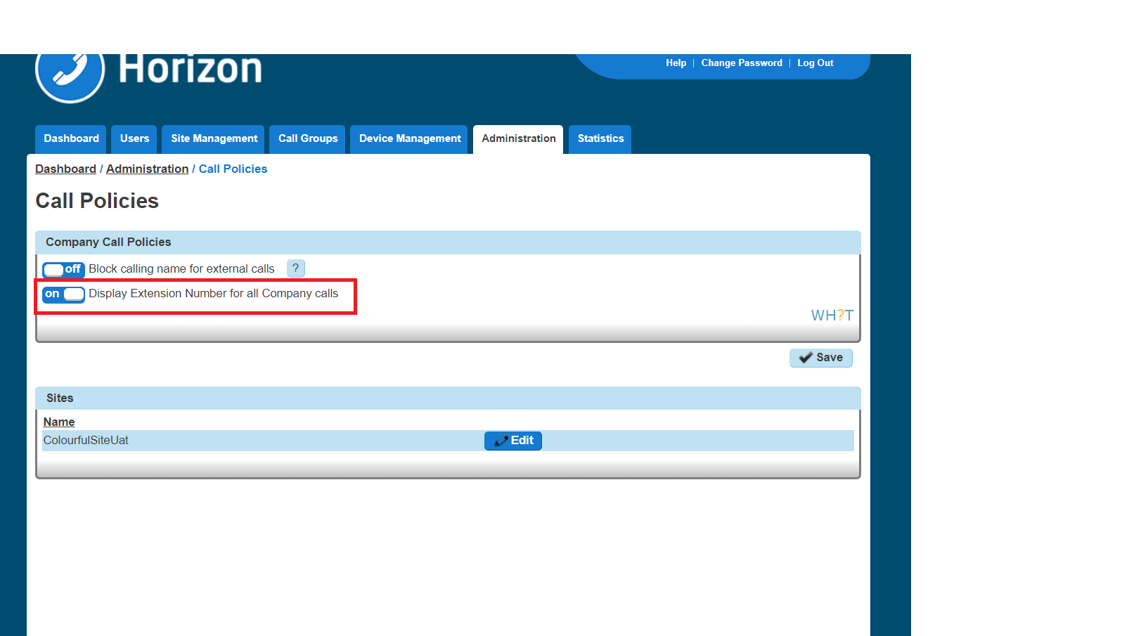
The setting is also available at the site level and is only applied to the caller.
In the use case where a company has three sites A, B and C, if site A has it enabled, users on any other site will see the extension number when called by any user of site A.
If site C has it disabled and site A and B has it enabled then a site C user calling a site A or B user will present their full DDI
When the option is set to off a site to site call will display the users full DDI number as per the following image.
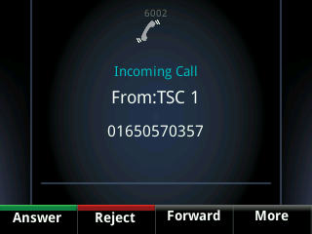
When the option is set to on that same call will present the extension number is as per the below image.
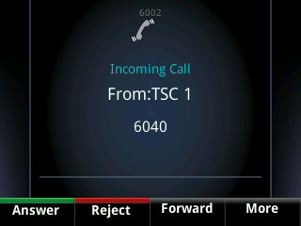

CLI Presentation
The Number Presentation functionality allows you to present a different CLI for outbound calls. You should refer to the Service Description for full terms and conditions of CLI Presentation.
For a user to be able to use CLI Presentation, the Administrator needs to switch on the "Override Site Call Policy" option. Use the Override Site Call Policy guide on how to do this.
You can quickly check what CLI Presentation rules a user has set up by using the Horizon Health Check

Override Site Call Policy
The Site Call Policy would normally dictate on what numbers are presented. Horizon allows a user to present a different number to what the site defines.
An Administrator can set up the Override Site Call Policy option.
Step 1
Log into the Gamma Portal and go to Provisioning and Service Management, Hosted, Horizon and Horizon Manage Company.
Step 2
Select your account and login to the company that you want by using the "Actions" button select "Login to Horizon".
Step 3
Click the "Users" option and then select "List Users" so you can search for the user that you want to override the site call policy for.
Locate the user and click the "Edit" button.
Step 4
Select "DDI" and then you can select the "Override Site Call Policy" option.
The Administrator can also set the CLI to present whilst in this screen by entering the telephone number that they would like to present in the "Phone Number" text box in the Number Presentation table.

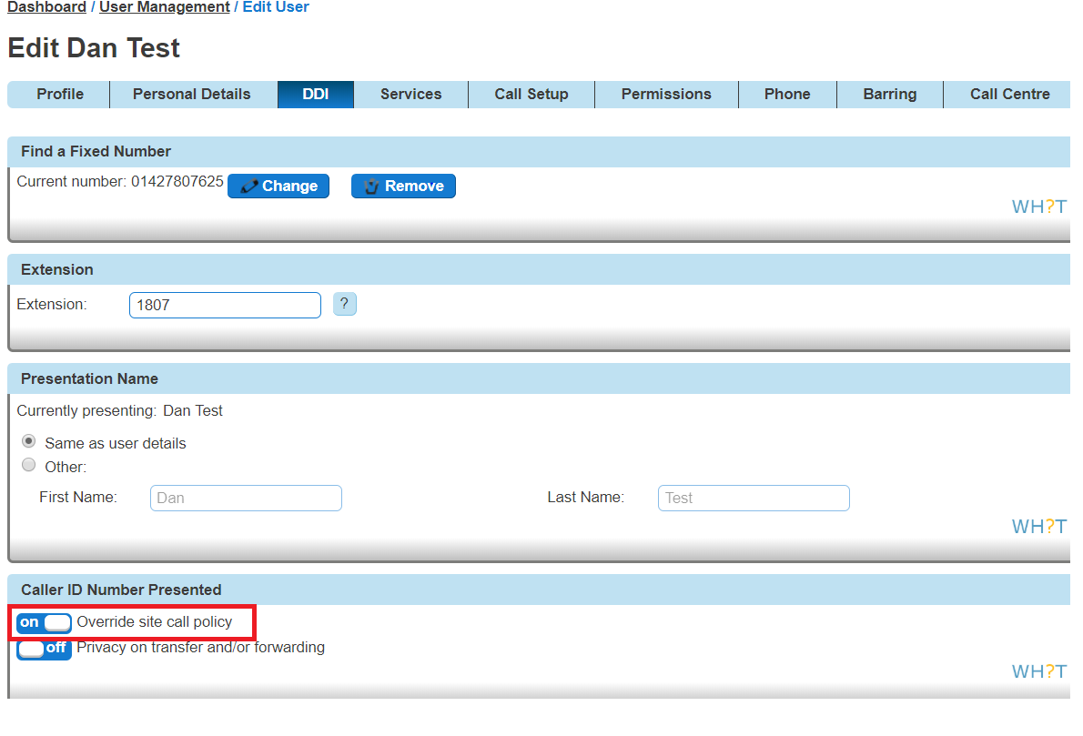

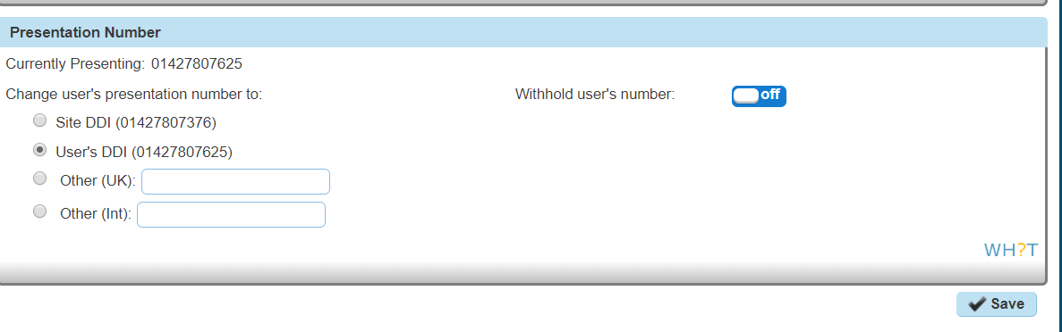

Comfort Messages
Horizon allows you to upload up to 4 different files and has a "Time between Messages" option. This has been set up so that larger files can play the four files in order, break for (in this case) 10 seconds and then play all for files at once. It isn't set up in a way where you can play four differing files (music, announcements) with a 10 second split between files.

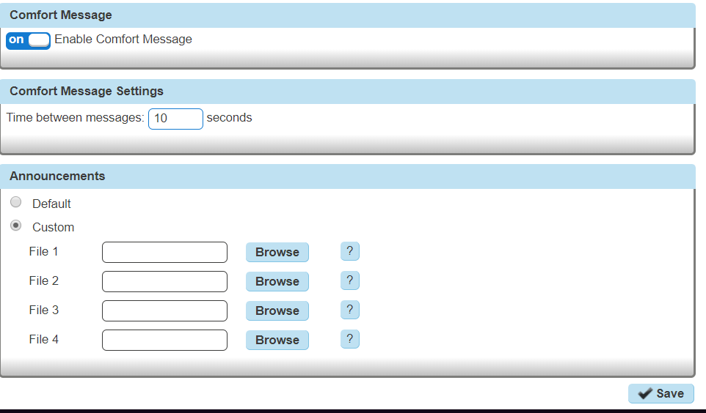

Departments
As the company administrator you have the ability under the “Administrator” tab to add and manage departments, so that users and services can be associated to them.

Setup Departments
Step 1
Log into the Gamma Portal and go to Provisioning and Service Management, Hosted, Horizon and Horizon Manage Company.
Step 2
Select your account and login to the company that you want by using the "Actions" button select "Login to Horizon".
Step 3
Click the "Administration" option and then select "Departments". Enter the name of a department and click "Add"
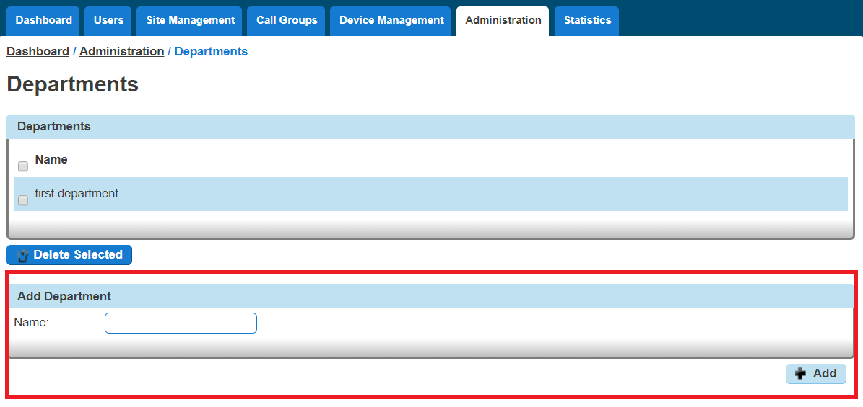

Delete Departments
Step 1
Log into the Gamma Portal and go to Provisioning and Service Management, Hosted, Horizon and Horizon Manage Company.

Step 2
Select your account and login to the company that you want by using the "Actions" button select "Login to Horizon".
Step 3
Click the "Administration" option and then select "Departments".
Select the Department that you are wishing to delete by using the tick-box next to it and then click "Delete Selected".
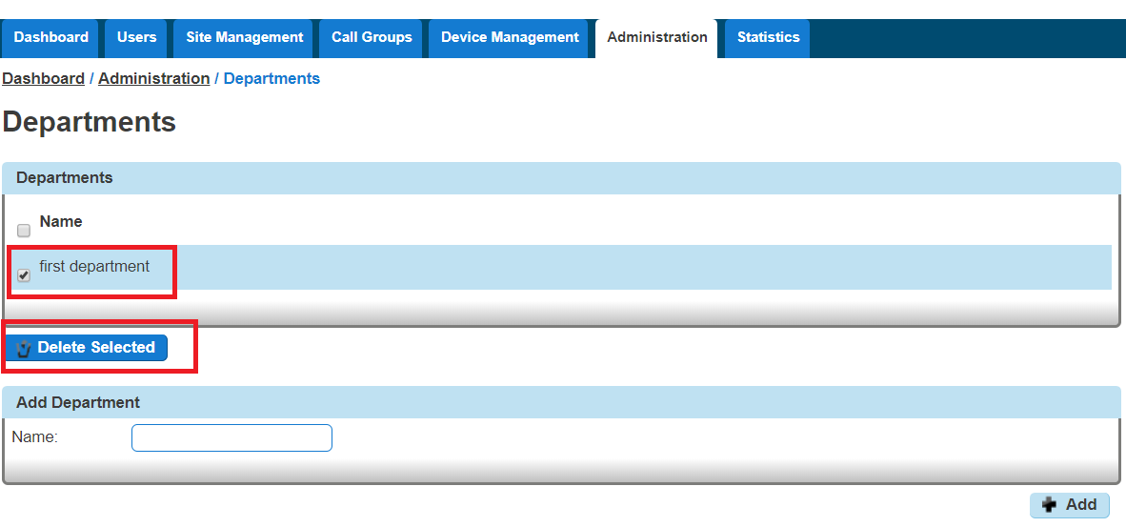

Add/Remove users from Departments
Step 1
Log into the Gamma Portal and go to Provisioning and Service Management, Hosted, Horizon and Horizon Manage Company.
Step 2
Select your account and login to the company that you want by using the "Actions" button select "Login to Horizon".
Step 3
Click the "Users" option and then select "List Users" so you can search for the user that you want add/remove the department for.
Locate the user and click the "Edit" button.
Step 4
On the "Profile" table you can select the Department of a user. If you wish for a user not to be assigned to a department then select the option "None". Click Save.
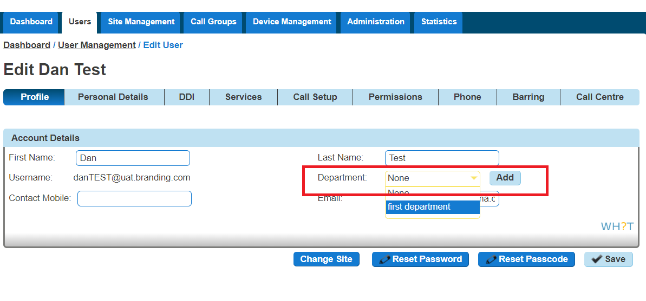

Device Customisation
Device Customisation allows you to set up the line keys and soft keys of your Horizon hardware. Device Customisation is available on the following handsets.
Cisco | Polycom
SPA504G | SoundPoint 450
SPA525G | VVX250
MPP 8841 | VVX410
MPP 8851 | VVX450
MPP 8861 | VVX500
 | VVX600

*Please note the VVX150, Trio 8500 and 8800's do not support Device Customisation.
The options you have with Device Customisation are:
Option | Meaning
Speed Dial | A key that quickly dials a number. This could be a number that is on the Horizon company or a different number
Busy Lamp Field | Sets up a Busy Lamp Field key so you can monitor a user's line
Call Park | Allows you to park a call against your own extension or to another defined extension
Call Retrieve | Allows you to retrieve a parked call from either your own extension or another defined extension
Group Call Park | Allows you to park a call again the call park group that you are in. Other users within the group will be able to pick up a call parked by using Group Call Pickup
Call Pickup | Allows you to pick up a call that has been parked against this extension or another defined extension
Group Call Pickup | Allows you to pick up a call that has been parked in the Call Park Group that you are in.
Page Group | This allows you to call the Page Group that the user is a member of. The user must be a Page Group sender.
Call Pull | This feature gives the opportunity to the user to retrieve a call that has been answered from a desktop client.
Empty | This will leave aa empty line key.
Last Call Redial | This will allow you will be able to redial they last call you have made.
Call Return | This will allow you to call the last received or missed call.
Voicemail | This will allow you to dial out to your voice portal using the mailbox number and voice pin you supply

If your user is using the Receptionist Console, Speed Dials set up within Device Customisation won't show in the Receptionist Console.

Give a user access to set up Device Customisation
A company Administrator can give a user permission to do their own device customisation.
Step 1
Log into the Gamma Portal and go to Provisioning and Service Management, Hosted, Horizon and Horizon Manage Company.
Step 2
Select your account and login to the company that you want by using the "Actions" button select "Login to Horizon".
Step 3
Click the "Users" option and then select "List Users" so you can search for the user that you want give device customisation permissions to.
Locate the user and click the "Edit" button.
Step 4
Click the "Permissions" tab and enable "This User can customise their soft keys" and "This User can customise their line keys"

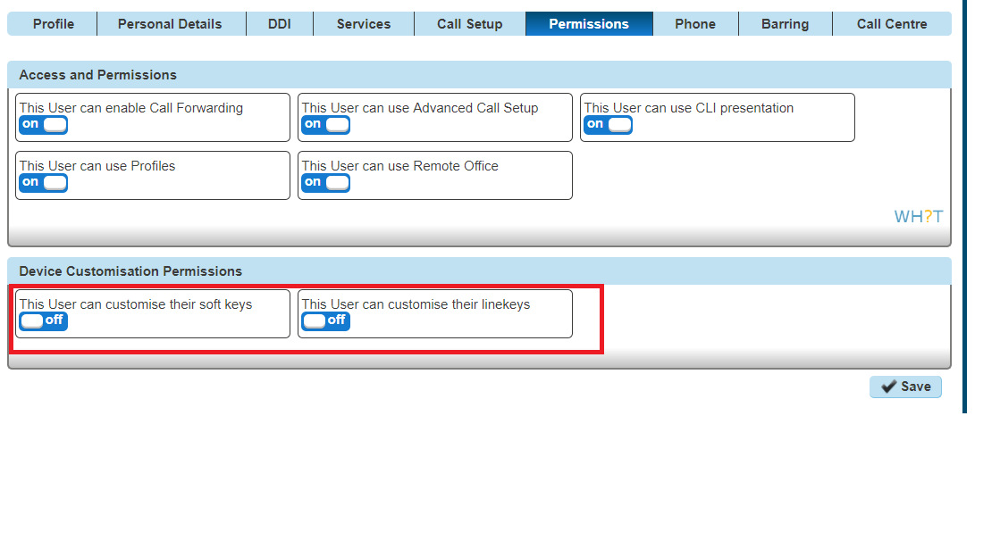

Device Customisation as a Company Admin
Step 1
Log into the Gamma Portal and go to Provisioning and Service Management, Hosted, Horizon and Horizon Manage Company.
Step 2
Select your account and login to the company that you want by using the "Actions" button select "Login to Horizon".
Step 3
Click the "Users" option and then select "List Users" so you can search for the user that you want give device customisation permissions to.
Locate the user and click the "Edit" button.
Step 4
Click the "Phone" tab and then select "Device Configuration".
Now refer to the Configure My Device sections for Cisco, Polycom VVX or Polycom Soundpoint
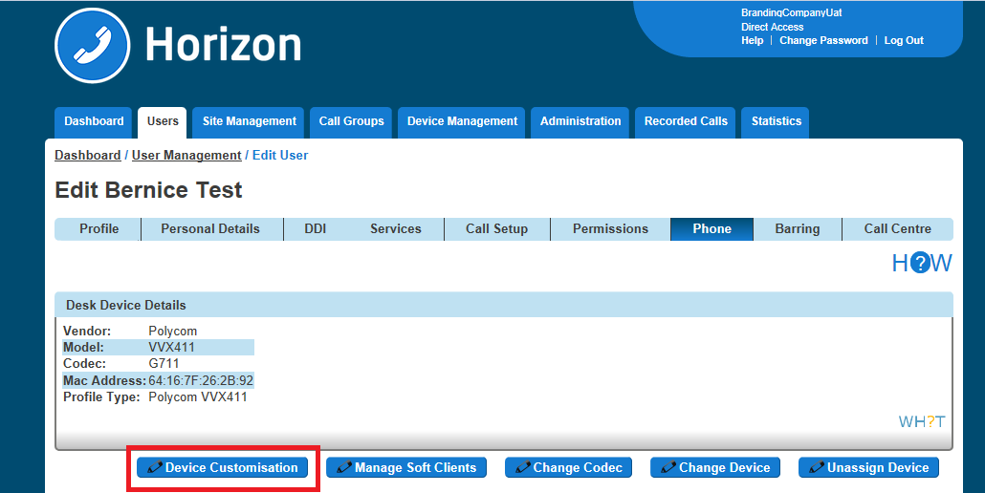

Configure my Cisco Device
For full user guides of Cisco devices, please see the Knowledgebase.

Assigning Soft Keys
Soft Keys are the buttons that go horizontal across your phone.
Step 1
When in the Device Customisation page for your Cisco device, select the "Soft Keys" option.
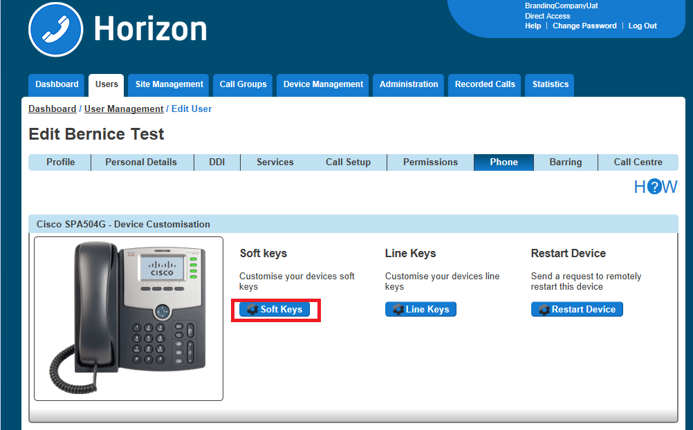

Step 2
Select a Soft Key that you want to configure

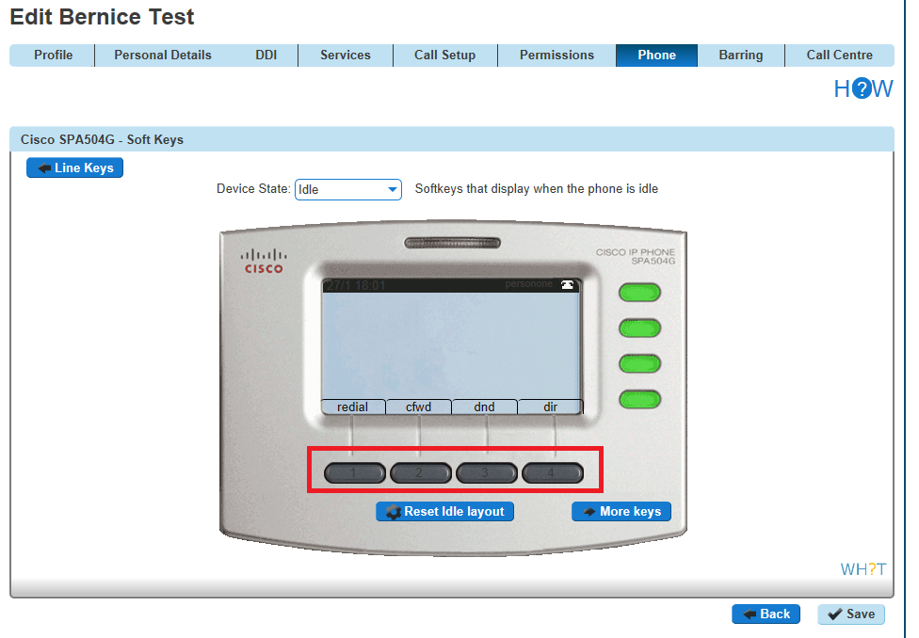 Remember to select the Device State that you want to configure (Idle or In Call).
If you have a Side Car set up and would like to configure the line keys on the Side Car, click "Side Car" to load up the buttons of the side car.
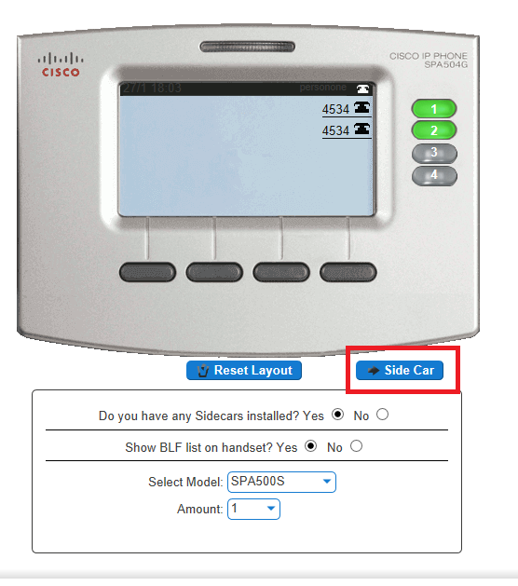
Step 3
Now select what you want that key to do. Please see the table in the Device Customisation section of this guide.
Clicking "Save" will restart the device(s) that you've configured to download the latest configuration file with your new handset setup.
Please note for newer Cisco models such as the MPP 8851 and MPP 8861 the device customisation screen is as follows:
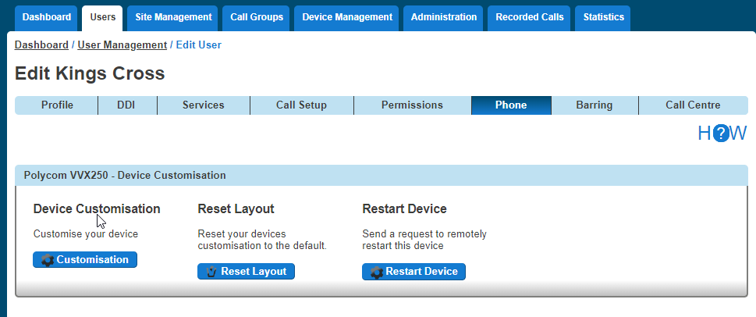

Step 2
Select a type of Soft Key that you want to configure , either “Idle” or “Connected”
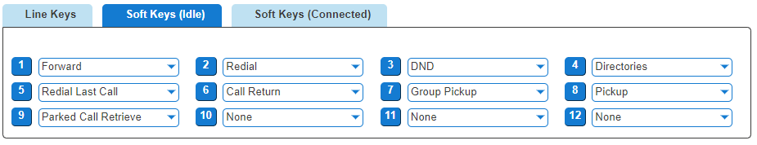
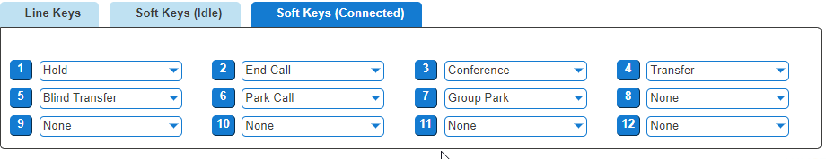

Assigning Line Keys
Line Keys are the buttons that go horizontal across your phone.
Step 1
When in the Device Customisation page for your Cisco device, select the "Line Keys" option.
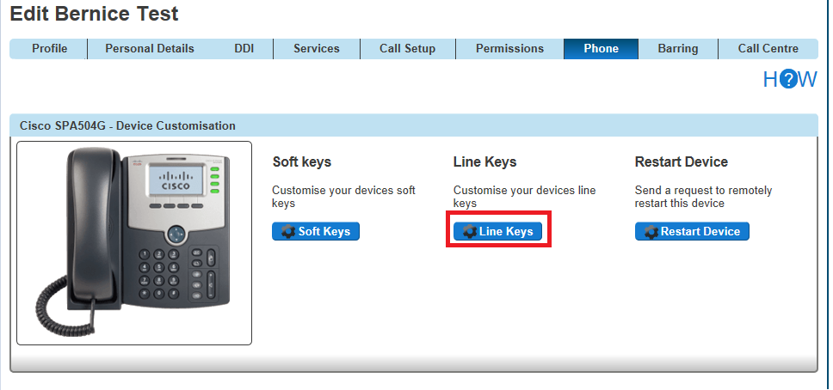
Step 2
Select a Line Key that you want to configure
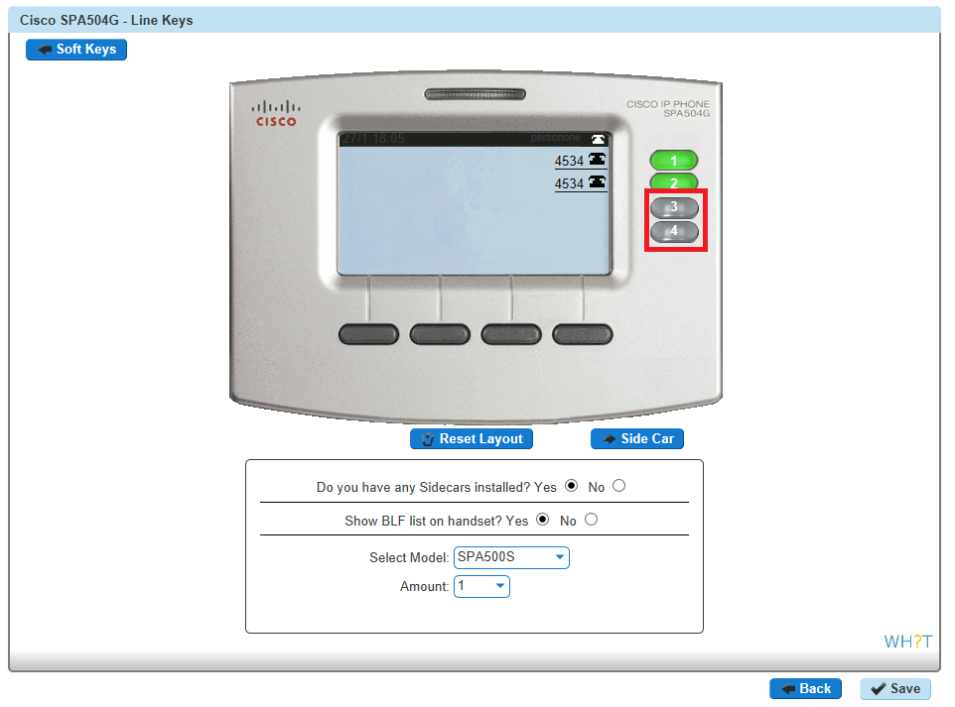
If you have a Side Car set up and would like to configure the line keys on the Side Car, click "Side Car" to load up the buttons of the side car.

Step 3
Now select what you want that key to do. Please see the table in the Device Customisation section of this guide.
Clicking "Save" will restart the device(s) that you've configured to download the latest configuration file with your new handset setup.
Please note for newer Cisco models such as the MPP 8851 and MPP 8861 the device customisation screen is as follows:
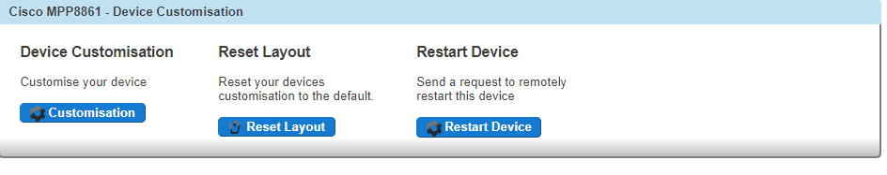
Step 1
When in the Device Customisation page for your Cisco device, select the "Line Keys" option.
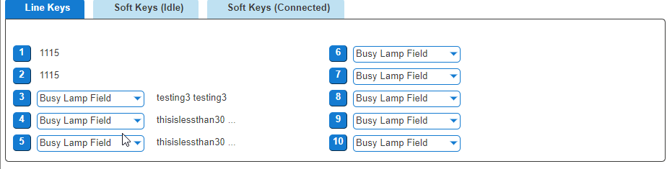
Step 2
Select a Line Key that you want to configure

For full user guides of Polycom VVX devices, please see the Knowledgebase.

Configure my Polycom VVX Device
For full user guides of Polycom VVX devices, please see the Knowledgebase.

Assigning Soft Keys
Soft Keys are the buttons that go horizontal across your phone. This are pre-set and you cannot currently change these options.

Assigning Line Keys
Line Keys are the buttons that go horizontal across your phone.
Step 1
When in the Device Customisation page for your Polycom VVX device, select the "Line Keys" option.
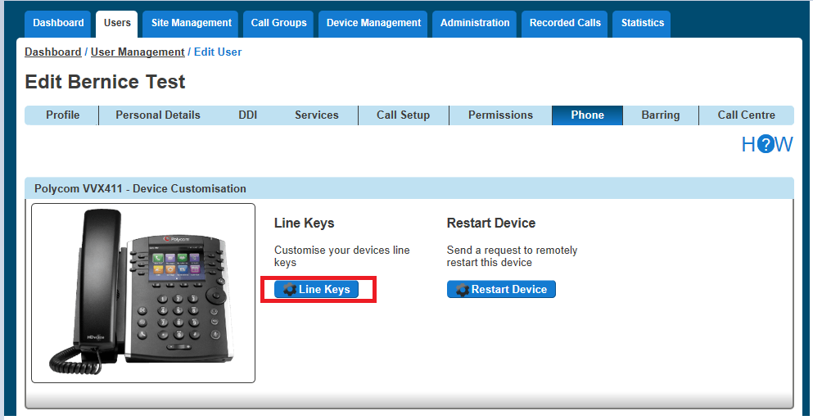
Please note for newer Polycom models such as the VVX250 and VVX450 the device customisation screen is as follows:

Step 2
Select a Line Key that you want to configure
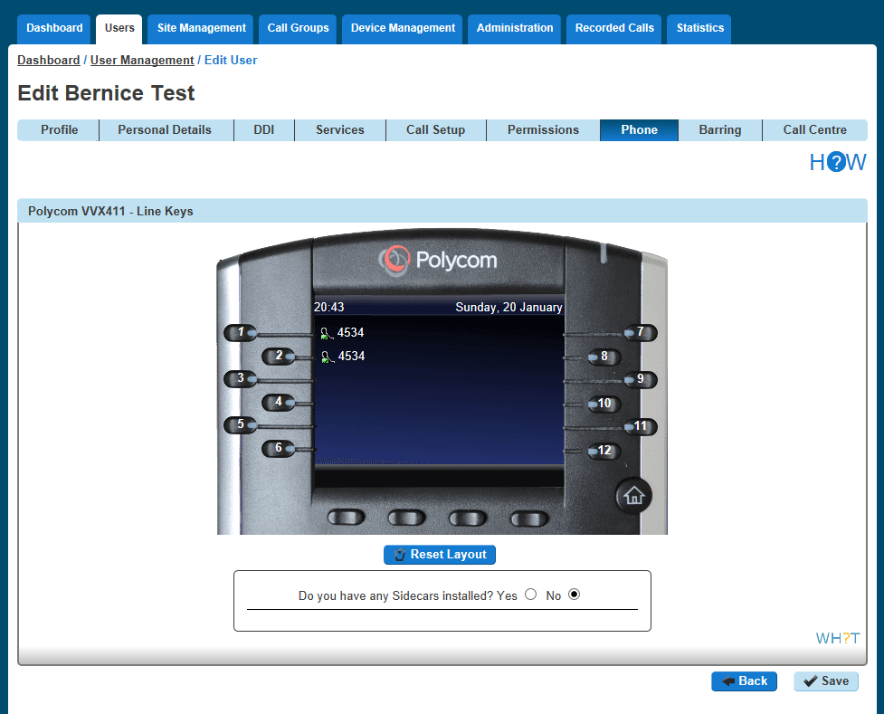
Please note for newer Polycom models such as the VVX250 and VVX450 the device customisation screen is as follows:
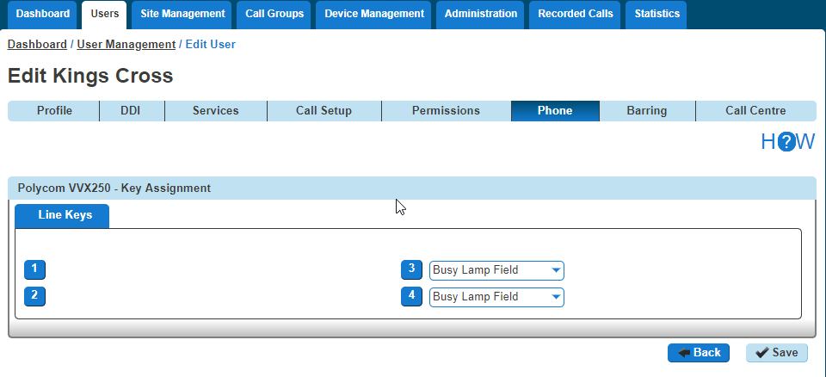
Step 3
Now select what you want that particular key to do. Please see the table in the Device Customisation section of this guide.
Clicking "Save" will restart the device(s) that you've configured to download the latest configuration file with your new handset setup.
If you have a Side Car set up and would like to configure the line keys on the Side Car, click "Side Car" to load up the buttons of the side car.
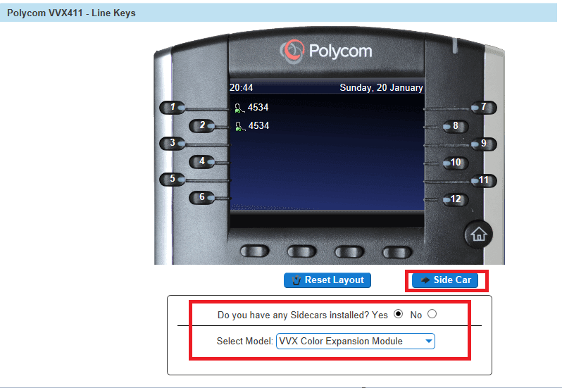

Configure my Polycom SoundPoint Device
For full user guides of Polycom SoundPoint devices, please see the Knowledgebase.

Assigning Soft Keys
Soft Keys are the buttons that go horizontal across your phone.
Step 1
When in the Device Customisation page for your Polycom SoundPoint device, select the "Soft Keys" option.
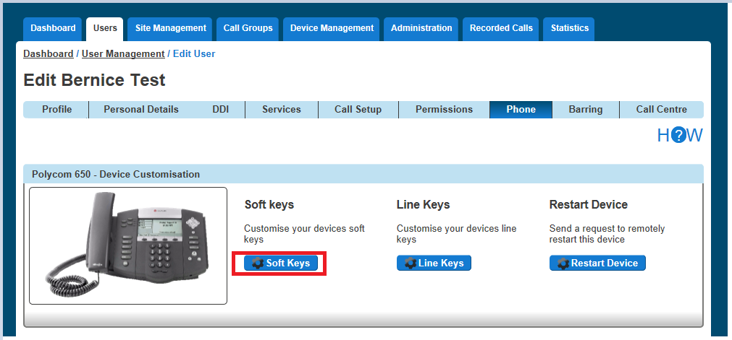
Step 2
Select a Soft Key that you want to configure

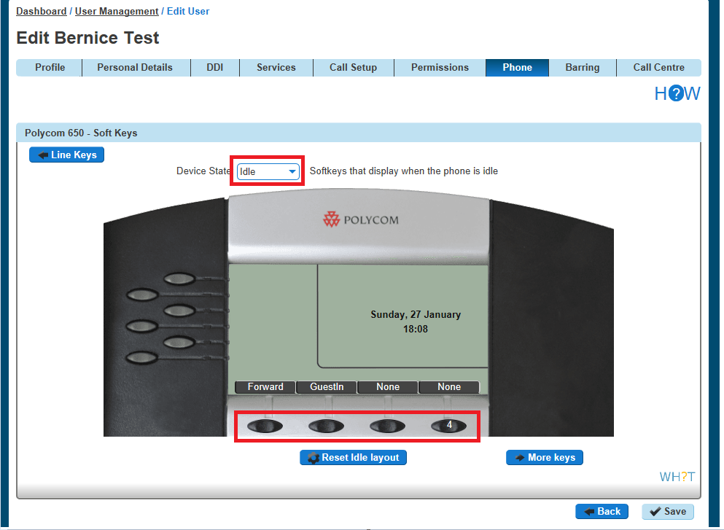
Remember to select the Device State that you want to configure (Idle or In Call).
If you have a Side Car set up and would like to configure the line keys on the Side Car, click "Side Car" to load up the buttons of the side car.
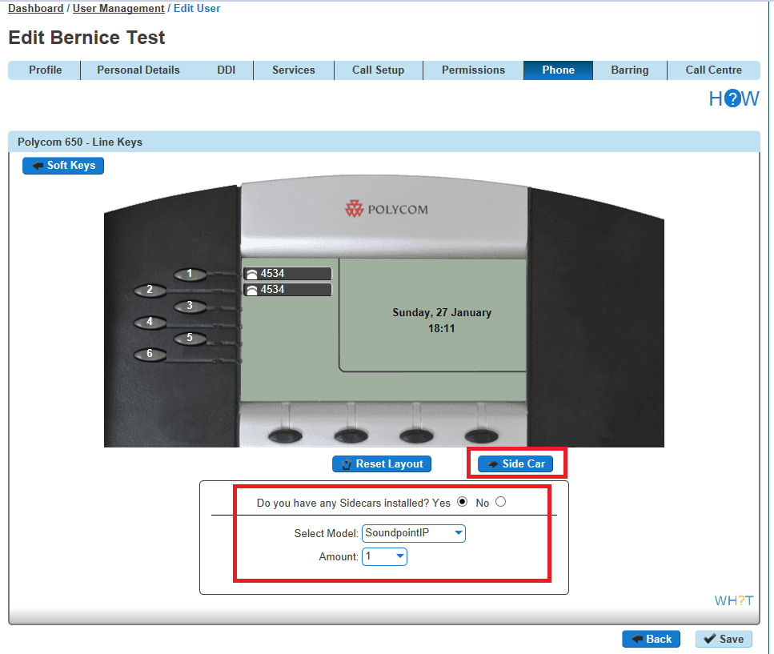

Step 3
Now select what you want that particular key to do. Please see the table in the Device Customisation section of this guide.
Clicking "Save" will restart the device(s) that you've configured to download the latest configuration file with your new handset setup.

Assigning Line Keys
Line Keys are the buttons that go horizontal across your phone.
Step 1
When in the Device Customisation page for your Polycom SoundPoint device, select the "Line Keys" option.
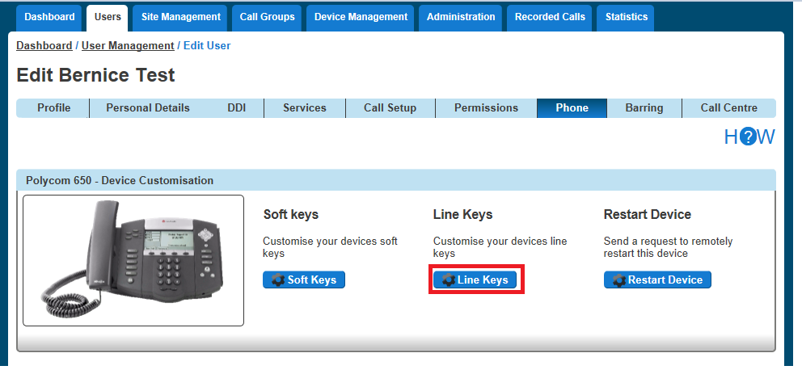
Step 2
Select a Line Key that you want to configure
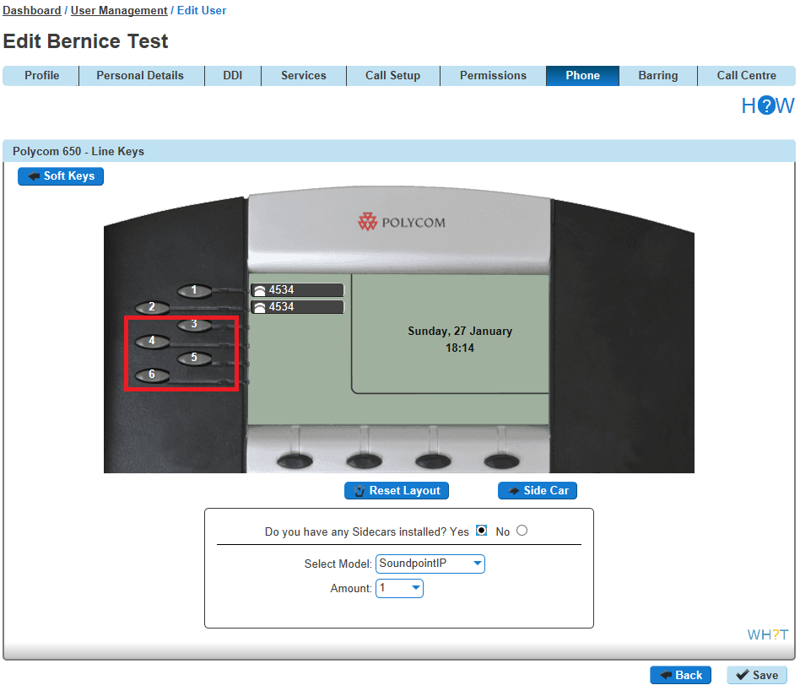
If you have a Side Car set up and would like to configure the line keys on the Side Car, click "Side Car" to load up the buttons of the side car.

Step 3
Now select what you want that particular key to do. Please see the table in the Device Customisation section of this guide.
Clicking "Save" will restart the device(s) that you've configured to download the latest configuration file with your new handset setup.

Directory
Horizon provides two types of directory, one that is updated by the company administrator and one by end users. The below table explains the differences, who is responsible for updating/maintaining and which users' device the directory additions will be available from.

Directory Type | Who Updates | Overview | Available To
Company Directory | Company Administrator | The Company Directory is a list of all the users within the Horizon Company.  You can also add contacts that are not part of the Horizon Company to appear in the Company Directory | All users within a Company
User Directory | Horizon User | The user directory allows the user to add contacts unique to them | Individual User only

Add New User to Company Directory
To add a new user to the Company Directory you just need to add a new user to the Horizon Company. For full information on this please see the Horizon Provisioning and In Life Changes Guide on the Knowledgebase.

Add/Remove External Contact(s) to the Company Directory
Step 1
Log into the Gamma Portal and go to Provisioning and Service Management, Hosted, Horizon and Horizon Manage Company.
Step 2
Select your account and login to the company that you want by using the "Actions" button select "Login to Horizon".

Step 3
Click the "Administration" option and then select "Directory".
Within the Company Directory you can add a new contact by clicking "Add" and go to Step 4 of this guide.
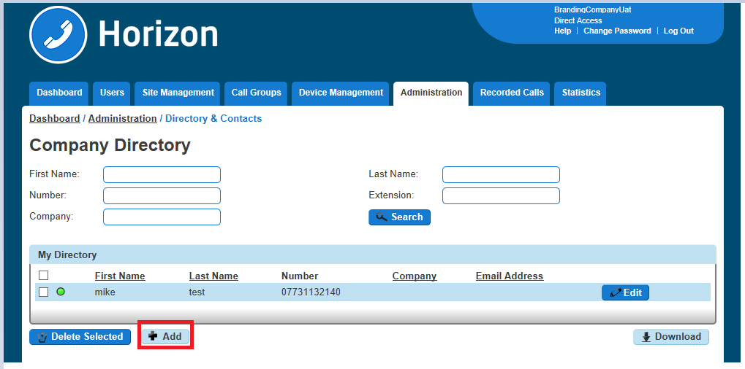
If you are wanting to delete contact(s) then select the contacts that you wish to delete and click the "Delete Selected" button. Confirm that you want to delete these items from the directory.
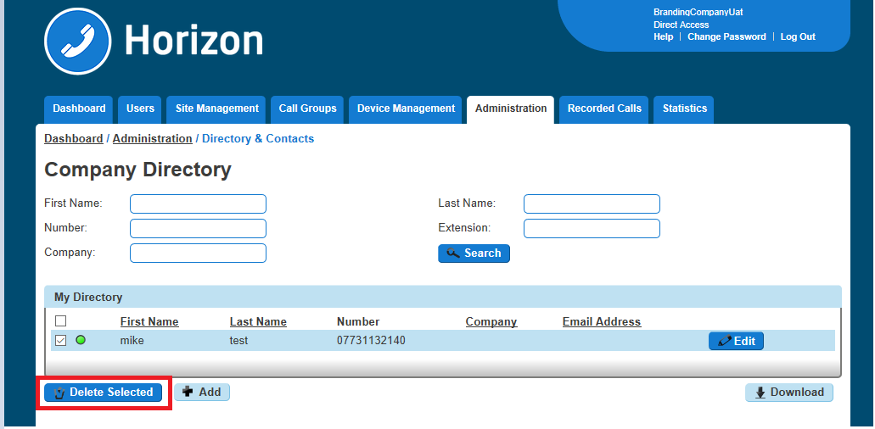
Step 4
Enter the details of the contact you want to appear in the directory. Remember that you don't need to add users of the Horizon Company in here as they should automatically appear in the Company Directory during the Add New User to Company Directory guide.
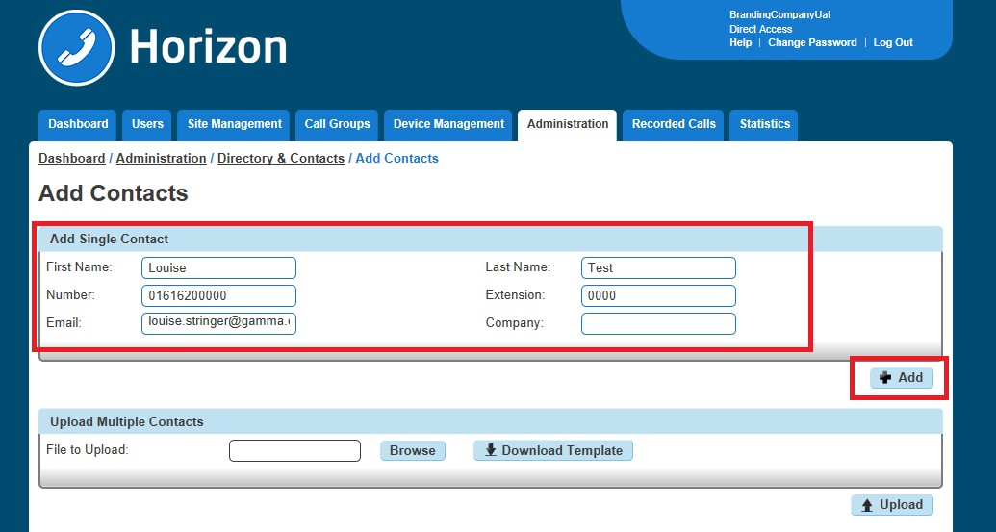

Add Multiple External Contacts to the Company Directory
Step 1
Log into the Gamma Portal and go to Provisioning and Service Management, Hosted, Horizon and Horizon Manage Company.
Step 2
Select your account and login to the company that you want by using the "Actions" button select "Login to Horizon".
Step 3
Click the "Administration" option and then select "Directory".
Within the Company Directory you should click "Add" and then "Download Template"
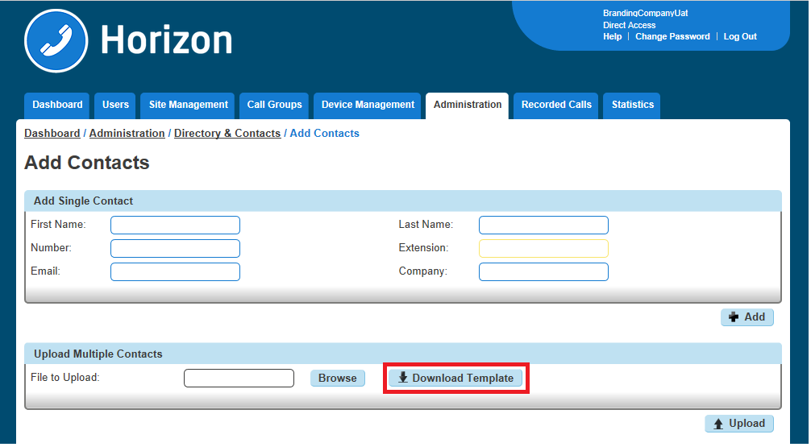
Step 4
This will download a CSV file with a couple of examples for you to follow. Delete the examples and enter the following details:

First Name (maximum 15 characters, no spaces)
Last Name (maximum 15 characters, no spaces)
Telephone Number (format of the cell should be "Text", number should have a leading "0")
Extension Number (match the extension number length that your Horizon Company has set up)
Email Address
Company (maximum 15 characters)
Step 5
Save the file, remembering to keep it as a CSV file and then in the Horizon Portal click "Browse", locate the file and then click "Upload"
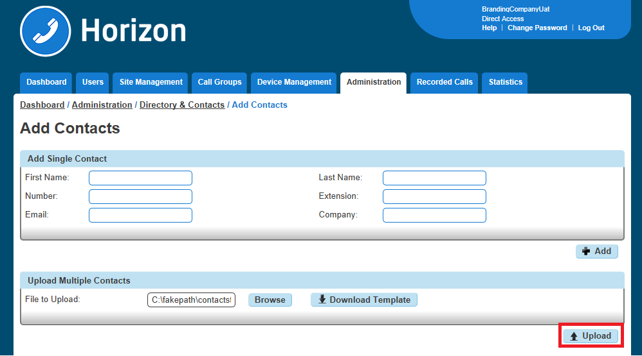
Step 6
Check the contacts in the "Confirm Contacts Upload" table and then click Confirm once you're happy with the results.
If you need to make a change you will need to enter these back in the CSV file and re-upload.
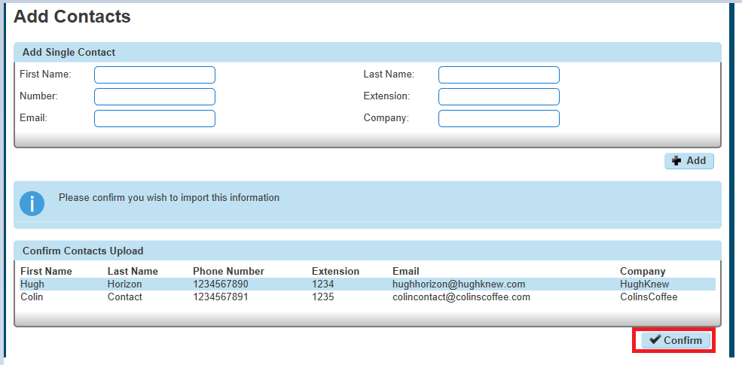

Add Single Contact to User Directory
Step 1
Log into the Horizon Portal and log in as a user.
Step 2
From the menu bar select 'Directory'.
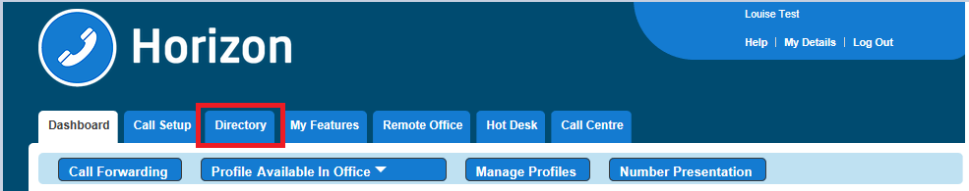
Step 3
Click on the blue '+ Add' button at the bottom.
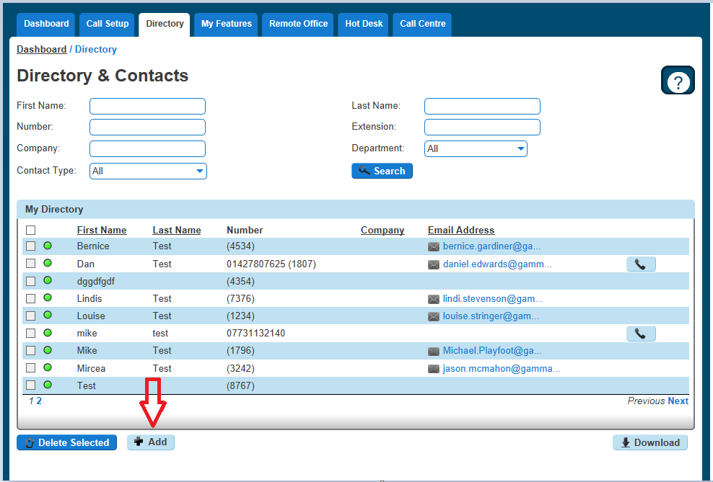

Step 4
Enter the contact details in the relevant fields and click the blue '+ Add' button at the bottom right
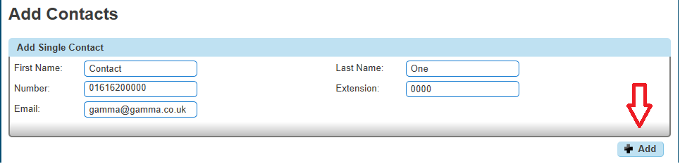
Step 5
You'll then see confirmation that the contact has been added. This will now appear in the users directory on the Horizon Portal.
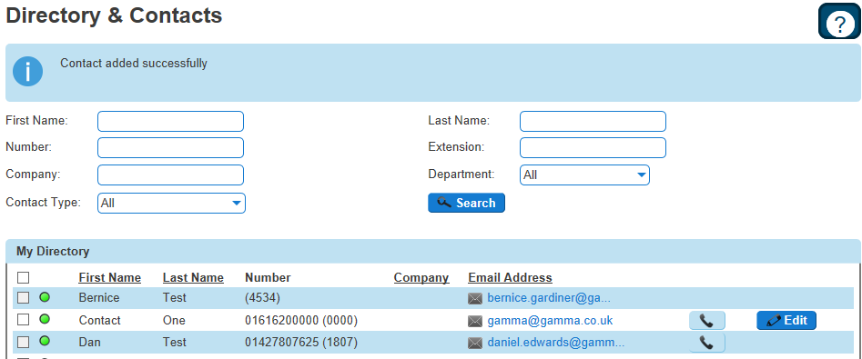

Add Multiple Contacts to User Directory
Step 1
Log into the Horizon Portal and log in as a user.
Step 2
From the menu bar select Directory.
Step 3
Click on the blue '+ Add' button at the bottom.
Step 4
Click on the blue 'Download Template' button within the 'Upload Multiple Contacts' section
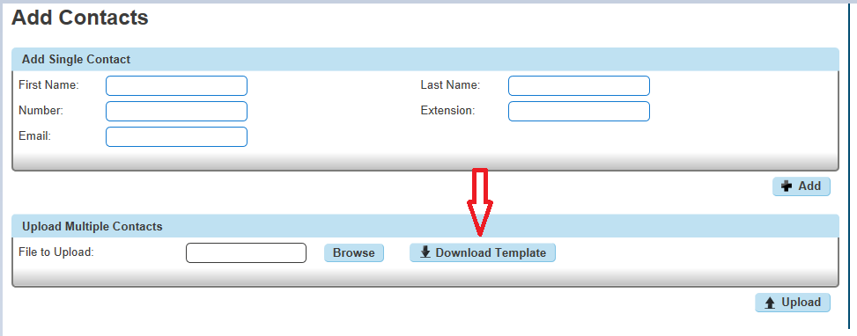
Step 5
Highlight the column with the telephone numbers and select 'format' - this should be changed to 'Text' which will allow the leading 0 to be retained when entered.
Note: The number in column C is what will be added to Horizon, if the 0 is missing then this is what will be uploaded.
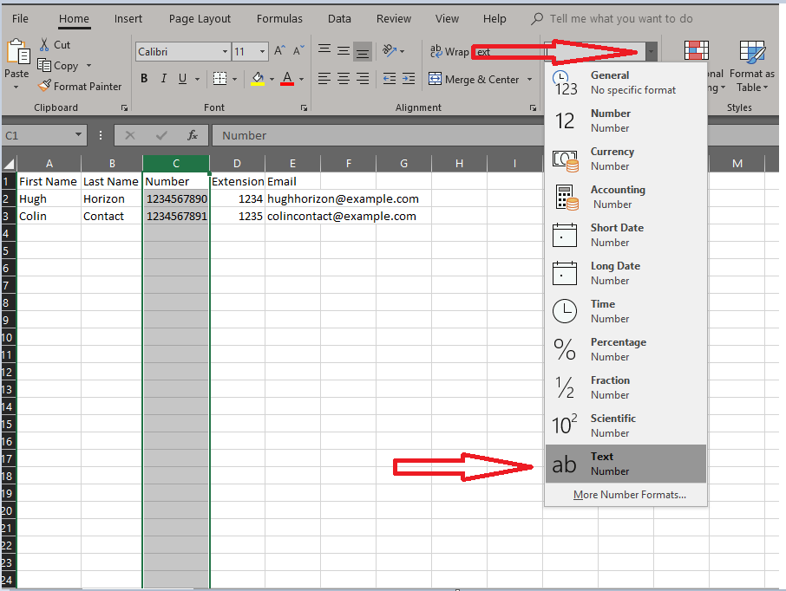

Delete Contact(s) from User Directory
Step 1
Log into the Horizon Portal and log in as a user.
Step 2
From the menu bar select Directory.
Step 3
Mark the contacts you'd like to delete with a tick and click 'Delete Selected'.
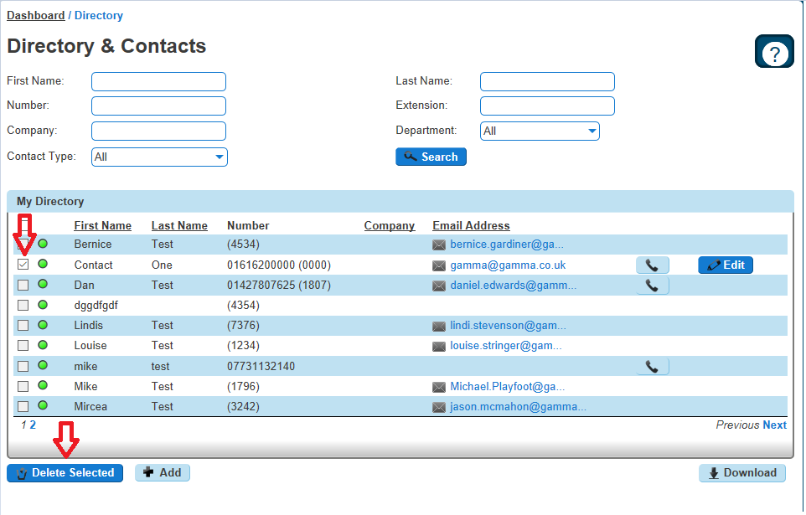

Distinctive Ringing for External Calls
Distinctive Ringing for External Calls gives the handset a different ringtone to calls that come from another Horizon user on the same Company

Setup Distinctive Ringing as a Company Administrator
Step 1
Log into the Gamma Portal and go to Provisioning and Service Management, Hosted, Horizon and Horizon Manage Company.
Step 2
Select your account and login to the company that you want by using the "Actions" button select "Login to Horizon".
Step 3
Click the "Users" option and then select "List Users" so you can search for the user that you want enable / disable do not disturb for.
Locate the user and click the "Edit" button.
Step 4
Click the "Call Setup" tab and then select "Settings" under Incoming Calls. From here you can set Distinctive Ring for External Calls to be on or off for the user.
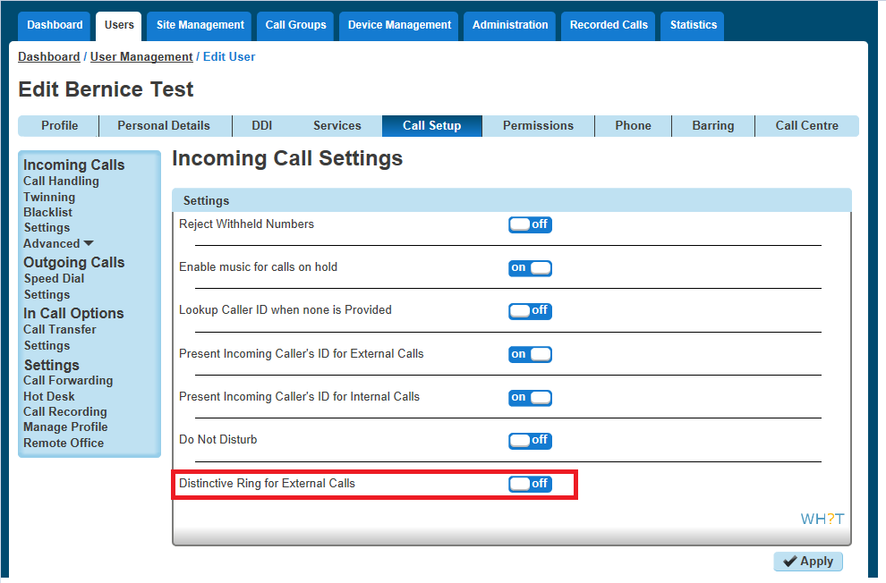

Do Not Disturb
Do Not Disturb (DND) allows users to set their phone as unavailable so that incoming calls are given a busy treatment. Users have the option to activate and deactivate the service by dialling a feature access code or configuring the service via their web interface or by pressing the DND button on phones which support it.
This can be activated and deactivated using the handset directly (if applicable), the voice portal or the Horizon Portal by a user or Company Administrator.
You can check to see if a user has Do Not Disturb switched on by using the Horizon Health Check.
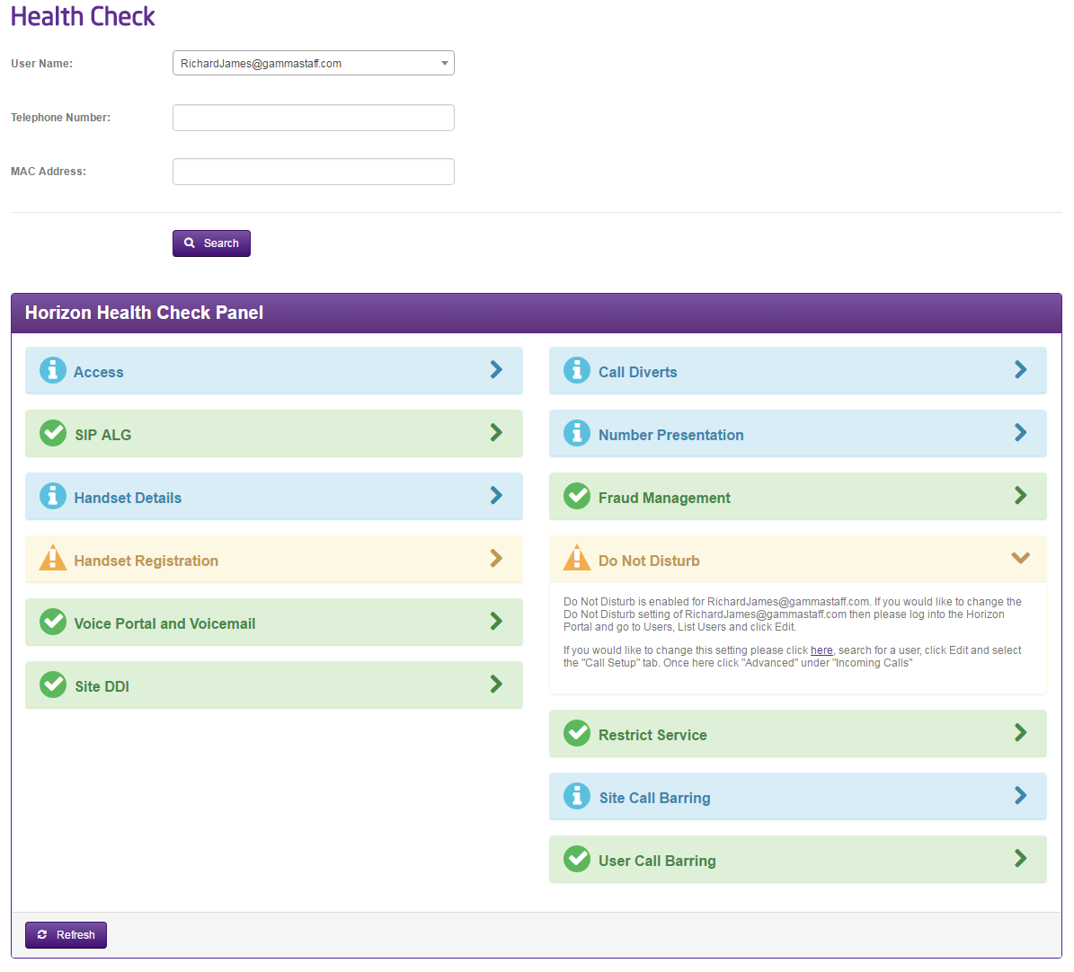

Shortcodes
Activate - *78
Deactivate - *79

Enabling Do Not Disturb (DND) from a Handset or soft Client
To see Do Not Disturb (DND) from your Horizon handset you can select the "DND" soft key on your Horizon Handset or dial *78 to switch on and *79 to switch off.
From the Soft Client go to the settings menu and select "Do Not Disturb". For more information on the Soft Clients please see our user guides on the Knowledgebase.

Enabling/Disabling Do Not Disturb (DND) from Administrator Portal
A Company Administrator can put a user into Do Not Disturb (DND) by completing the following steps.
Step 1
Log into the Gamma Portal and go to Provisioning and Service Management, Hosted, Horizon and Horizon Manage Company.
Step 2
Select your account and login to the company that you want by using the "Actions" button select "Login to Horizon".
Step 3
Click the "Users" option and then select "List Users" so you can search for the user that you want enable / disable do not disturb for.
Locate the user and click the "Edit" button.
Step 4
Click the "Call Setup" tab and then select "Settings" under Incoming Calls. From here you can set Do Not Disturb to be on or off for the user.
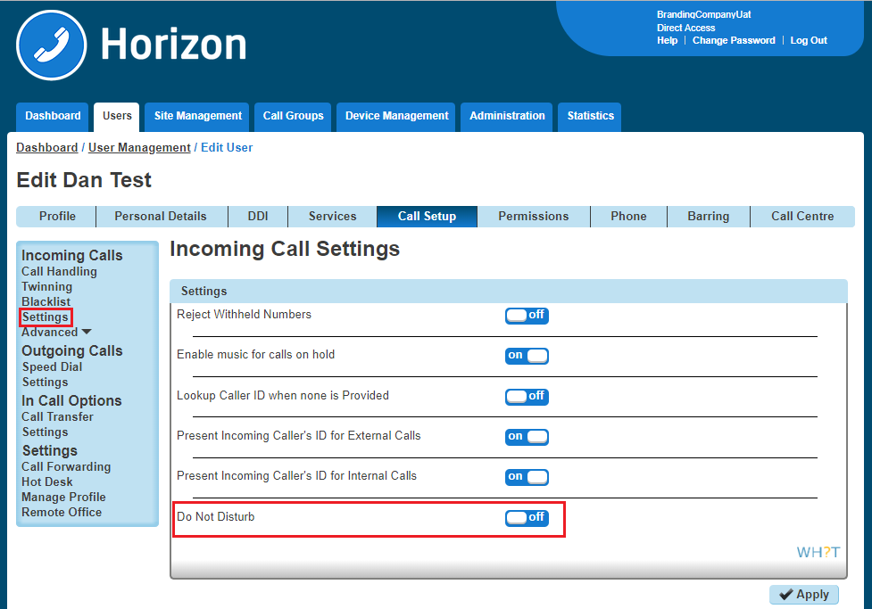

Health Check
Our Horizon Health Check gives you information to some of the most common queries we receive on the Service Desk so that you've got the information up front and in one easy to view place. This can help you whilst setting up your Horizon Company, adding or changing features or if your Horizon Company is experiencing any technical problems.

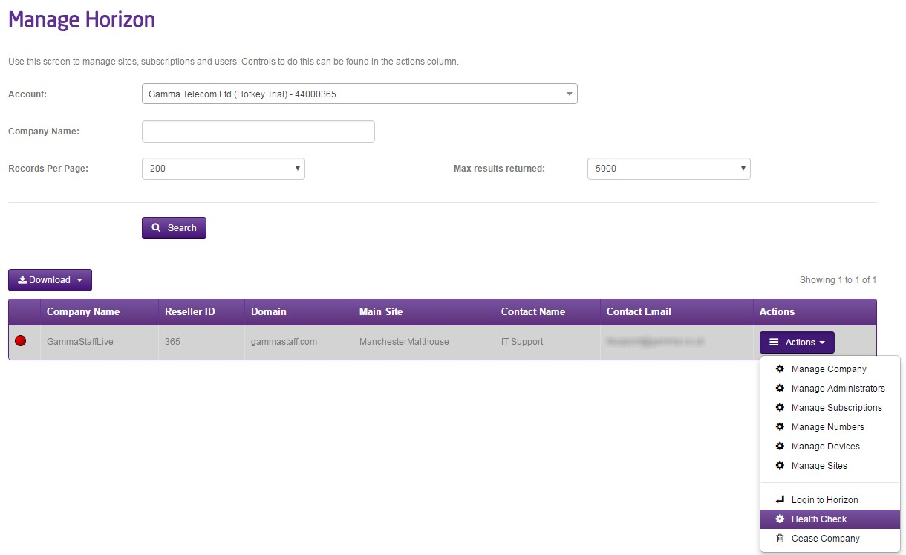
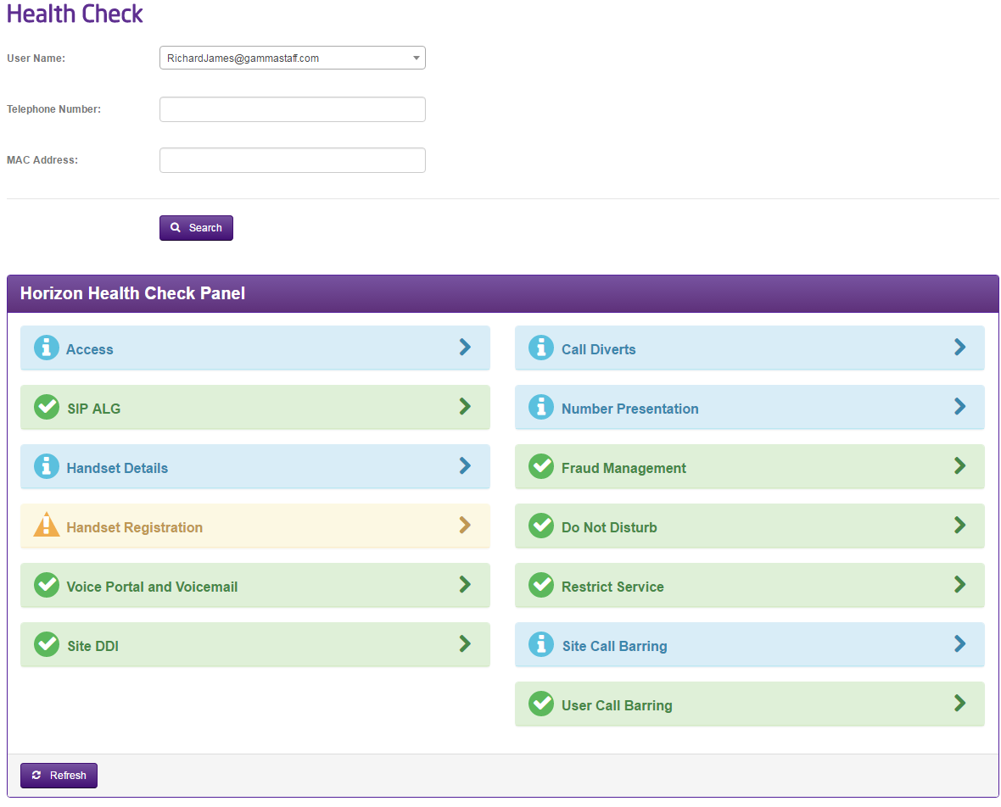
To access the Health Check go to the Gamma Portal, Provisioning and Service Management, Hosted, Horizon and select Manage Horizon Company. Locate the company and then using the actions drop down select "Health Check"

Access Tab
If the access is Gamma Broadband this will link you to the Broadband service management page of the exact circuit that your user is connected to, and also let you know if the PPP session is up or down at that moment in time. If the access is 3rd party then a blue panel will be displayed advising you that your user is connected to a 3rd party circuit, and if they are experiencing any dropped calls or media related issues to check your access first (this is usually the root cause of these issues).

SIP ALG
SIP ALG is a setting on your customer’s router, for Horizon to work this setting needs to be disabled. This check see’s if the router that your user is connected to has SIP ALG disabled.

Handset Details
Handset details will let you know what make & model of handset a user has, together with the MAC of the handset and codec choice.

Handset Registration
This checks to see if we've seen the handset register within the last 10 minutes (green). If it has been longer than 10 minutes this panel will show as amber.

Voice Portal and Voicemail
Does your Horizon Company have a Voice Portal set up to enable Voicemail, and does the user have the voicemail subscription enabled? This will tell you straight away.

Site DDI
This checks to see if the site that your user is assigned to has a Site DDI assigned. If not this could cause unexpected problems.

Call Diverts
Call diverts lets you know what settings your user has configured, such as Call Forwarding, Remote Office, Availability Profiles, Twinning and Sequential Ringing.

Number Presentation
Number Presentation lets you know what a user has set up to present when making outbound calls.

Fraud Management
You can see if Fraud Management is set up, and if it is whether the agreed limits have been breached or not. For more information on Fraud Management, please see the Horizon Provisioning and In Life Changes guide.

Do Not Disturb (DND)
This check lets you know if the user you're searching against has Do Not Disturb enabled or disabled.

Restrict Service
Checks to see if there are any restrictions in place for your Horizon Company, and if they are what they are. For more information on Restrict Service, please see the Horizon Provisioning and In Life Changes guide.

Site Call Barring
What are the call barring options for the site that your user is assigned to? The health check will provide a quick and simple snapshot.

User Call Barring
What are the call barring options for the site that your user is assigned to? The health check will provide a quick and simple snapshot.

Hot Desking
As the company administrator, you have the ability to allow a user to use a pre-configured hot desk where a phone is available for a user to login to. Hot Desk is also referred to as "Hotelling".

If you are using a Polycom SoundPoint 450 or SoundPoint 650, when hot desking the extension will appear as the guest's extension number. For every other handset it will still appear as the host's extension number, even if the guest is logged in.

By default, all users Hot Desk Options are disabled for security purposes. When switched on, it provides the ability for all devices in all locations under one Company to be used in a hot desk environment. You can disable a user from being set up as a host device.

Switch Hot Desking On/Off
To switch Hot Desking either on or off you do this based on the handset that is associated with the user.

Step 1
Log into the Gamma Portal and go to Provisioning and Service Management, Hosted, Horizon and Horizon Manage Company.

Step 2
Select your account and login to the company that you want by using the "Actions" button select "Login to Horizon".

Step 3
Go to "Users" and "List Users" and locate the user that you want to have the handset available for hot desking for and then click the "Edit" button. Please note this will not work if

Step 4
On the "Profile" tab you should make sure that the "Enable Hot Desk" is set to yes or no.
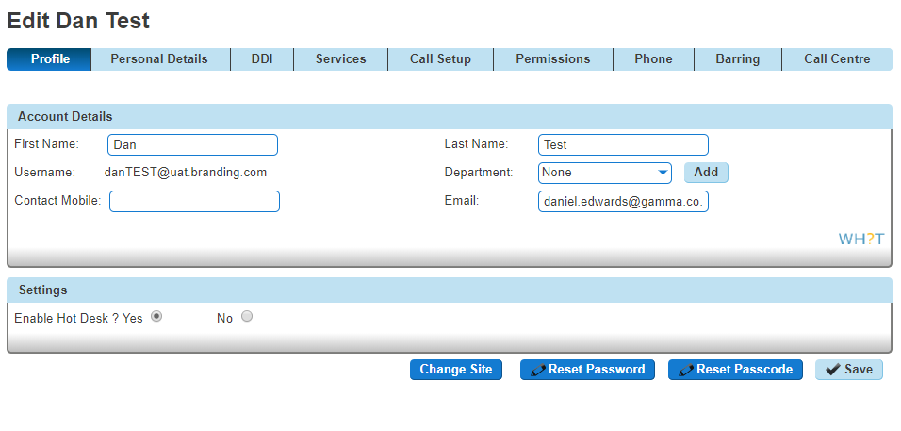

Login to a Hot Desk as Administrator
A Company Administrator can give a user a hot desk. To do this,

Step 1
Log into the Gamma Portal and go to Provisioning and Service Management, Hosted, Horizon and Horizon Manage Company.
Step 2
Select your account and login to the company that you want by using the "Actions" button select "Login to Horizon".
Step 3
Go to "Users" and "List Users" and locate the user that you want to have the handset available for hot desking for and then click the "Edit" button.
Step 4
On the "Call Setup" tab select "Hot Desk" under Settings. From here you can search for a handset on the site using any of the following search criteria:
First Name
Last Name
MAC Address
Extension

Click on the blue tick to start an association between the user (guest) and the handset (host).

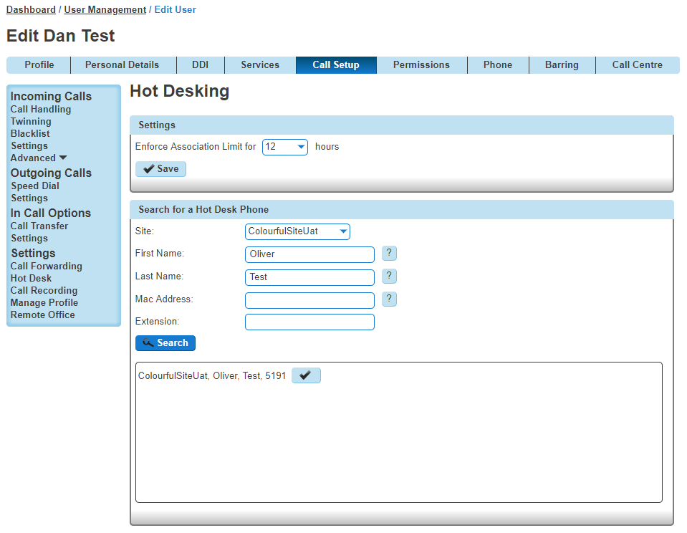

End Hot Desk Association as Administrator
Step 1
Log into the Gamma Portal and go to Provisioning and Service Management, Hosted, Horizon and Horizon Manage Company.
Step 2
Select your account and login to the company that you want by using the "Actions" button select "Login to Horizon".
Step 3
Go to "Users" and "List Users" and locate the user who is hot desking and then click the "Edit" button.
Step 4
Click the "Call Setup" tab and "Hot Desk" under the Settings section. From here click "Stop Using" to end the association.

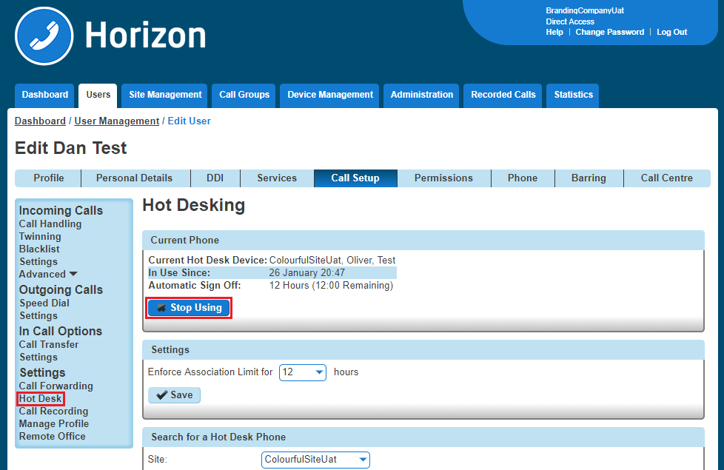

Login to a Hot Desk as a User
Step 1
Log into the Horizon Portal and log in as a user.
Step 2
From the menu bar select 'Hot Desk'.
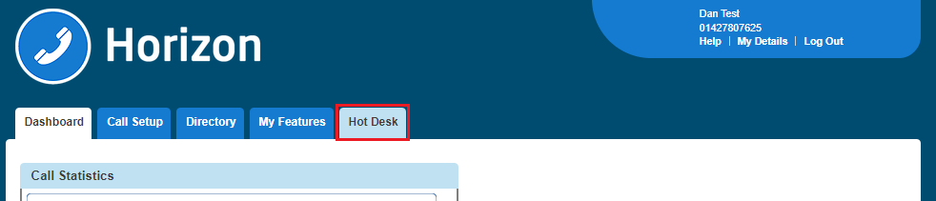

Step 3
From here you can search for a handset on the site using any of the following search criteria:

First Name
Last Name
MAC Address
Extension
Click on the blue tick to start an association between the user (guest) and the handset (host).
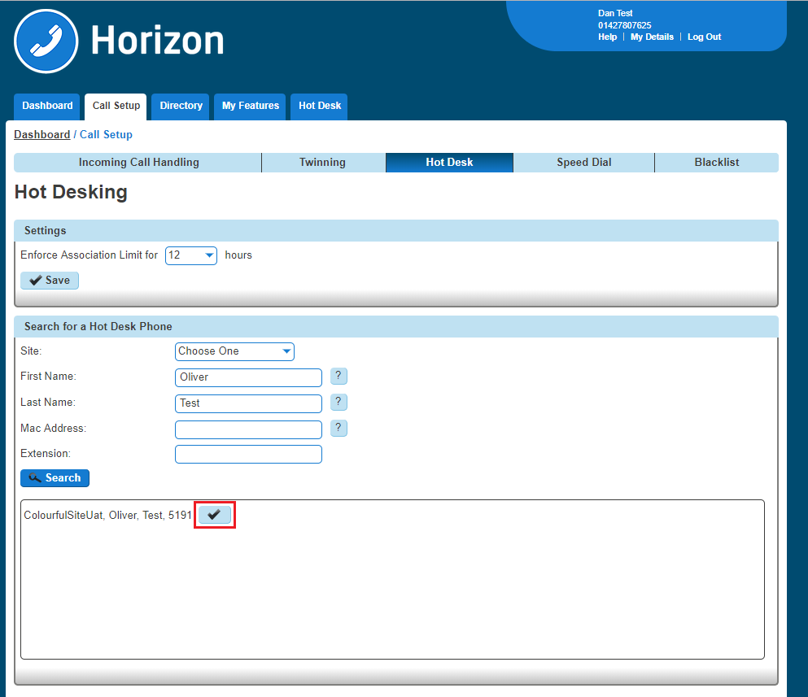

Login to a Hot Desk using a Polycom Handset
Step 1
On the Polycom handset you should see a "GuestIn" button. Press this.
Step 2
Enter the Voice Portal user ID and Voice Portal Passcode and press OK.
Step 3
If successful, the GuestIn button will become "GuestOut"

Login to a Hot Desk using a Cisco Handset and the Voice Portal
Step 1
Dial the Voice Portal from the handset that the user wishes to hot desk into.
If the user is already associated with the device, simply enter the passcode credentials.
If the user is not associated with the device, the user will need to press * to login with credentials that aren’t currently associated to the handset.
Step 2
Select Option 7 - "Access Hoteling"
Please note the Cisco The Cisco MPP series will NOT support hoteling.

Step 3
Select one of the following options:

1 - the operator will check if there is an ongoing associated with this Host
2 - the Guest will associate with the Host
3 - the Guest can end the association with the Host.

Step 4
Once the association has been made with the Host phone, Guests using the Polycom Soundpoint 450 and Soundpoint 650 will visibly see their own extension number on the Host device display. Guests using other handsets will continue to see the display name and extension of the Host.
Login will disassociate after 24 hours.

Hunt Groups
Horizon has the ability to establish a variety of hunt groups to route calls to multiple locations when an incoming call is received. Each user will be called in order of the group until a free user is reached.

Hunt Group Types
Hunt Group | Description
Circular | A Circular hunt group sends the incoming calls to users according to their position in the list. After a call has been answered, the next call will be answered by the person following the user who answered, even if the call is at the top of the list.
Regular | A Regular hunt group sends the incoming call to the next available user in the hunt group. Regular hunt groups will restart from the 1st member of the group when a new call is delivered.
Simultaneous | A Simultaneous hunt group sends incoming calls to all users in the group at the same time. Once the call has been answered, the remaining calls to all the other users will be released.
Uniform | A Uniform hunt group sends the incoming call to the user who has been idle the longest. After a user has answered the call, they'll move to the bottom of the queue.
Weighted | A Weighted hunt group sends the incoming call to the users according to a percentage you assign them.

Setup a Hunt Group
 Hunt Groups are setup by the Company Administrator
Before you start to set up your Hunt Group, you need to make sure that you have Hunt Group Add- ons to do this. This is done by completing the following actions:

Log into the Gamma Portal and go to Provisioning and Service Management, Hosted, Horizon and Horizon Manage Company.
Select your account and locate the company that you want to setup a Hunt Group.
Using the "Actions" drop down select "Manage Bolt ons".
From here you can see what bolt ons you have and how many are currently in use. If you need to add any more Hunt Group add-ons if you scroll to the bottom of the page and click "Add More Bolt ons" and then you can add as many bolt ons as you need by adding against "Hunt Group".
Step 1
Log into the Gamma Portal and go to Provisioning and Service Management, Hosted, Horizon and Horizon Manage Company.
Step 2
Select your account and login to the company that you want by using the "Actions" button select "Login to Horizon".
Step 3
Click the "Call Groups" option and then select "Hunt Group". On the Hunt Group page click "Add".
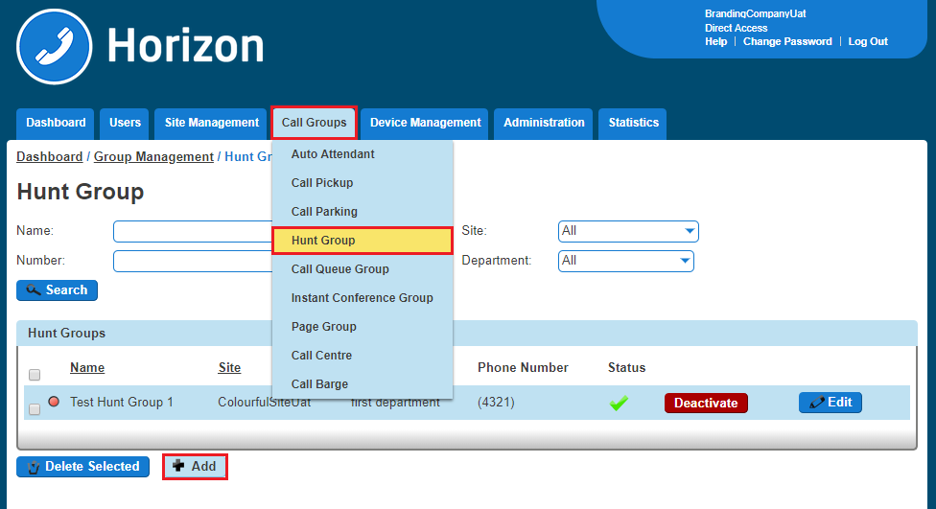
Step 4
You will now be in the wizard for Hunt Groups. The first page you will be setting up the following:

Site - the site that the Hunt Group will be used for. All the users of the Hunt Group will be on this site.
Group Details - enter the name, username and department that you'd like the group to be assigned to. This is so that you can quickly identify the group if you ever need to edit or delete the group.
Caller ID - this will be what is displayed on the handset when the Hunt Group is used.

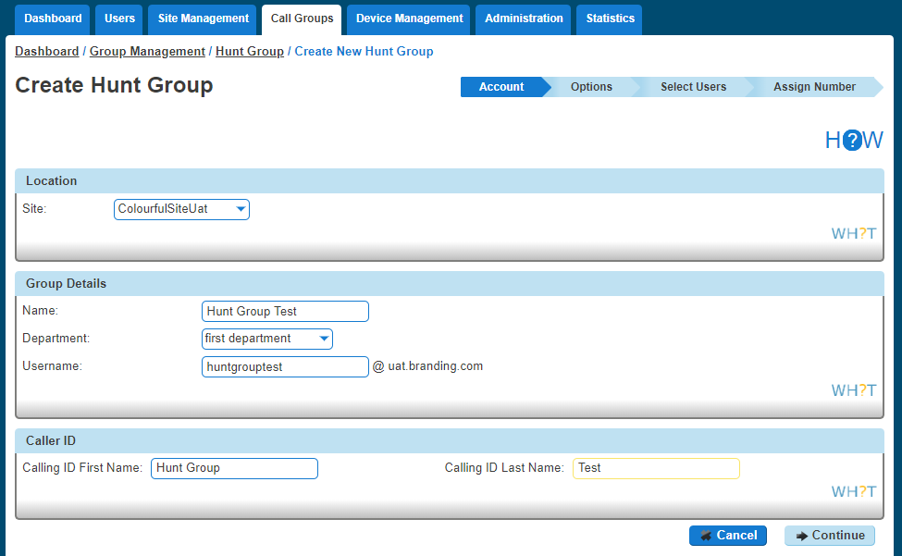
Step 5
Now you can configure the options for the Hunt Group. The available options during the setup of the Call Queue Group are:
Ring Order:
Select if you want a Circular, Regular, Simultaneous, Uniform or Weighted Hunt Group
No Answer Action
If a user does not answer the call, how many rings before it skips to the next user, or if you want to forward the call to a specific number after a defined amount of seconds.
Unreachable Action
  - If you want to set up Call Forwarding if unreachable. This is designed to forward a call in the event that the subscribers device is not registered with the Horizon platform. In the case of a call group, all devices associated with the call group need to be unregistered for the unreachable divert to be applied. The unreachable divert only occurs in the event that the device or devices become unregistered from the Horizon platform, typically due to an issue with connectivity between Horizon and the site/device being hard down, unreachable should not be considered as a disaster recovery feature for any other scenario outside of this.
Additional Options
If you would like Distinctive Ringing for external calls.
If you would like to enable Call Waiting

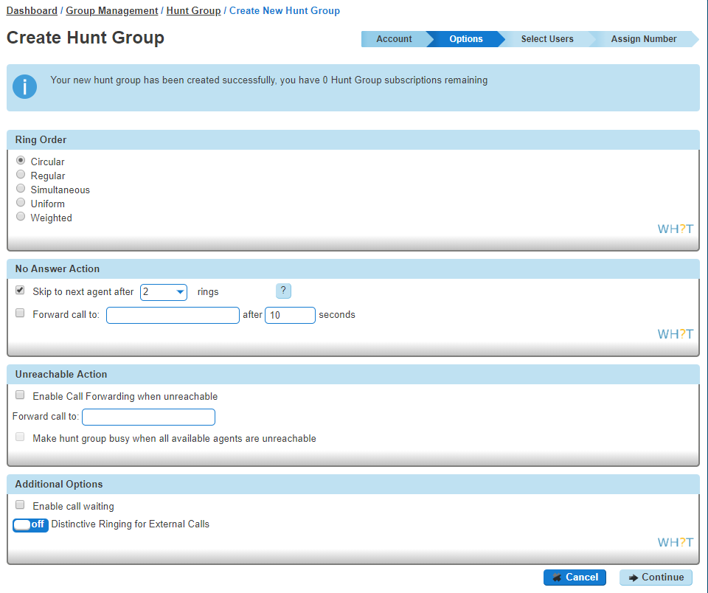
Step 6
Select the users which you want in the Hunt Group, click "Add Selected" so that they move to the box on the right hand side of the screen and then click "Continue".
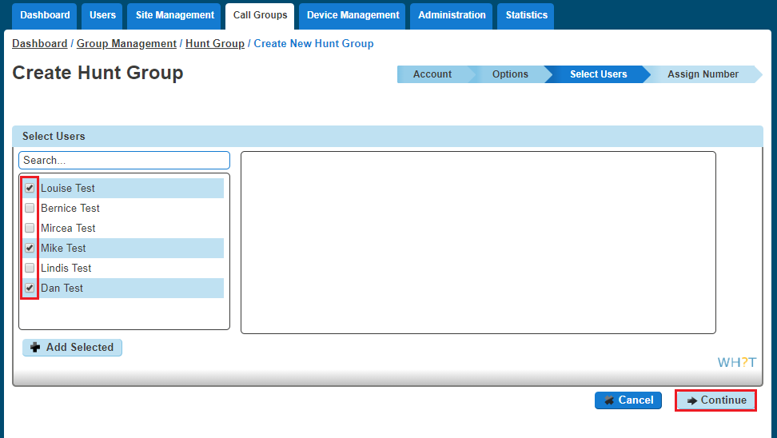

Step 7
Find an available number that you have on your Horizon Company to assign to and type in a free extension.
"Finish and Show List" will finish the set up with basic settings of the Hunt Group.
"Finish and Edit" will finish the setup with the basic settings of the Hunt Group and allow you to edit some of the more advanced options. These include:

Call Recording
Voicemail
What announcement should be used for the voicemail
If you want voicemail notifications to be sent to an email address
If you want all calls to be sent to voicemail
Change Voicemail Passcode for the Call Queue Group
Scheduling (Advanced Settings)
Call Forwarding (Advanced Settings)
Call Forwarding when Busy (Advanced Settings)

Add/Remove Users to/from a Hunt Group
Step 1
Log into the Gamma Portal and go to Provisioning and Service Management, Hosted, Horizon and Horizon Manage Company.

Step 2
Select your account and login to the company that you want by using the "Actions" button select "Login to Horizon".
Step 3
Click the "Call Groups" option and then select "Hunt Group". On the Hunt Group page click "Edit".
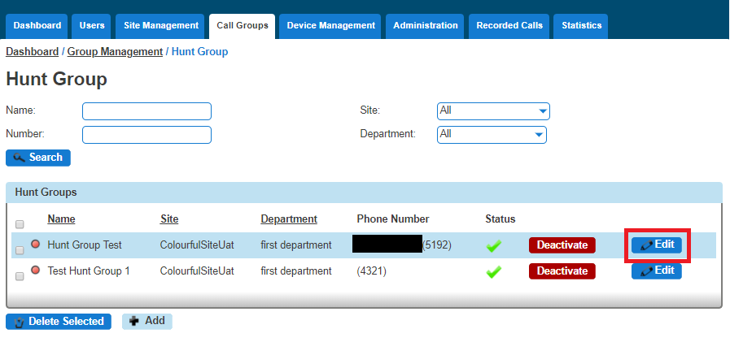
Step 4
Select the "Select Users" tab. From here you can add new users from the table on the left hand side and clicking "Add Selected", and remove users by clicking the white "X" next to the user you want to remove.
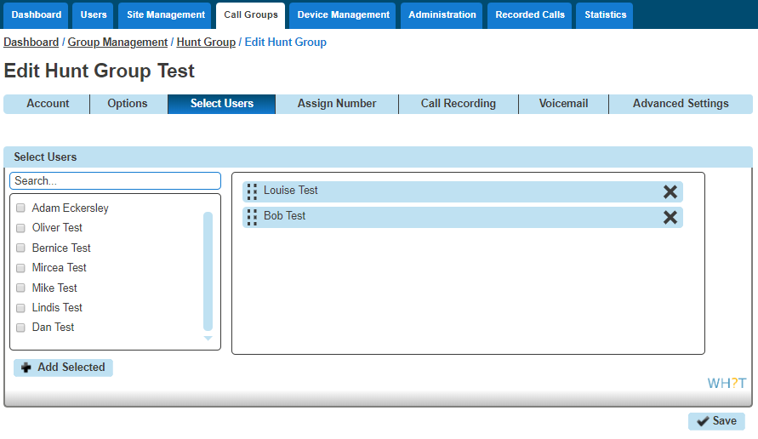

Edit a Hunt Group Settings
Step 1
Log into the Gamma Portal and go to Provisioning and Service Management, Hosted, Horizon and Horizon Manage Company.
Step 2
Select your account and login to the company that you want by using the "Actions" button select "Login to Horizon".
Step 3
Click the "Call Groups" option and then select "Hunt Group". On the Hunt Group page click "Edit".

Step 4
From here you will be presented with the following options:

Account
Change the name and Caller ID settings

Options
Change the Hunt Group Settings, including:
Ring Order
No Answer Action
Unreachable Action
Call Waiting
Distinctive Ring for External Calls

Select Users
Add or remove users from the Hunt Group

Assign Number
Change the telephone number of the Hunt Group
Change the extension number of the Hunt Group

Call Recording

Voicemail
What announcement should be used for the voicemail
If you want voicemail notifications to be sent to an email address
If you want all calls to be sent to voicemail
Change Voicemail Passcode for the Call Queue Group

Scheduling (Advanced Settings)

Call Forwarding (Advanced Settings)

Call Forwarding when Busy (Advanced Settings)

Delete a Hunt Group
Step 1
Log into the Gamma Portal and go to Provisioning and Service Management, Hosted, Horizon and Horizon Manage Company.
Step 2
Select your account and login to the company that you want by using the "Actions" button select "Login to Horizon".
Step 3
Click the "Call Groups" option and then select "Hunt Group". On the Hunt Group page select the Hunt Group(s) that you want to delete and then click the "Delete Selected" option.
Click "Confirm" when asked if you are sure that you want to continue in deleting the Hunt Group.
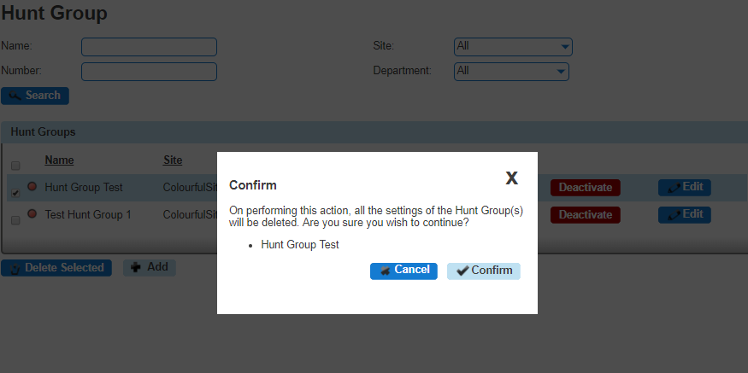

Apply a Schedule to a Hunt Group
For help on how to set up a Schedule, please see our Schedule section of this guide.
Step 1
Log into the Gamma Portal and go to Provisioning and Service Management, Hosted, Horizon and Horizon Manage Company.
Step 2
Select your account and login to the company that you want by using the "Actions" button select "Login to Horizon".

Step 3
Click the "Call Groups" option and then select "Hunt Group". On the Hunt Group page click "Edit".
Step 4
Select the "Advanced Settings" tab and switch "Enable Virtual Package" to On.
Click the "Edit" button next to Schedule and this will load up the settings for Schedules.
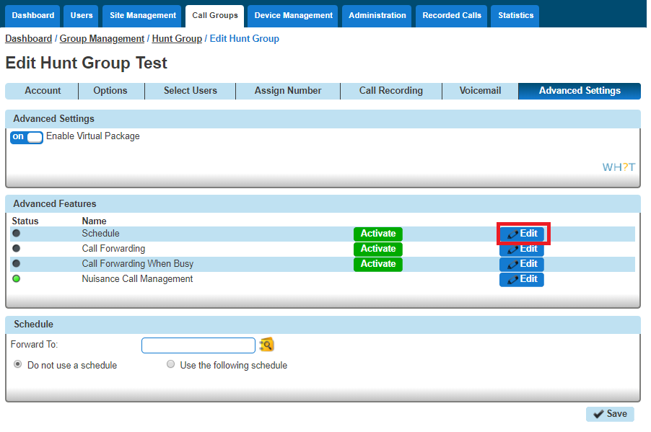

Select "Use the following schedule". You should apply the out of hours schedule in the "Closed hours". With this you're telling Horizon what times you want it to forward calls.
Additional Routing allows you to set up another schedule to run alongside the main schedule, such as Bank Holidays.
If you don't put any schedule in Closed Hours and only use Additional Routing, the calls will always forward instead of following the schedule.
If you haven't actually set up a schedule yet, you can use the "+" icon to set up a new schedule. Please see the Schedules section of the document on how to create schedules for Hunt Groups.

Listening to your Hunt Group Voicemail
Step 1
Dial the Voice Portal extension or full number.
If you are dialling from a Horizon Company handset then you should press "*" and then enter the hunt group extension number.
If you dial the full number from a phone that is not on the Horizon Company then you will be prompted to enter the extension number of the Hunt Group.
Step 2
Enter the Voicemail Passcode for the Hunt Group and then press 1 to access the voicemail box.

Resetting a Hunt Groups Voicemail Passcode
Step 1
Log into the Gamma Portal and go to Provisioning and Service Management, Hosted, Horizon and Horizon Manage Company.
Step 2
Select your account and login to the company that you want by using the "Actions" button select "Login to Horizon".
Step 3
Click the "Call Groups" option and then select "Hunt Group". On the Hunt Group page click "Edit".

Step 4
Select the "Voicemail" tab and press the "Change Voicemail Passcode" button.
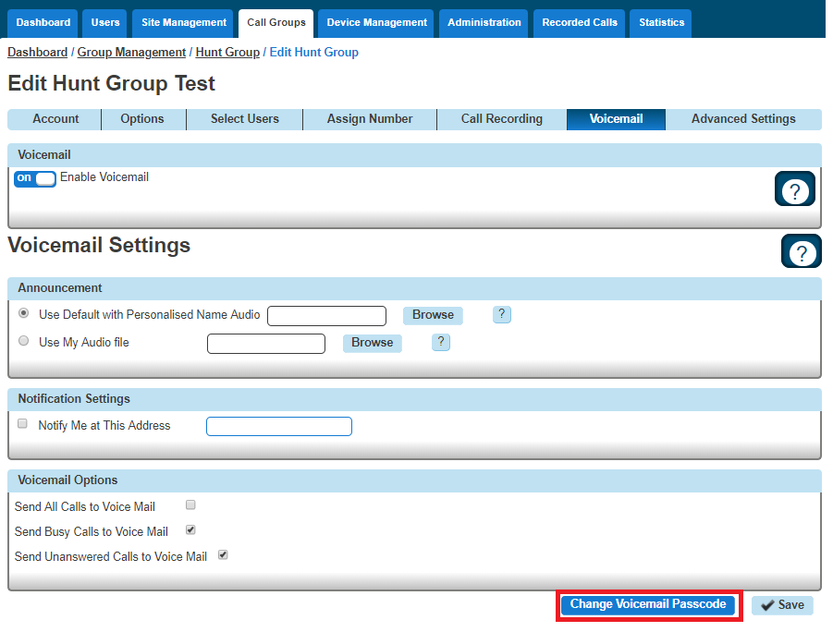
Step 5
Enter the new PIN and then confirm the PIN.

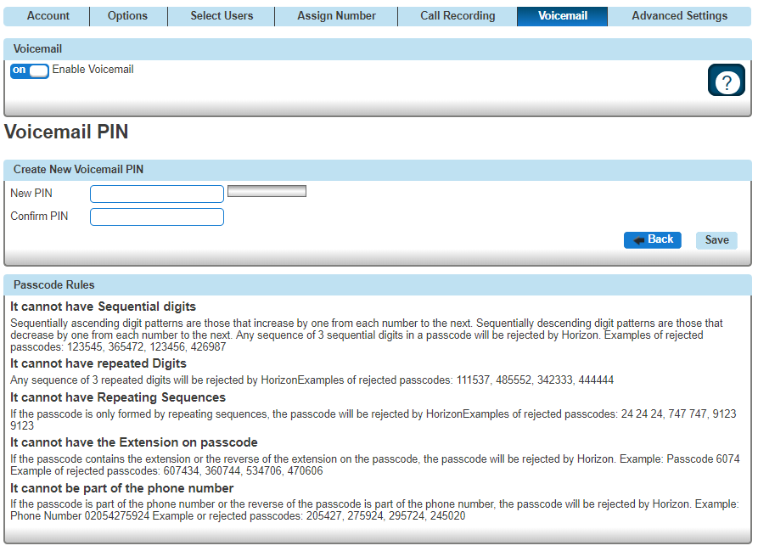

Instant Conference Group
As the company administrator you can setup a conference group allowing up to 20 different people to be called automatically once the conference has been started. You may choose to use this to create incident bridges or similar instant conference groups for your company.
For this to be activated the conference group can be started by any user calling the conference number, which will then trigger calls to other group members.

Setup an Instant Conference Group
Instant Conference Groups are setup by the Company Administrator
Before you start to set up your Instant Conference Group, you need to make sure that you have Instant Conference Group Add-ons to do this. This is done by completing the following actions:

Log into the Gamma Portal and go to Provisioning and Service Management, Hosted, Horizon and Horizon Manage Company.
Select your account and locate the company that you want to setup a Hunt Group.
Using the "Actions" drop down select "Manage Bolt ons".
From here you can see what bolt ons you have and how many are currently in use. If you need to add any more Instant Conference Group add-ons if you scroll to the bottom of the page and click "Add More Bolt ons" and then you can add as many bolt ons as you need by adding against "InstantConferenceGroup".

Step 1
Log into the Gamma Portal and go to Provisioning and Service Management, Hosted, Horizon and Horizon Manage Company.
Step 2
Select your account and login to the company that you want by using the "Actions" button select "Login to Horizon".
Step 3
Click the "Call Groups" option and then select "Instant Conference Group". On the Instant Conference Group page click "Add".

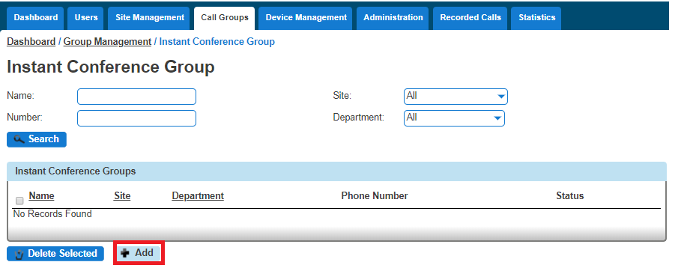
Step 4
You will now be in the wizard for Instant Conference Groups. The first page you will be setting up the following:

Site - the site that the Instant Conference Group will be used for.
Group Details - enter the name, username and department that you'd like the group to be assigned to. This is so that you can quickly identify the group if you ever need to edit or delete the group.
Caller ID - this will be what is displayed on the handset when the Instant Conference Group is used.

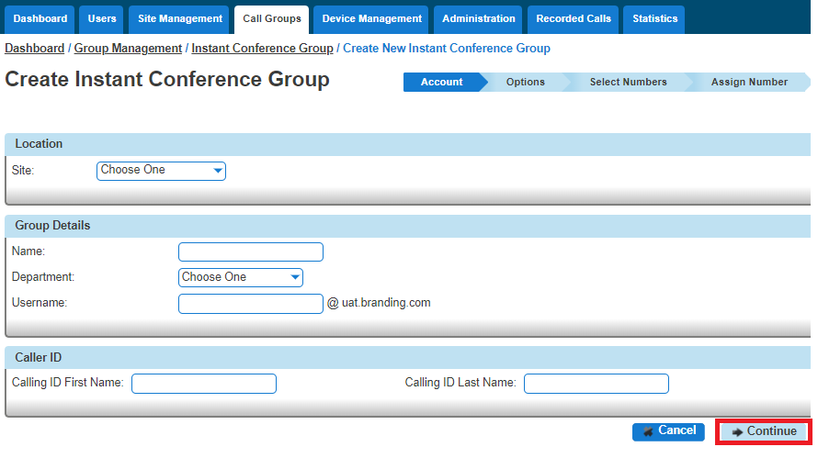

Step 5
On the options screen, select the Maximum Call Time for Unanswered Calls. This is the maximum ring time for the user phones to be dialled if unanswered to avoid ongoing ringing.
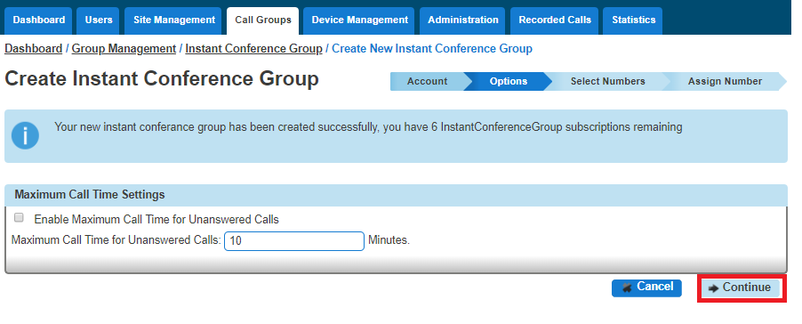
Click "Continue".
Step 6
Now enter the telephone numbers you want to be involved in the Instant Conference. You can use the Directory icon to search for a user's telephone number if they are a Horizon user. You can enter non-Horizon numbers in here as well.
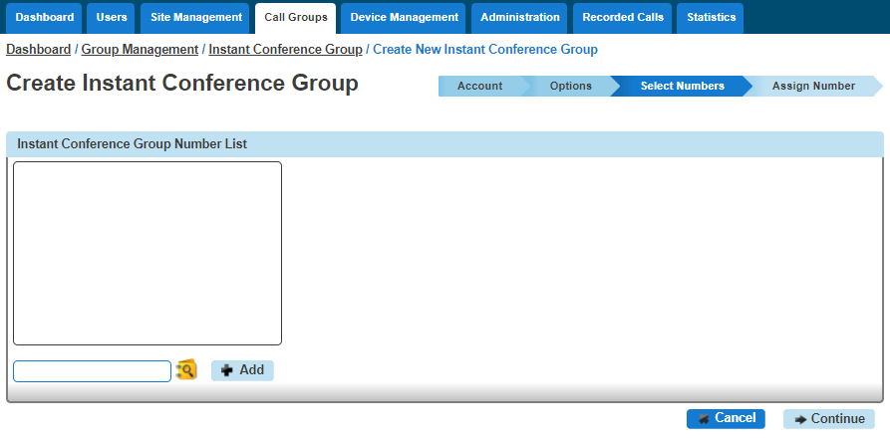
Step 7
Select the number that you want for the Conference Group from the available list, and then assign an Extension number into the text box. If the extension number has been taken, then this will prompt you to choose another.
Click "Finish and Show List" and your new Instant Conference Group will show in the list.

Edit an Instant Conference Group
Step 1
Log into the Gamma Portal and go to Provisioning and Service Management, Hosted, Horizon and Horizon Manage Company.
Step 2
Select your account and login to the company that you want by using the "Actions" button select "Login to Horizon".
Step 3
Click the "Call Groups" option and then select "Instant Conference Group". On the Instant Conference Group page click "Edit".
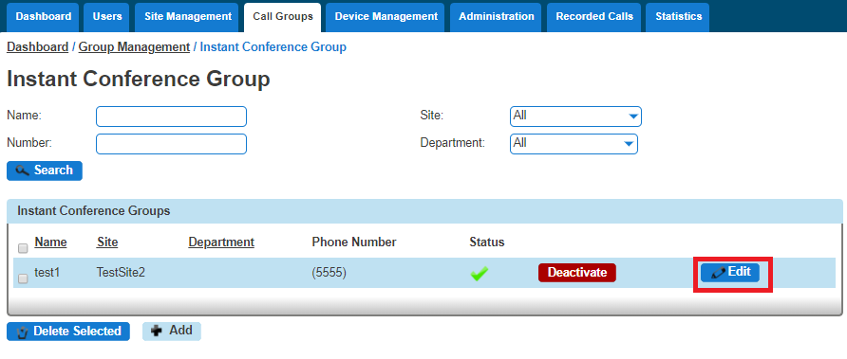
Step 4
From here you will be presented with the following options:
Account
Change the name, department and Caller ID settings
Options
Enable or disable the maximum call time for unanswered calls, and define this figure in minutes.
Select Numbers
Add or remove numbers from the Instant Conference Group
Assign Number
Change the telephone number of the Instant Conference Group
Change the extension number of the Instant Conference Group

Delete an Instant Conference Group
Step 1
Log into the Gamma Portal and go to Provisioning and Service Management, Hosted, Horizon and Horizon Manage Company.
Step 2
Select your account and login to the company that you want by using the "Actions" button select "Login to Horizon".
Step 3
Click the "Call Groups" option and then select "Instant Conference Group". On the Instant Conference Group page select the Instant Conference Group(s) that you want to delete and then click the "Delete Selected" option.
Click "Confirm" when asked if you are sure that you want to continue in deleting the Instant Conference Group.
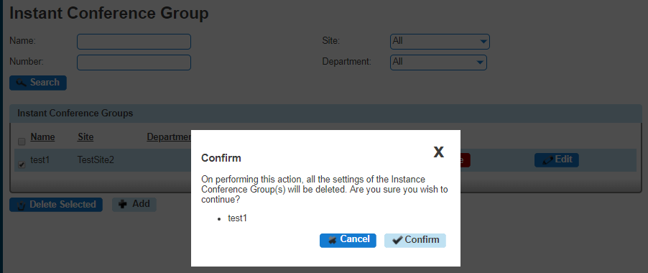

Music on Hold
Music on Hold allows an administrator to set up and maintain an audio source that can be played to held parties when calls are on hold, on a site by site basis. This music will be played across company calls with the exceptions Call Centre and Call Queue Group that has music set differently.
Gamma accepts no responsibility for the gathering of copyrights and bolt ons required for the music held within Horizon. Please also not that Horizon cannot support live feed music.
Music on hold has a maximum file size of 5MB or 625 Seconds
To create a file for use with music on hold, it needs to be in the following format:

.wav format and encoded with CCITT u-Law
Formatted at 8000Khz sample rate, 8 bit mono, 7 kb/sec

Shortcodes
Music on Hold per call Deactivation - *60

Setup Music on Hold
Step 1
Log into the Gamma Portal and go to Provisioning and Service Management, Hosted, Horizon and Horizon Manage Company.
Step 2
Select your account and login to the company that you want by using the "Actions" button select "Login to Horizon".
Step 3
Select "Site Management" and on the Site Management page click the Manage button for the site you want to add Music on Hold for.
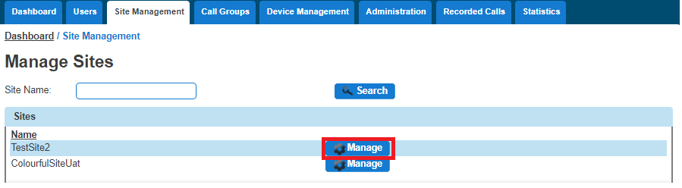

Step 4
Select "Music on Hold"
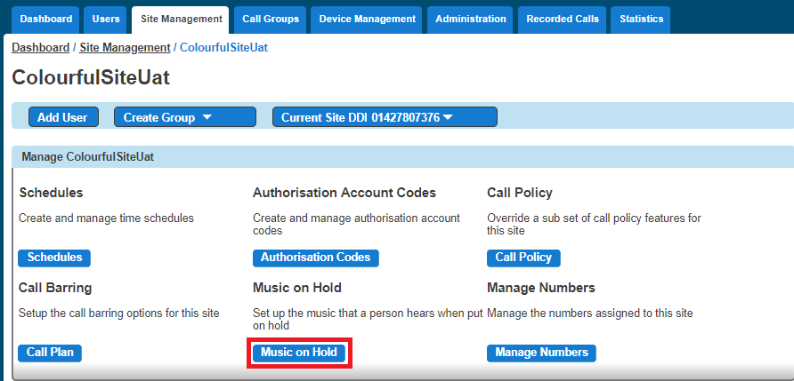
Step 5
From here, you can select when you want Music on Hold to be enabled, if you want to use the System Default or if you want to have a custom audio file for External and Internal calls.
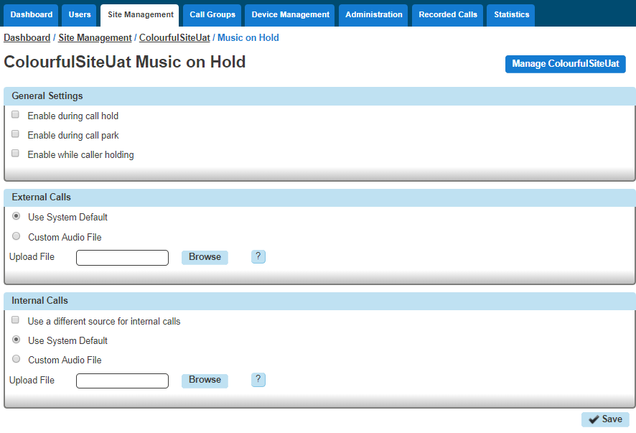

Nuisance Call Management for Horizon Call Groups
This is the ability to reject incoming calls from a user defined list and/or anonymous numbers directly via the Hunt, Auto Attendant (AA) Call Queue (CQ) and Call Centre (CC) type Call Groups as part of the Advanced Settings option.
Incoming calls with a caller ID found to exactly match a number on the Blacklist will be rejected with an appropriate announcement before automatically terminating the call. The end user can enter up to a maximum of 12 numbers onto the Blacklist per Call Group instance.
Incoming calls where the caller ID is anonymous or withheld can also be set to reject to an appropriate announcement before being terminated.
The announcements are system wide and cannot be customised on a per Company or Call Group basis.
Nuisance Call Management will be available to a Company as part of the "Group Advanced Settings" subscription and, if not already assigned to the Call Group, can be assigned to the Company via the Gamma portal under Hosted>Horizon>Manage Company or New Company Order menu's. Each Hunt, AA, CQ or CC will need a Group Advanced Settings subscription per instance if Nuisance Call Management (NCM) is required.
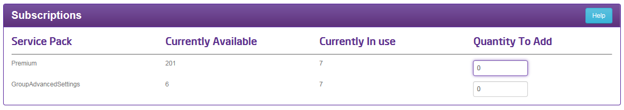
You can also check if there are any spare VPP's to assign via the Administration>Subscription Centre menu on the Horizon GUI or if you encounter the below message then you can add more VPP's to the Company via the Gamma Portal as described previously.
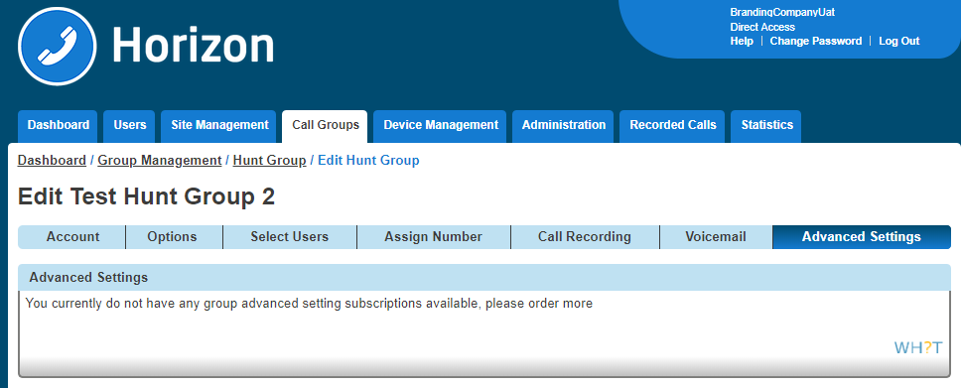

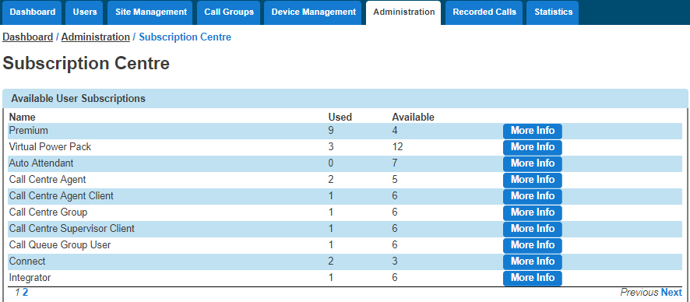
To configure NCM select the Call Group type from the drop down menu on the Horizon GUI and choose the specific category the Call Group number is configured as.
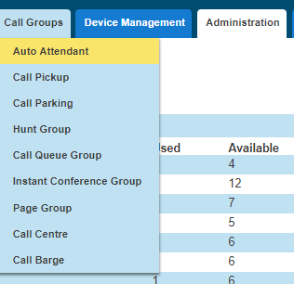
To set up the NCM option for a Call Group find the group you wish to modify and click edit

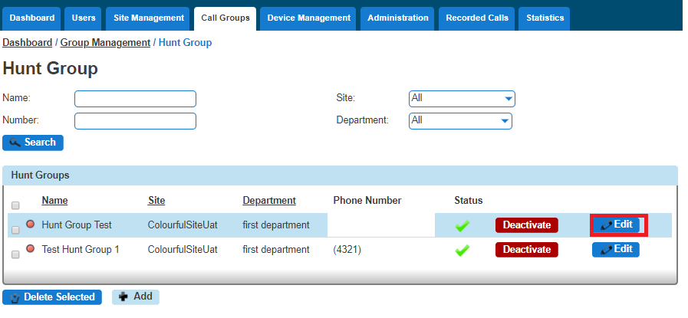
The NCM feature can be found under the Advanced Settings tab for all 4 Call Group types.
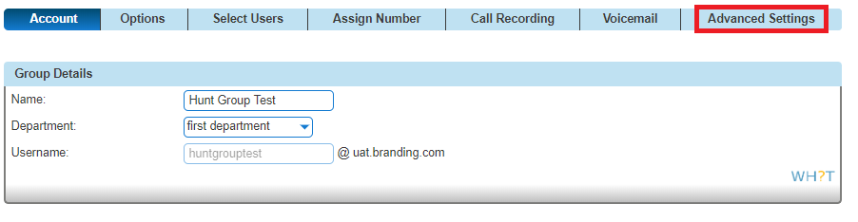
If not already, enable the Virtual Package by toggling the button to on and the relevant options will appear for the Call Group. Click on the Nuisance Call Management edit button for the configuration panel.
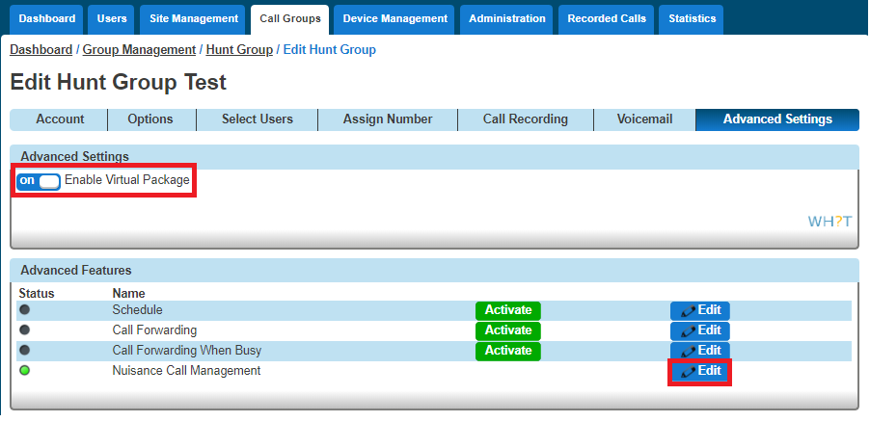
You can add specific numbers to the Blacklist of numbers by typing them freehand into the highlighted panel and clicking the button, there is also the option to add numbers from the Company Directory via the icon. To delete a number from the Blacklist click the icon.

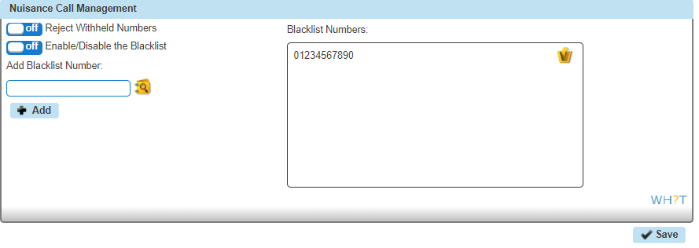
To enable or disable the NCM feature you now just need to toggle the appropriate button between on and off. The options are:
Will only reject those incoming calls where the callers ID exactly matches a number in the Blacklist
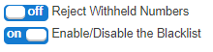

Will reject those incoming calls where the callers ID exactly matches a number in the Blacklist or the callers ID is anonymous or withheld.
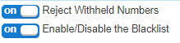

Will only reject those incoming calls where the callers ID is anonymous or withheld.
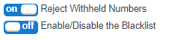

Availability Profiles
Availability (Express) Profiles enables users to pre-configure multiple profiles for managing incoming calls differently based on the user’s status. There are four pre-set profiles with the available options:

Profile | Option 1 | Option 2 | Option 3
Available In Office | Also ring this number | If I'm busy:  Send to Voicemail  Forward call to… | If I don't answer:  Send to Voicemail  Forward call to…
Available Out of  Office | Send to voicemail | Forward call to… | Send me an email at…
Busy | Send all calls to voicemail… | But forward the following numbers to… | Send me an email at…
Unavailable | Send all calls to voicemail… | But forward the following numbers to… | Have voicemail take the call using:  No answer greeting  Unavailable greeting

If a user elects to use Availability Profiles then this takes precedence over all other service settings associated with processing incoming calls. A user can have either one or no profile activated at any one time.

Give permission to a user to use Availability Profiles
Step 1
Log into the Gamma Portal and go to Provisioning and Service Management, Hosted, Horizon and Horizon Manage Company.
Step 2
Select your account and login to the company that you want by using the "Actions" button select "Login to Horizon".
Step 3
Click the "Users" option and then select "List Users" so you can search for the user that you want setup Availability Profiles for.
Locate the user and click the "Edit" button.
Step 4
Click the "Permissions" tab and select "This user can use Profile" to On or Off.

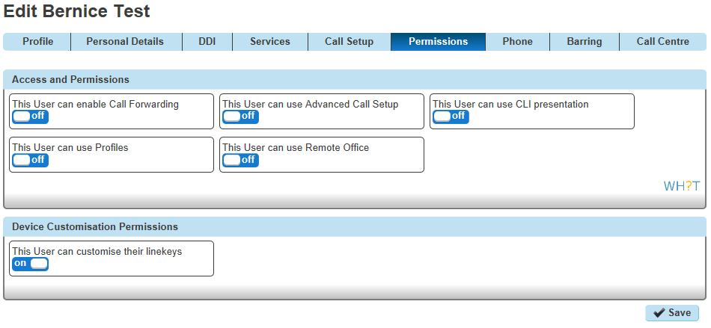

Setup and Edit Availability Profiles as a User
Step 1
Log into the Horizon Web Portal as a Horizon User and click on "Manage Profiles"
If you cannot see the "Manage Profiles" button then you need to be granted this access by the Company Administrator
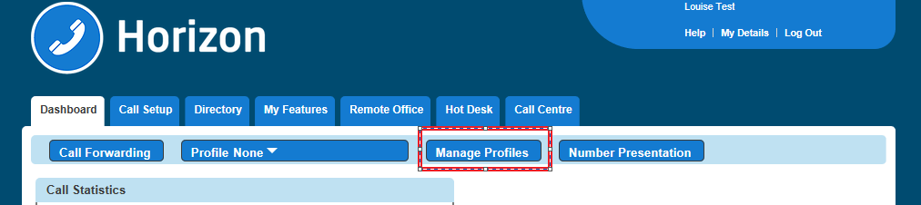
Step 2
Select the profile that you're wanting to edit by clicking the corresponding "Edit" button.
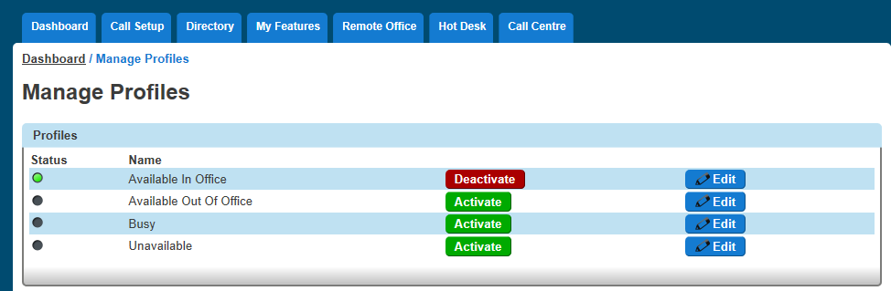

Activate Availability Profiles as a User
To activate an availability profile as a user you simply just have select the profile you want from the Horizon Dashboard.
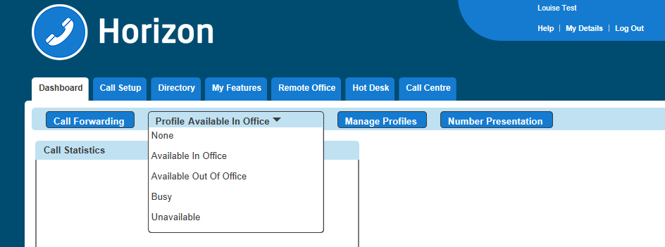

Remote Office
Remote office allows a Horizon user to use any phone as their 'Horizon phone' - meaning they won't need to pay locally for calls and their Horizon number will be presented on outgoing calls. This can be particularly useful in the likes of hotels, where calls can often be costly.
If a user has a restriction to mobile phones (calling them or transferring to them) then Remote Office to a mobile phone will not work. A "This call cannot be completed" message will be played.

Give permission to a user to use Remote Office
Step 1
Log into the Gamma Portal and go to Provisioning and Service Management, Hosted, Horizon and Horizon Manage Company.
Step 2
Select your account and login to the company that you want by using the "Actions" button select "Login to Horizon".
Step 3
Click the "Users" option and then select "List Users" so you can search for the user that you want grant Remote Office permissions to.
Locate the user and click the "Edit" button.
Step 4
Click the "Permissions" tab and select "This user can use Profile" to On or Off.

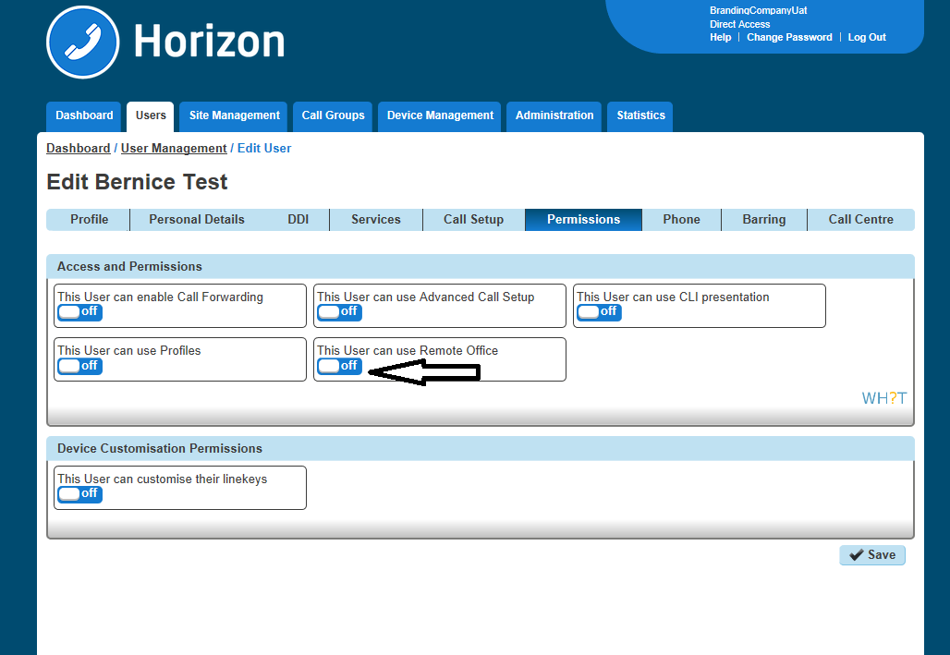

Activate / Deactivate Remote Office as a User
Step 1
Log into the Horizon Portal as a user and if the user has permission to use Remote Office they will see "Remote Office" as an option in the menu bar. Select this to load up the Remote Office page.
Step 2
You can then input the phone number you'd like to use for remote office and click 'Activate' or 'Deactivate'.
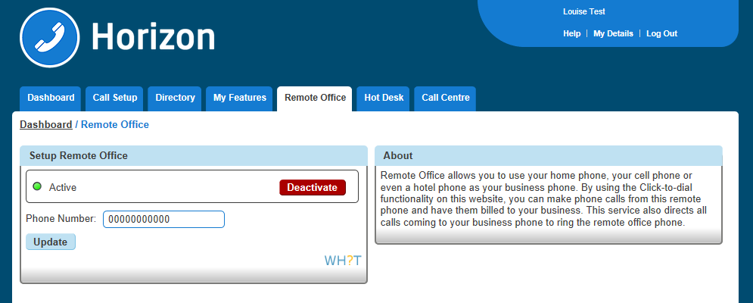

How to make outgoing calls using Remote Office
Step 1
Log into the Horizon Portal as a user and if the user has permission to use Remote Office they will see "Remote Office" as an option in the menu bar. Select this to load up the Remote Office page.
Step 2
Make sure that Remote Office is activated.
Outgoing calls must be made through the Horizon Portal using Click to Dial. You can either enter the telephone number you would like to call and tick the blue "Dial" button or click the blue telephone icon next to someone in the Company Directory.

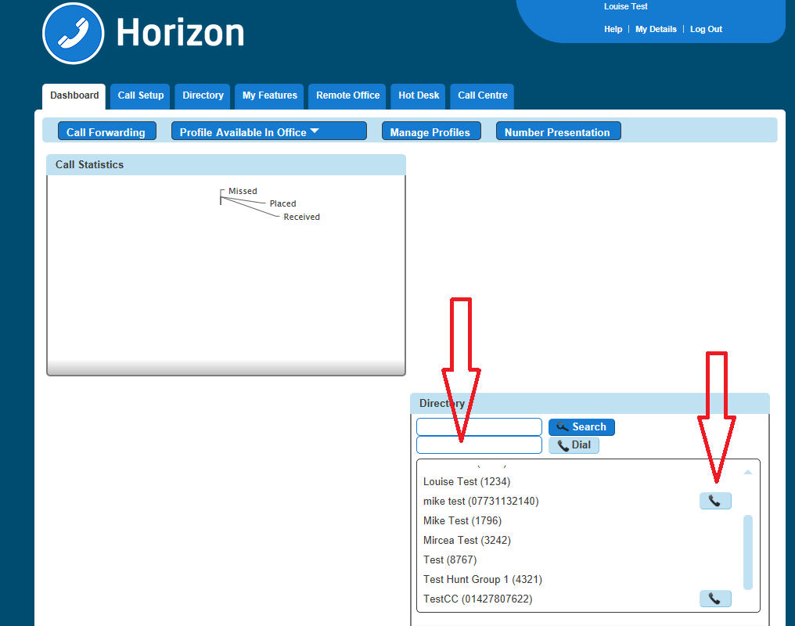

How to receive calls using Remote Office
Incoming calls will be delivered directly to the number that's been enabled for Remote Office.

Sequential Ringing
Sequential Ringing enables users to define a list of phone numbers that are alerted sequentially for incoming calls that match specified criteria. While Horizon searches for the user, the calling party is provided with a greeting followed by periodic comfort announcements. The caller can also interrupt the search to leave a message by pressing a telephone key. The user must set the number of rings after which the sequence will continue to the next phone number.
Sequential ringing works in the same way a Hunt Group would, in that you can define a set of numbers for an incoming call to try when an incoming call is made to your number.

Enable/Disable Sequential Ringing
A company Administrator sets up Sequential Ringing for a user.
Step 1
Log into the Gamma Portal and go to Provisioning and Service Management, Hosted, Horizon and Horizon Manage Company.
Step 2
Select your account and login to the company that you want by using the "Actions" button select "Login to Horizon".
Step 3
Click the "Users" option and then select "List Users" so you can search for the user that you want set up Sequential Ringing for.
Locate the user and click the "Edit" button.

Step 4
Click the "Call Setup" tab and under "Incoming Calls" select Advanced and Sequential Ringing. Within the Sequential Ringing setup you can enable/disable.
For basic Sequential Ringing you can enter up to five numbers to call moving on to the next number after a defined number of rings (between 2 and 5 rings).
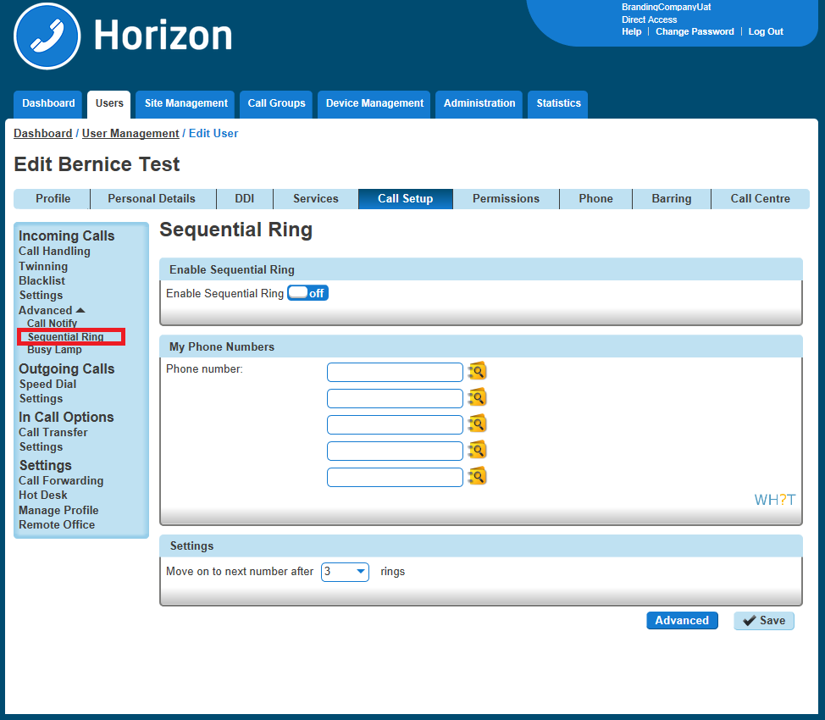

Step 5
If you would like to have Sequential Ringing for just certain numbers or would like to use Sequential Ringing during certain hours then click on the "Advanced Button.
See our guide on Schedules for help with setting up schedules and how to apply them.
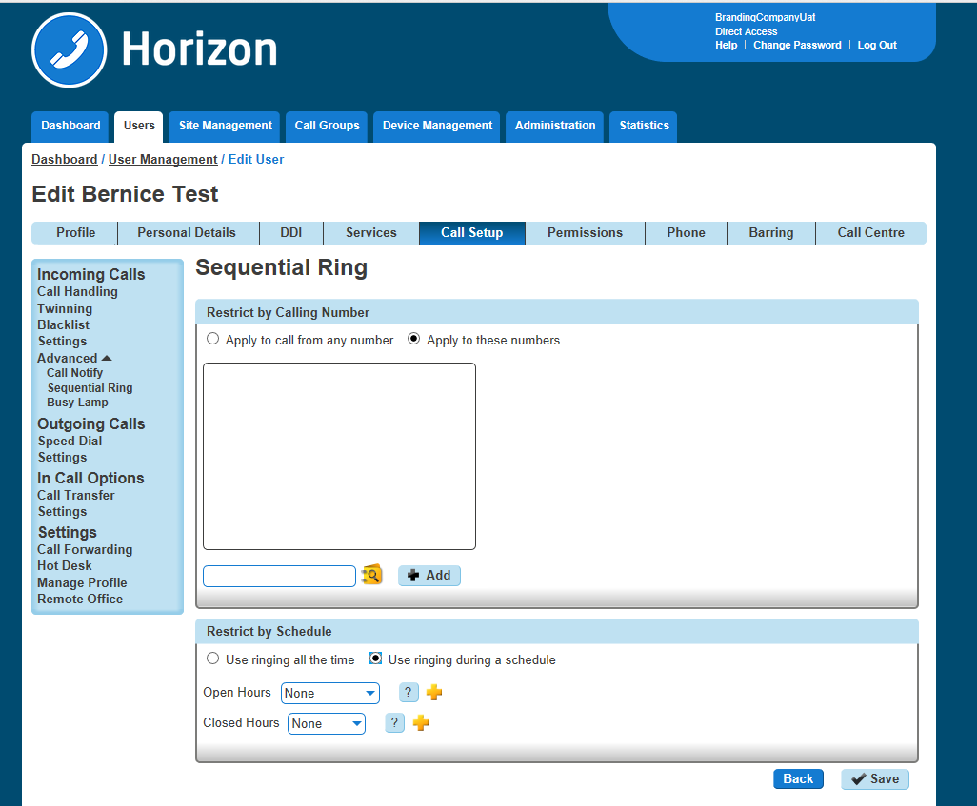

Schedules
You can set up schedules within Horizon for certain features to behave a certain way during certain times of the day.

Setup Schedules
Step 1
Log into the Gamma Portal and go to Provisioning and Service Management, Hosted, Horizon and Horizon Manage Company.
Step 2
Select your account and login to the company that you want by using the "Actions" button select "Login to Horizon".
Step 3
Select the Call Group that you want to apply the schedule to using the Call Groups menu and then click Edit. Select Advanced Settings, set Enable Virtual Package to On and edit Edit next to Schedule.
Step 4
In Closed hours, you can select either a predefined schedule you've previously set up or click the + icon to create a new schedule.
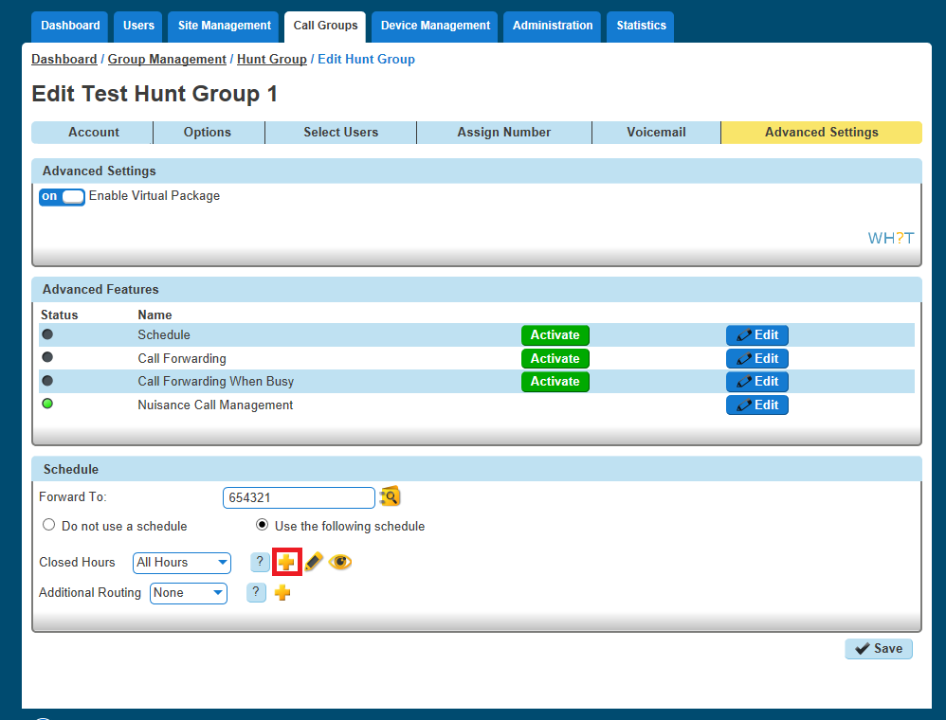
Step 5
Name the Schedule something memorable. The schedule needs to be set to "Open", even if you are setting up a schedule for outside of business hours, the colour you'd like to assign to the schedule for appearing on the calendar and then click "+ Create".

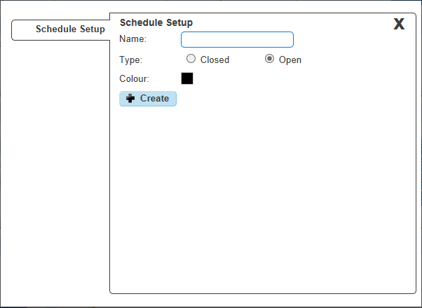
Step 6
Now you can Add Events to the schedule, therefore building the schedule. Name the event, if the event is all day keep this ticked, if it is between two times, untick the All Day Event option and this will give you extra options under the Start and End Date fields which allows you to set the time. Select how often you want the event to occur and then click create.

Please note the following when creating a schedule:
An All Day Event is from 00:00 until 23:59 on the selected day.
To define hours (such as office hours), untick the "All Day Event" box and define the time. Also select the "Weekly" option and tick all the days you wish to have selected.
Recommended if you want an out of hours schedule - select all days apart from Saturday and Sunday.

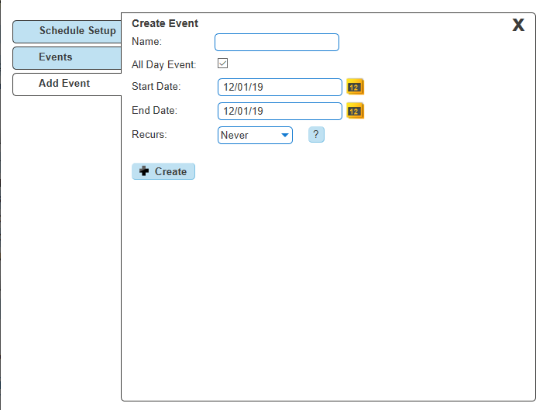

Example out of hours schedules (Company open hours 09:00 - 17:00 Monday to Friday)
Your first event should cover the morning out of hours, in this case from 00:00 (midnight) – 08:59. We want this to recur weekly on Monday – Friday so you will need to tick Mon/Tue/Wed/Thu/Fri and click create at the bottom.

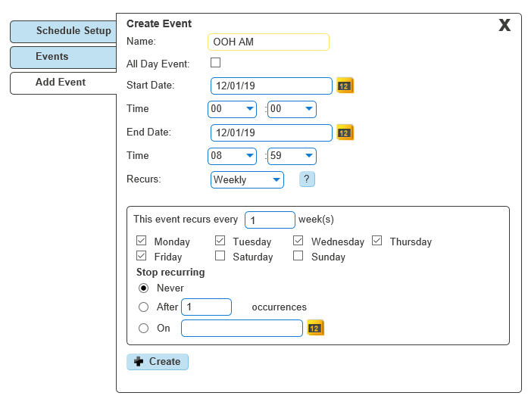
The next step is to click ‘Add’ in the events page which will then take you back to the creating a new event page. Create your afternoon out of hours, in this case from 17:00 – 23:59. We also want this event to recur weekly from Monday – Friday.
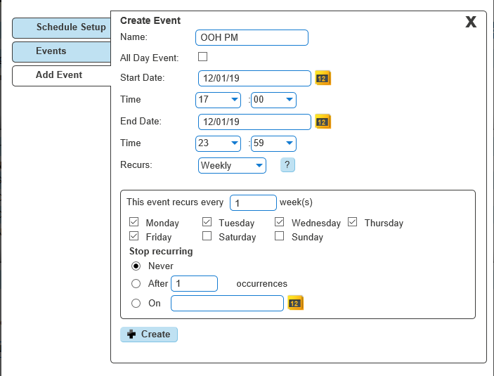
You will now need to add in the weekend section. As the office is closed all weekend we can leave ‘All Day Event’ ticked. We want this to recur weekly on Saturdays and Sundays.
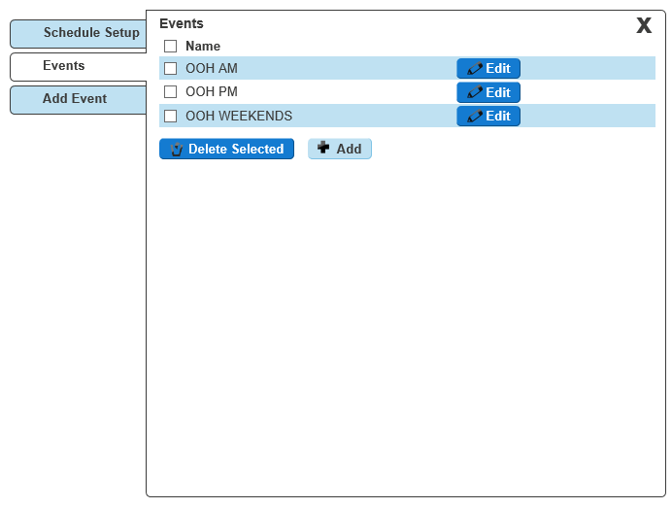
After you have saved all of your events, you will see them here under ‘Events’ where you can either add more, edit the existing events or if you are happy with what is already created, click the X to close this pop-out.
Once you are happy with your events, click the X and you should now see this page. You will need to input a CLI or extension number into the Forward To: box. This is where calls will be diverted to whenever it is within the scheduled hours.

Please note if you wish to forward the call to the voicemail box of this particular group, you will need to input the company voice portal extension here (the extension only, as when putting in the full DDI for the voice portal it will act as if you are calling the company voice portal).
After you have created your schedule and have inputted the number you wish for calls to forward to during the scheduled hours, click ‘save’ at the bottom of the page to save your schedule settings. and to activate this schedule click the ‘Activate’ button halfway up the page and then click ‘save’ again.
The above example is a basic schedule, for more complex schedules please contact the Horizon Provisioning team who will be able to advise how to create a schedule based on your requirements.

Edit Schedules
Step 1
Log into the Gamma Portal and go to Provisioning and Service Management, Hosted, Horizon and Horizon Manage Company.
Step 2
Select your account and login to the company that you want by using the "Actions" button select "Login to Horizon".
Step 3
Select "Site Management" and click on the Manage button the site you want to create a schedule for.
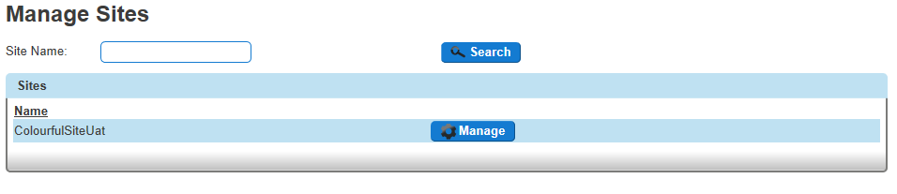

Step 4
Click on the "Schedules" button.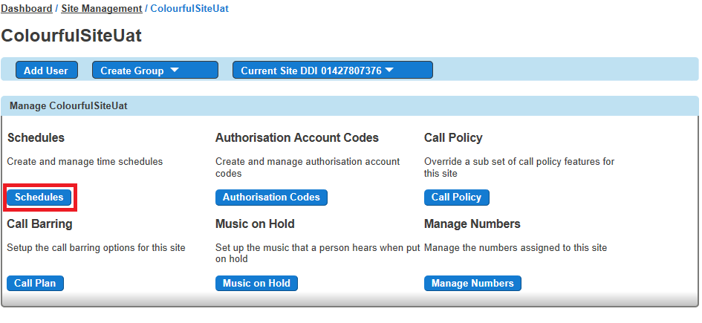
Step 5
Click on the "Edit" button of the schedule that you want to edit.
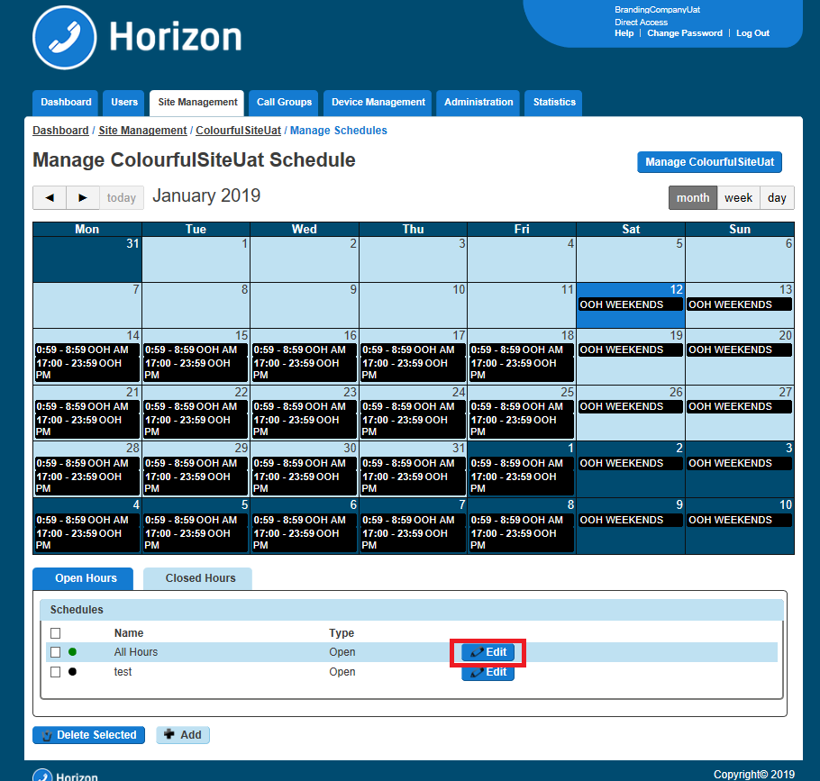

Step 6
"Schedule Setup" will allow you to change the name, type and colour of the schedule.
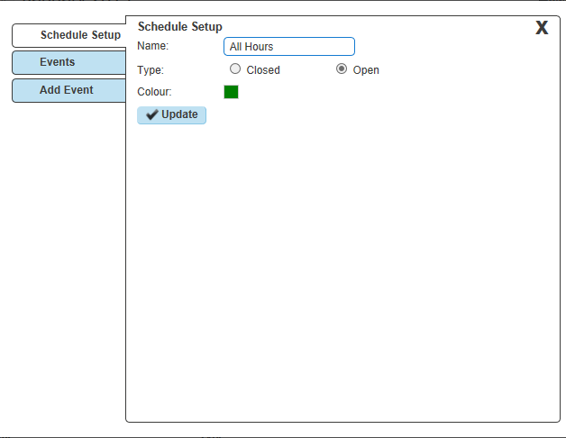
Step 7
"Events" will allow you to delete an event by selecting the schedule's tick box and then press "Delete selected", or add a new schedule by clicking Add New.
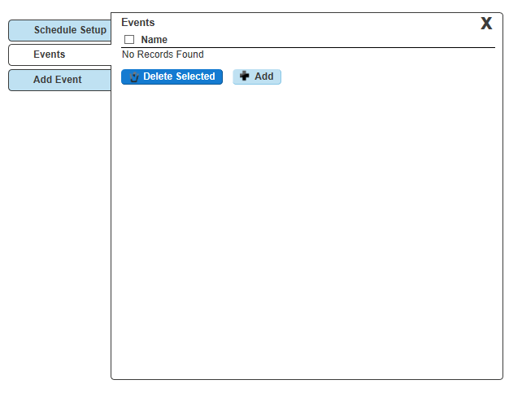

Step 8
"Add Event" will allow you to add an event to the schedule.

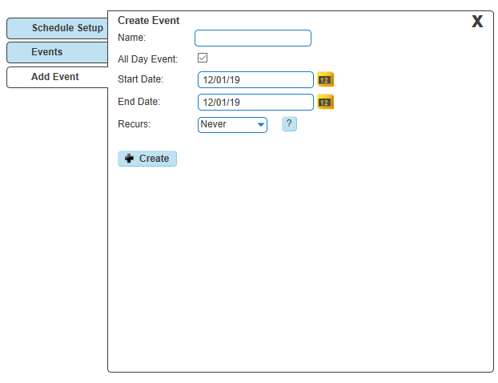

Twinning
Twinning is a service that allows a user to use their mobile phone, or any other non-Horizon handset to behave as if it was part of the Horizon Company. For example, if someone calls your Horizon handset and you've got twinning enabled to a mobile phone, your mobile will ring at the same time as your Horizon handset, allowing you freedom to answer your calls from anywhere.

Enable/Disable Twinning as an Administrator
Step 1
Log into the Gamma Portal and go to Provisioning and Service Management, Hosted, Horizon and Horizon Manage Company.
Step 2
Select your account and login to the company that you want by using the "Actions" button select "Login to Horizon".
tep 3
Click the "Users" option and then select "List Users" so you can search for the user that you want Twinning set up for.
Locate the user and click the "Edit" button.
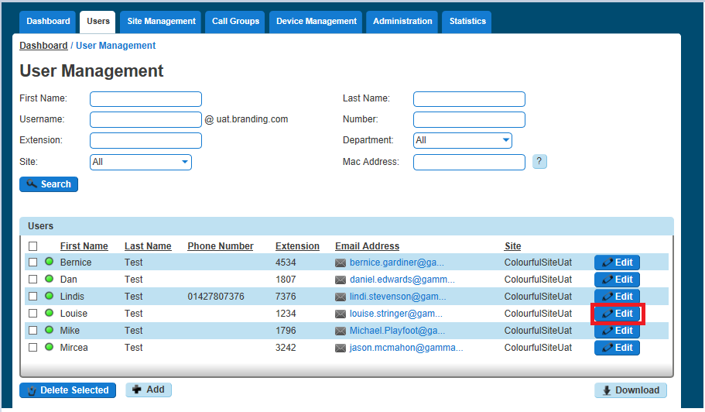
Step 4
Click "Call Setup" and then under the "Incoming Calls" section of the side-menu, click "Twinning".
From here you can enable twinning; enter the number(s) that you'd like to add for a user. You can have up to 7 numbers per user.

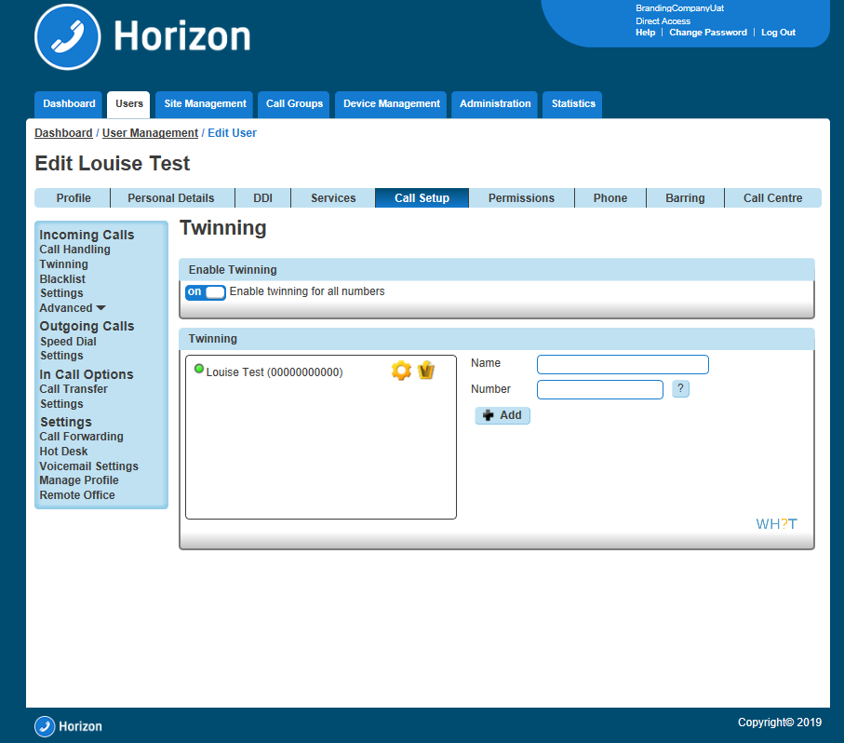

Enable/Disable Twinning as a User

Enable / Disable Twinning using the Horizon Portal
Step 1
Log into the Horizon Portal and log in as a user.

Step 2
From the menu bar select Call Setup and the Twinning.
rom here you can add a new number and give it a name (though you don't have to) and then click Add. You can also delete any numbers by clicking the Bin icon.
If there is a green light next to a number, this means that twinning is active with that number. A red light means that this is switched off.
A user can have up to 7 numbers set up for twinning.

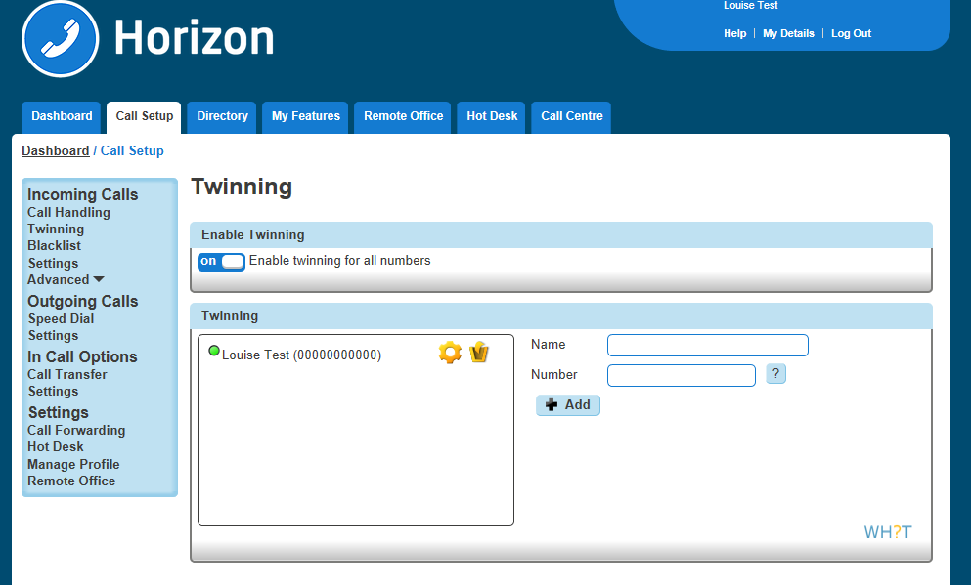

Enable / Disable Twinning using the PC Soft Client and Collaborate
A user an enable / disable Twinning using the PC Client by clicking the Settings icon, Incoming Calls and then Twinning and then you can either select "Configure" to add/delete numbers, or by selecting/de-selecting an already configured number.
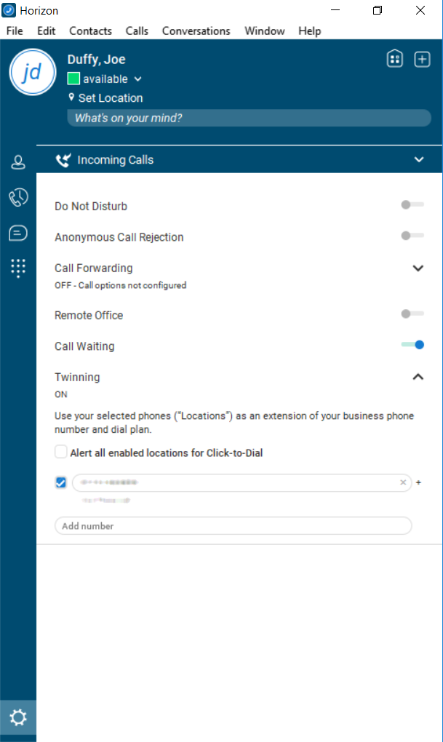

Voice Portal
The Company Voice Portal provides an interactive voice response (IVR) application that can be called by any user, from any phone. The IVR allows the user to manage their services and voice mailbox, as well as changing their passcode if needed.
For this feature to work a site DDI needs to be setup under the Site Management pages.
To setup the Company Voice Portal you simply need to assign it to a site, and select a free number, whilst giving it an extension if required for easier internal access.

Setup a Company Voice Portal
Step 1
Log into the Gamma Portal and go to Provisioning and Service Management, Hosted, Horizon and Horizon Manage Company.
Step 2
Select your account and login to the company that you want by using the "Actions" button select "Login to Horizon".
Step 3
Select "Administration" and then "Voice Portal" and then select the site that you want the Voice Portal to be against (The voice portal will be created on a company level, and it will be available for all users across all of the sites within the company.
Step 4
Select the number you want to have for the Company Voice Portal. Then enter the extension number you want for the Company Voice Portal and click save.
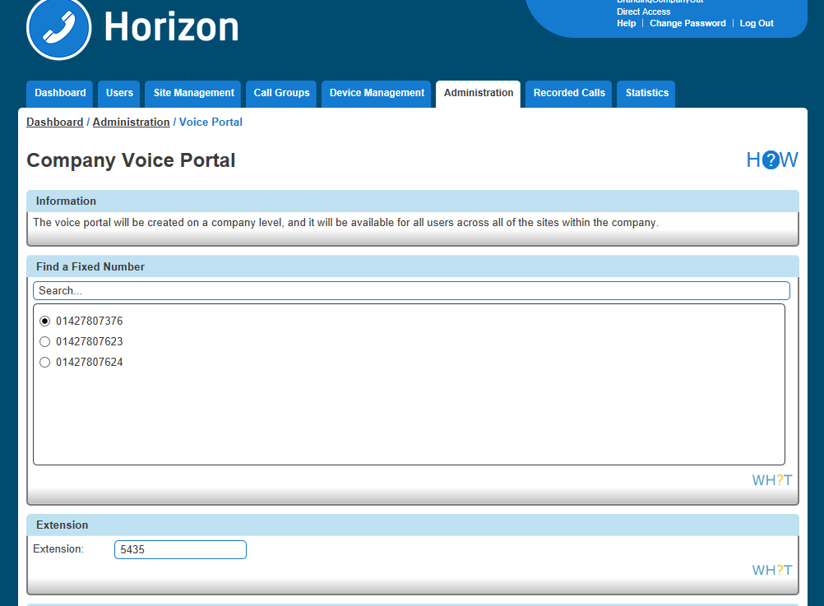

Managing a Company via the Voice Portal

Option 1 - Voicemail
1 - Messages
This plays all new or saved messages
2 - Change the busy greeting
Within this option you can:
Record a new Busy greeting - allows you to record a fully personalised message without any additional messaging.
Play the saved message - lets you listen back to the current saved message.
Implement the system default - to reset the message to the system default with your personalised name greeting. To manage your name greeting, use Option 3 on the voice portal.
Please note the personalised name greeting is a maximum of 10 seconds
3 - Change the no answer greeting
Within this option you can:
Record a new No Answer greeting - allows you to record a fully personalised message without any additional messaging.
Play the saved message - lets you listen back to the current saved message.
Implement the system default - to reset the message to the system default with your personalised name greeting. To manage your name greeting, use Option 3 on the voice portal.
Please note the greeting maximum is 120 seconds (2minutes)

5 - Record and Send Messages
This enables you to record a message and forward it to another user's mailbox. To do this, follow the in-call instructions to record your message, type the extension and send.

7 - Delete all messages
Allows you to delete all stored messages on your mailbox.

Option 2 - Voicemail Express
To use this option, you need to set up an Availability Profile - e.g. Available, Unavailable, Busy - in the Horizon Portal. Once set up, you have the option to implement each profile, whether you're in the office or on the move, by selecting the corresponding option.
Changes made in Voicemail Express will also appear in the Horizon portal.

Option 3 - Recording your name greeting
This lets you record or adjust your mailbox name greeting, as well as being the name used on the system default voicemail greeting.

Option 4 - Call Forwarding
This can also be set up and managed through the Horizon portal, where you will also have the ability to define, activate, and de-activate call forwarding on your user account. See Call Forwarding for more details.

Option 8 - Call Forwarding
You can change your passcode using the voice portal or via the Horizon portal.

Voicemail
For Voicemail to work, the Horizon Company needs the Voice Portal to be set up first.
Voicemails have a 30-day limit. This applies to all messages left on the voice portal, including saved messages. If you wish to save certain messages, we recommend using the "Notification Settings" when editing a user to send an email with a file of the voicemail by selecting "Notify Me at the address".
The capacity on a voicemail is 100 minutes. After this, the caller will be unable to leave a voicemail message.
The user can skip to the end of the voicemail message by pressing 6.

Voicemail Map
Go to our Knowledgebase to download a copy of our Horizon Voicemail Map.

Setup Voicemail for a user
Step 1
Log into the Gamma Portal and go to Provisioning and Service Management, Hosted, Horizon and Horizon Manage Company.
Step 2
Select your account and login to the company that you want by using the "Actions" button select "Login to Horizon".
Step 3
Click the "Users" option and then select "List Users" so you can search for the user that you want Voicemail set up for.
Locate the user and click the "Edit" button.
Step 4
Click on "Services" and ensure that you've got ensure Voicemail services left, and then tick the tick box. If you haven't, these can be ordered on the Gamma Portal using the "Manage Bolt ons" action.
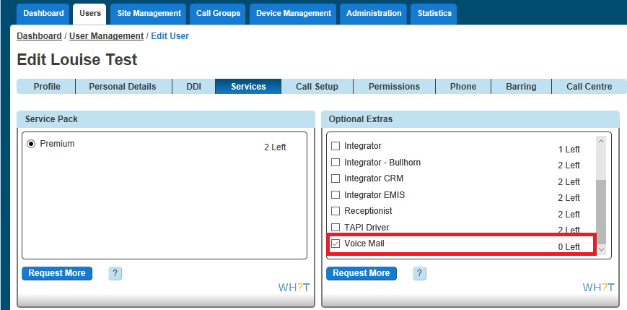

Step 5
Click "Call Setup" and under the Settings header, click "Voicemail Settings". Here, you can choose which file is to be played upon no answer as well as choosing to receive an email notification when a voice mail is left.
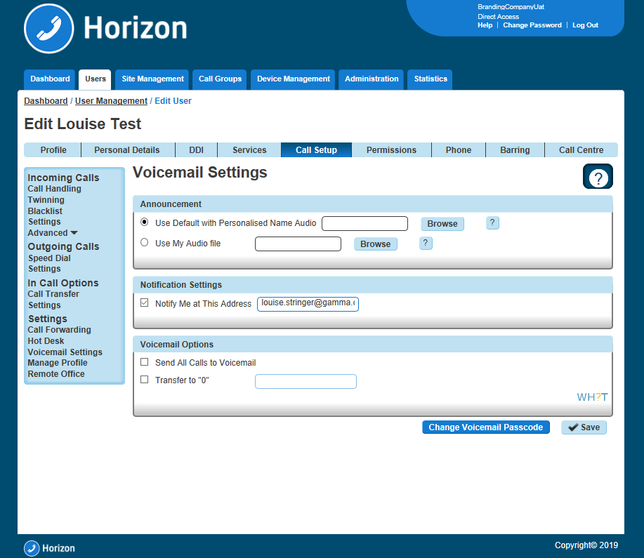
Step 6
Now select Call handling" under the Incoming Calls menu so that you can set up what calls should be sent to the users voicemail, and when.
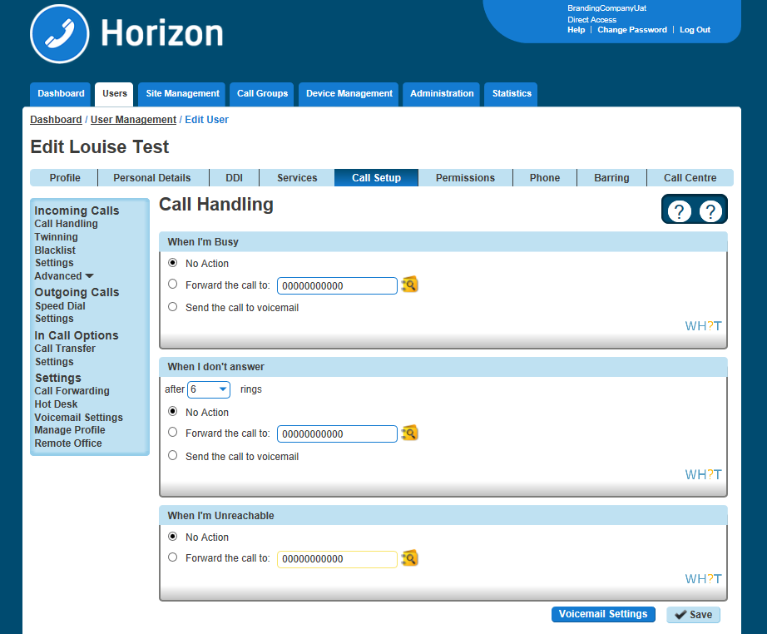

Setup Voicemail from a handset
You can setup voicemail directly from a user's handset, including personalised name greetings, no answer greetings and busy greetings. This can be applied to both a user or group telephone number.

Step 1
Dial the company Voice Portal and enter the user or group extension number when prompted for an ID.
Step 2
Enter the passcode of the user / group.
If the user does not know their password, then this can always be reset in the "Edit User" tab on the Horizon Portal.
A hunt group the passcode can be manually set in the "Edit Hunt Group" page under the Voicemail tab.
Step 3
If the user is accessing this voicemail box for the first time, then the Voice Portal will ask the user to change the passcode.
The Voice Portal will then proceed to ask the user to record a personalised name greeting. The user must do this in order to proceed.
Step 4
After this is complete the user should be presented with the following message:
"You are now ready to use your voicemail system. To access your voice mailbox, press 1".
Press ‘1’ to listen to your messages, to change ‘your mailbox busy greeting’, press ‘2’ and to change ‘your mailbox no answer greeting’ press ‘3’.
Step 5
Finally, you will need to specify on the Horizon Portal what message you would wish to use during "No Answer" and "Busy" actions

Change a user's passcode for Voicemail
Step 1
Log into the Gamma Portal and go to Provisioning and Service Management, Hosted, Horizon and Horizon Manage Company.

Step 2
Select your account and login to the company that you want by using the "Actions" button select "Login to Horizon".
Step 3
Click the "Users" option and then select "List Users" so you can search for the user that you want to change the passcode for.
Locate the user and click the "Edit" button.
Step 4
Click "Call Setup" and under the Settings header, click "Voicemail Settings". From here you can click the "Change Voicemail Password" button. This will generate an email to the user with a new voicemail passcode.

Change a user's passcode for Voicemail
Step 1
Log into the Gamma Portal and go to Provisioning and Service Management, Hosted, Horizon and Horizon Manage Company.
Step 2
Select your account and login to the company that you want by using the "Actions" button select "Login to Horizon".
Step 3
Click the "Call Groups" option and then select "Hunt Group" or "Call Queue Group". Locate the call group and click the "Edit" button.
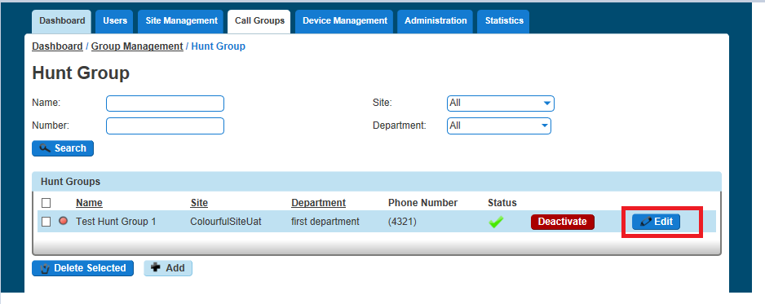
Step 4
Click on "Voicemail" from here you can edit the Settings, and if you want to enable voicemail.
Now select Call handling under the Incoming Calls menu so that you can set up what calls should be sent to the group voicemail, and when.

Send All Calls To Voicemail
Step 1
Log into the Gamma Portal and go to Provisioning and Service Management, Hosted, Horizon and Horizon Manage Company.
Step 2
Select your account and login to the company that you want by using the "Actions" button select "Login to Horizon".
Step 3
Click the "Users" option and then select "List Users" so you can search for the user that you want to amend the Voicemail settings for and click the "Edit" button.
Step 4
Select the "Call Setup" tab and click Voicemail Settings. Towards the bottom of this page there will be a "Voicemail Options" section and here you will be able to tick the Send All Calls to Voicemail box.
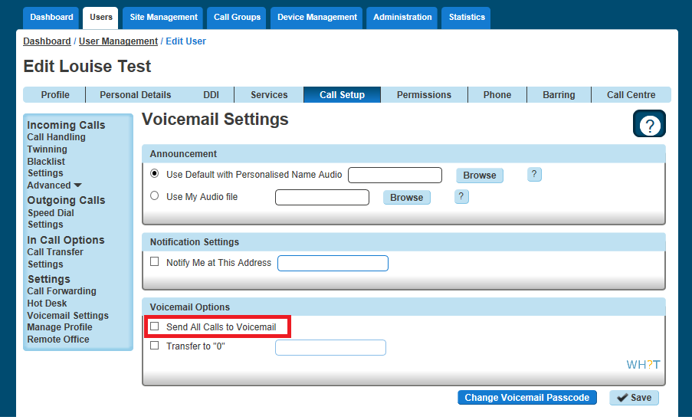

Transfer on 0 for Voicemail
Step 1
Log into the Gamma Portal and go to Provisioning and Service Management, Hosted, Horizon and Horizon Manage Company.
Step 2
Select your account and login to the company that you want by using the "Actions" button select "Login to Horizon".
Step 3
Click the "User Management" button and next to your selected User click "Edit".
Step 4
On the Edit screen select the "Call Setup" tab at the top of the screen and then click Voicemail Settings. Here you will be able to tick the "Transfer to 0" box.
To ensure the caller is aware of the transfer option this feature provides, it is important that the user records an appropriate voicemail message such as the following example:
“Hi, you’re through to the voicemail of ___. I can’t take your call right now so please leave a message and I’ll get back to you. Alternatively, press 0 to be transferred to the Service Desk”
This voicemail greeting should advise that the feature is available to the calling party in addition to programming the destination number.
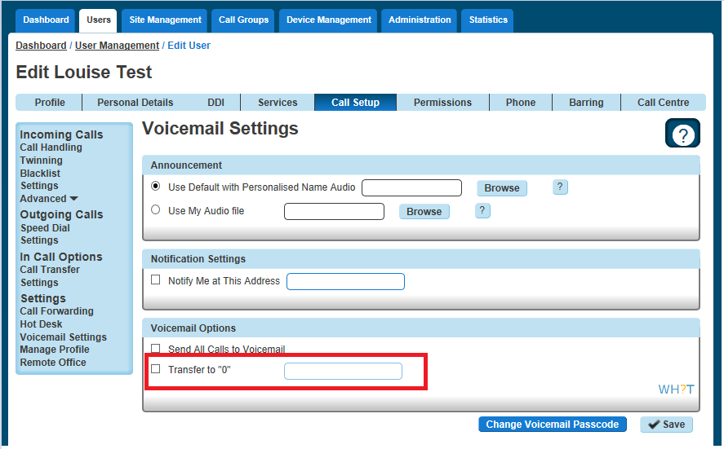
Please note, it not currently possible to program an extension number into the provided field, the full DDI number must be used.

Feedback
 | portalfeedback@gamma.co.uk
 | 0333 240 7771

